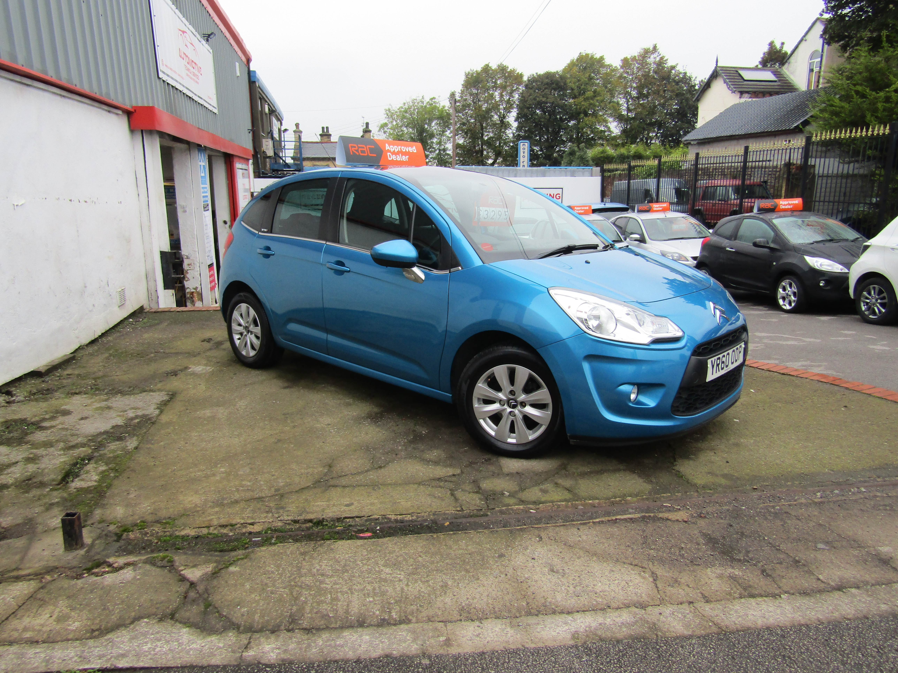
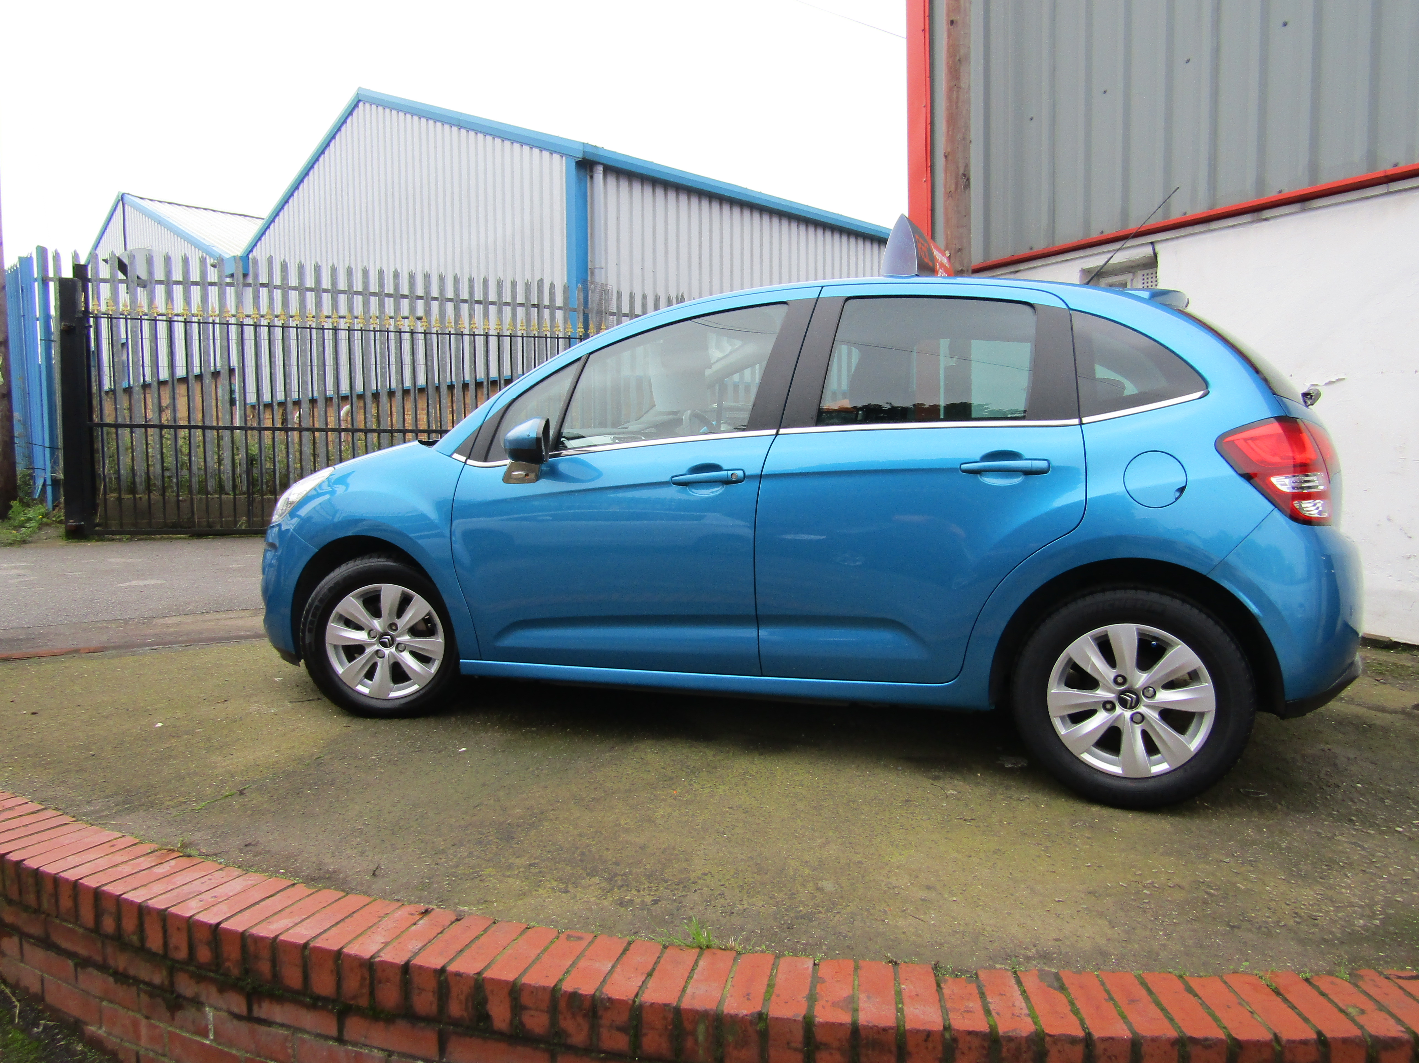
2010 (60) Citroen C3 1.4i VTR+ 5dr £3,295

Registration | YR60ODP | Transmission | Manual
Mileage | 40053 | Fuel Type | Petrol
Colour | Blue | Engine Size | 1360cc
No Doors | 5 | Previous owners | 0
Body Style | Hatchback | Reg Date | 25/10/10

We are pleased to offer this one owner vehicle with full service history covering only 40k miles. The car is in superb condition throughout, It has the extended windscreen and retractable roof lining to give sky view. Here at Automotive Technical Service we are proud to be able offer very well prepared used vehicles at affordable prices. We are a small family run business that take pride in finding only the best vehicles to offer for sale at a price to suite everyone! We don't have a large forecourt to fill so take our time finding quality vehicles. All vehicles offered for sale will have been through our RAC approved workshop for a 82 point inspection, new service & MOT with no advisories. 'Unless otherwise stated in the advert' We also provide a minimum of 3 months RAC Warranty & 12 months free breakdown cover including home

