**We Carry Fresh**

**Jaindl Farms Turkey**

Jaindl Turkey Farms located in Orefield, Pennsylvania, is the largest independent agricultural operation in the Lehigh Valley, producing approximately 750,000 turkeys each year.  Jaindl also prides itself as the largest independently owned and fully integrated turkey business in the world. Jaindl breeds, hatches, grows, processes and markets their own unique breed on 12,000 acres of family-owned prime Lehigh Valley farmland***.***

**We Can Season, Cook & Carve any sized Turkey for you! Ask your server today !**

**Fresh Jaindl Whole Turkey**

**Sizes & Pricing**

**We can also Cook & Carve your Turkey for $5.00 more per lb**

|  |  |
| --- | --- |
| **10-12lb.** | **$5.49/lb.** |
| **12-14lb.** | **$5.49/lb.** |
| **14-16lb.** | **$5.49/lb.** |
| **18-20lb.** | **$5.49/lb.** |
| **20-22lb.** | **$5.49/lb.** |
| **22-24lb.** | **$5.49/lb.** |
| **24-26lb.** | **$5.49/lb.** |
| **26-28lb.** | **$5.49/lb.** |
| **30-32lb.** | **$5.49/lb.** |

**Fresh Jaindl Turkey Breast**

**Sizes & Pricing**

**All Turkey Breast are Fresh, never frozen. They come with the skin-on unless specified otherwise. All Boneless Breasts are weighed & priced at the time of when they are bone-in. Example: If you order a whole boneless breast, it will be priced out at the bone-in weight, and then boned out.**

|  |  |
| --- | --- |
| **Whole Bone-in 12-18lb.** | **$9.99/lb.** |
| **Half Bone-in 6-9lb.** | **$9.99/lb.** |
| **Whole**  **Boneless**  **Avg 8-10lb.** | **$10.99/lb.** |
| **Half**  **Boneless**  **Avg 4-5lb.** | **$10.99/lb.** |

**Thanksgiving Holiday Add-ons**

|  |  |
| --- | --- |
| **Rath’s Homemade Turkey Gravy. Made from scratch.** | **$14.99 per quart**  **$7.99 per pint** |
| **Rath’s Homemade Vegetable, Cranberry, or Apple Stuffing** | **$10.99/lb.** |
| **Rath’s Homemade Cranberry Sauce** | **$8.99 per pint** |
|  |  |
| **Rath’s Smoked Kielbasa** | **$11.99/lb.** |
| **Rath’s Double Smoked Kielbasa** | **$13.99/lb.** |
| **Rath’s Fresh Kielbasa (Not Smoked)** | **$10.99/lb.** |

**Holiday Hams**

Looking to add a Ham to your Holiday Dinner Table? Here are our following options:

|  |  |
| --- | --- |
| **Boneless Smoked Ham**  **(Avg. 12lbs. Cut size to order)** | **$9.99/lb.**  **$10.99/lb. Sliced & Decorated** |
| **Bone-In Smoked Ham**  **(Avg. 18lbs. Whole or Half)** | **$8.99/lb.**  **$10.99/lb. Sliced & Decorated** |
| **Bone-In Fresh Ham (Whole or Half)** | **Whole: $4.99/lb.**  **Half: $5.99/lb.** |
| **Boneless Fresh Ham (Cut size to order** | **$6.99/lb.** |
| **\*Decoration includes:** | **Glaze, Pineapple, Cherries** |

**Thanksgiving Complete Dinner Option**

Let us do the cooking for you so that you can spend more time creating lasting memories with your family!

**What’s Included:**

* **½ Tray Rath’s Seasoned & Sliced Boneless Turkey Breast**
* **Choice of ½ Tray Vegetable, Cranberry, or Apple Stuffing**
* **Choice of ½ Tray Garden Blend Vegetables or Baby Carrots**
* **Choice of ½ Tray Mashed Yukon Gold Butter Potatoes or Sweet Mashed Potatoes**
* **½ Tray of Corn**
* **1 Quart Rath’s Turkey Gravy**
* **1 Pint Rath’s Cranberry Sauce**

**Feeds 10-14 Guests Comfortably**

**Cost: $360 +Tax**

Full Payment required at time of order.

Store Credit for Cancellations.

**Other Catering Options**

We have many other catering trays available for the holidays. Everything from Chicken Francaise to Baked Mac n Cheese. We do it all. Check out our many available options on our website at [www.rathsdeli.com](http://www.rathsdeli.com) under the Catering Tab. Prices listed are for Half Trays (Feed 10-12 Guests comfortably). Full Trays (Feed 20-24 Guests comfortably) are double the price.

**Popular Centerpiece Platters & Appetizers**

Choose from our list of beautiful platters guaranteed to make your dinner table stand out and your guests happy!

* **Jumbo Shrimp Platter**
* **Antipasto Platter**
* **Fresh Cut Vegetable Platter**
* **Cheese & Grapes Platter**
* **Fresh Cut Fruit Platter**
* **Fresh Mozz & Roasted Red Pepper Platter**
* **Lunch Meat & Cheese Platter**

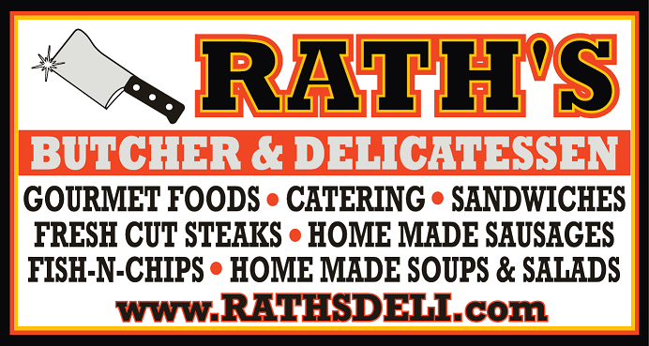

**Thanksgiving Menu, Specials & Items**

**Phone: 908-213-2121**

[**www.rathsdeli.com**](http://www.rathsdeli.com)

