We Carry Fresh
Jaindl Farms Turkey
Jaindl Turkey Farms located in Orefield, Pennsylvania, is the largest independent agricultural operation in the Lehigh Valley, producing approximately 750,000 turkeys each year. Jaindl also prides itself as the largest independently owned and fully integrated turkey business in the world. Jaindl breeds, hatches, grows, processes and markets their own unique breed on 12,000 acres of family-owned prime Lehigh Valley farmland.

We Can Season, Cook & Carve any sized Turkey for you! Ask your server today !

Fresh Jaindl Whole Turkey
Sizes & Pricing
We can also Cook & Carve your Turkey for $6.00 more per lb
10-12lb. | $5.99/lb.
12-14lb. | $5.99/lb.
14-16lb. | $5.99/lb.
18-20lb. | $5.99/lb.
20-22lb. | $5.99/lb.
22-24lb. | $5.99/lb.
24-26lb. | $5.99/lb.
26-28lb. | $5.99/lb.
30-32lb. | $5.99/lb.
Fresh Jaindl Turkey Breast
Sizes & Pricing
All Turkey Breast are Fresh, never frozen. They come with the skin-on unless specified otherwise.

Whole Bone-in 10-12lbs. | $11.99/lb.
Half Bone-in 5-6lbs. | $11.99/lb.
Whole  Boneless  Avg 8lbs. | $14.99/lb.
Half  Boneless  Avg 4lbs. | $14.99/lb.

Thanksgiving Holiday Add-ons
Rath’s Homemade Turkey Gravy. Made from scratch. | $15.99 per quart  $8.99 per pint
Rath’s Homemade Vegetable, Cranberry, or Apple Stuffing | $11.99/lb.
Rath’s Homemade Cranberry Sauce | $8.99 per pint
Rath’s Smoked Kielbasa | $11.99/lb.
Rath’s Double Smoked Kielbasa | $13.99/lb.
Rath’s Fresh Kielbasa (Not Smoked) | $10.99/lb.
Holiday Hams
Looking to add a Ham to your Holiday Dinner Table? Here are our following options:
Boneless Smoked Ham  (Avg. 12lbs. Cut size to order) | $9.99/lb.  $10.99/lb. Sliced & Decorated
Bone-In Smoked Ham  (Avg. 18lbs. Whole or Half) | $8.99/lb.  $10.99/lb. Sliced & Decorated
Bone-In Fresh Ham (Whole or Half) | Whole: $4.99/lb.  Half: $5.99/lb.
Boneless Fresh Ham (Cut size to order | $6.99/lb.
*Decoration includes: | Glaze, Pineapple, Cherries

Thanksgiving Complete Dinner Option
Let us do the cooking for you so that you can spend more time creating lasting memories with your family!
What’s Included:
- Whole Cooked Boneless Turkey Breast Seasoned & Sliced
- Choice of ½ Tray Vegetable, Cranberry, or Apple Stuffing
- Choice of ½ Tray Garden Blend Vegetables or Baby Carrots
- Choice of ½ Tray Mashed Yukon Gold Butter Potatoes or Sweet Mashed Potatoes
- ½ Tray of Corn
- 1 Quart Rath’s Turkey Gravy
- 1 Pint Rath’s Cranberry Sauce
Feeds 12-15 Guests Comfortably
Cost: $399 +Tax
Full Payment required at time of order.
Store Credit for Cancellations.

Other Catering Options
We have many other catering trays available for the holidays. Everything from Chicken Francaise to Baked Mac n Cheese. We do it all. Check out our many available options on our website at www.rathsdeli.com under the Catering Tab. Prices listed are for Half Trays (Feed 10-12 Guests comfortably). Full Trays (Feed 20-24 Guests comfortably) are double the price.

Popular Centerpiece Platters & Appetizers
Choose from our list of beautiful platters guaranteed to make your dinner table stand out and your guests happy!
- Jumbo Shrimp Platter
- Antipasto Platter
- Fresh Cut Vegetable Platter
- Cheese & Grapes Platter
- Fresh Cut Fruit Platter
- Fresh Mozz & Roasted Red Pepper Platter
- Lunch Meat & Cheese Platter

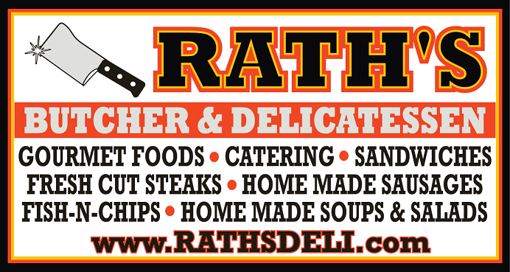
Thanksgiving Menu, Specials & Items
Phone: 908-213-2121
www.rathsdeli.com
