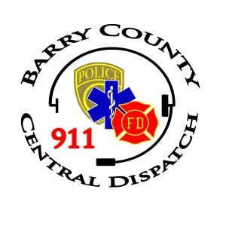
Barry County Central Dispatch
Administrative Board Meeting Minutes
Monday, March 23rd, 2026

- Forbes called the meeting to order at 2:00 p.m.
Roll call was taken.
Attendance: Forbes, Leaf, Linebaugh, Peck, Cove, Boulter, Yarger, Smelker, and Dunn. Vujea, Peck, Weeks were absent with advanced notice.
Others in attendance: (BCCD) Hall and Booth. Stephanie via teams.
- A motion was made by Leaf and supported by Smelker to approve the March 23rd, 2026 meeting agenda. All in favor Motion carried.
- A motion was made by Yarger and supported by Linebaugh to approve the February 23rd, 2026 meeting minutes. All in favor. Motion carried.
- No Public Comment
- Committee Reports
  - No Personnel Committee meeting and no report.
  - No Finance Committee meeting and no report
  - No Equipment Committee meeting and no report.
- Deputy Directors Report was reviewed.
- New Business
  - Discussed the adding the new AT & T wireless back up voucher bill which is due on the 23rd of each month and the need to add it to the contingent voucher list. Motion made by Leaf and supported by Boulter for the approval of adding AT & T Wireless Back up to the contingent vouchers. Roll call vote. 7 aye 1 nay. Motion carried.
  - Discussed National Telecommunicator Week April 12-18th.
  - Discussed Policy 385 School Camera Access. Motion made by Boulter supported by Leaf for the approval of Policy 385 School Camera Access adding in section 6.2 School Security and or Superintendent. Motion carried.
- February 2026 Operating & State Budget Reports were reviewed and discussed.
- March Expenses
  - Operating Disbursements were reviewed. A motion was made by Leaf and supported by Smelker to approve the March 2026 Operating Disbursements. Roll call vote. All in favor. Motion carried.
  - State Disbursements were reviewed. A motion was made by Leaf and supported by Linebaugh to approve the March 2026 State Disbursements. Roll call vote. All in favor. Motion carried.
  - Motion was made by Leaf and supported by Cove to approve the April 2026. Contingent Vouchers. Roll call vote. All in favor. Motion carried.
- Old Business
  - Reviewed the State 9-1-1 Compliance approval letter.
- No Miscellaneous
- No Limited Public Comment
- Motion was made by Leaf and supported by Smelker to adjourn at 2:19 p.m. All in favor. Motion carried.

The next Administrative Board Meeting will be held on Monday, April, 2026 at 2:00 p.m.
Respectfully submitted by Vanessa Booth

