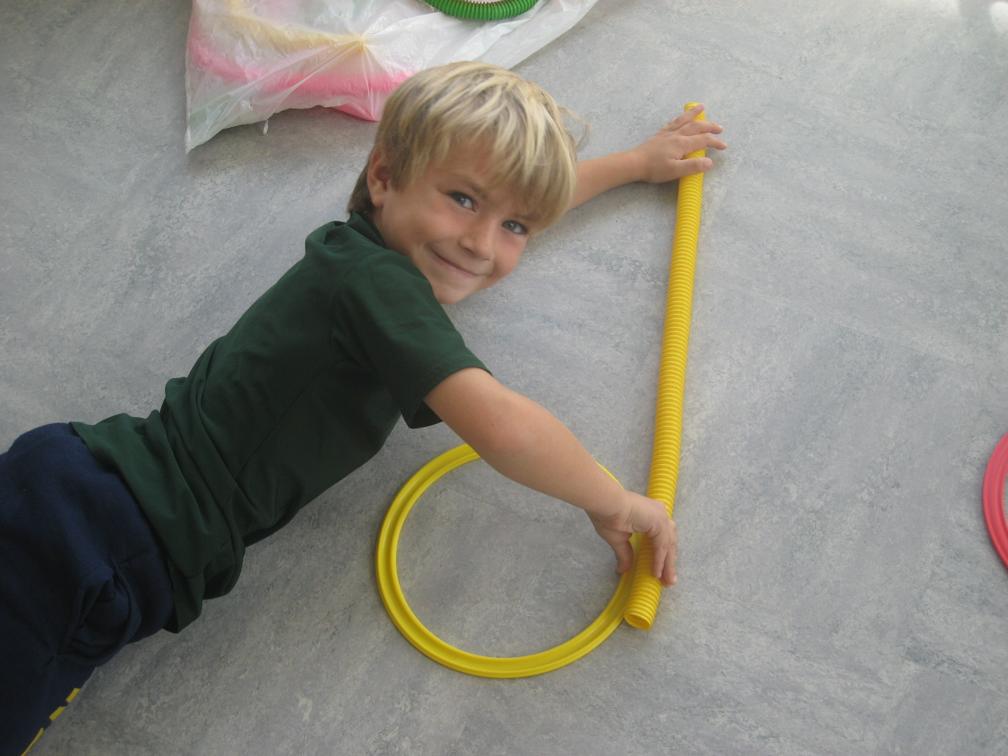
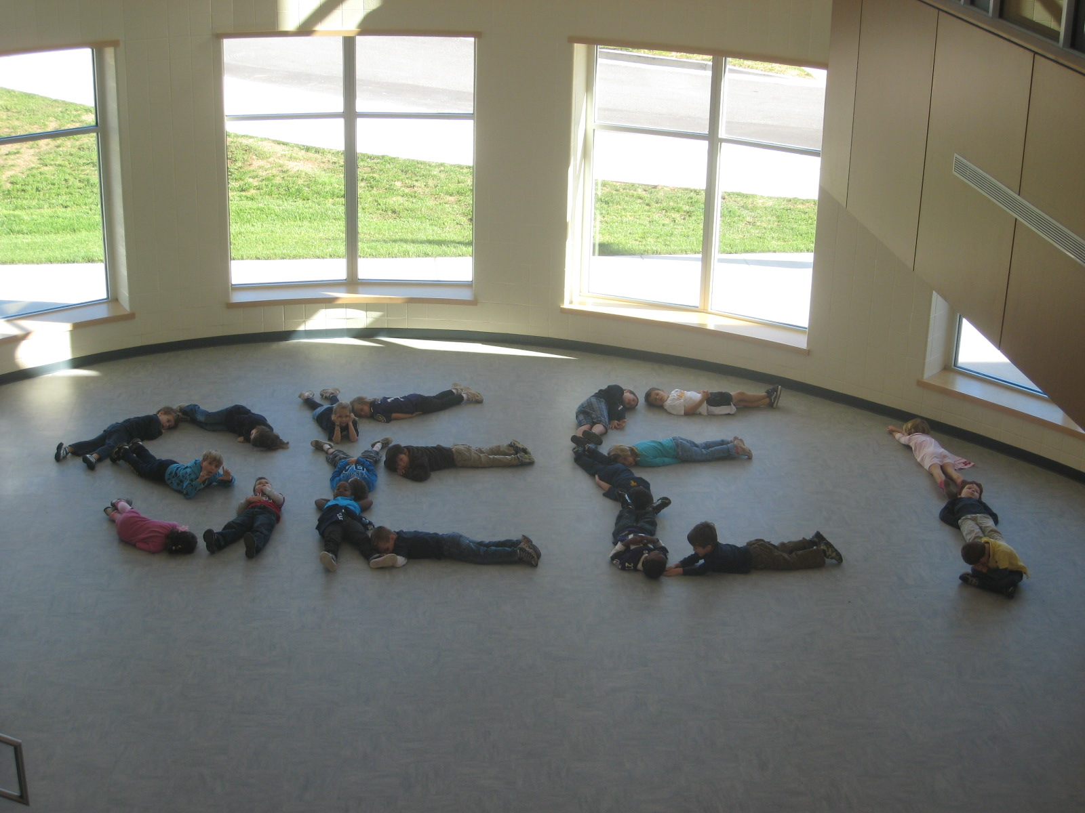

West Towson
Elementary School
Dance Integration Lessons
2010-2011
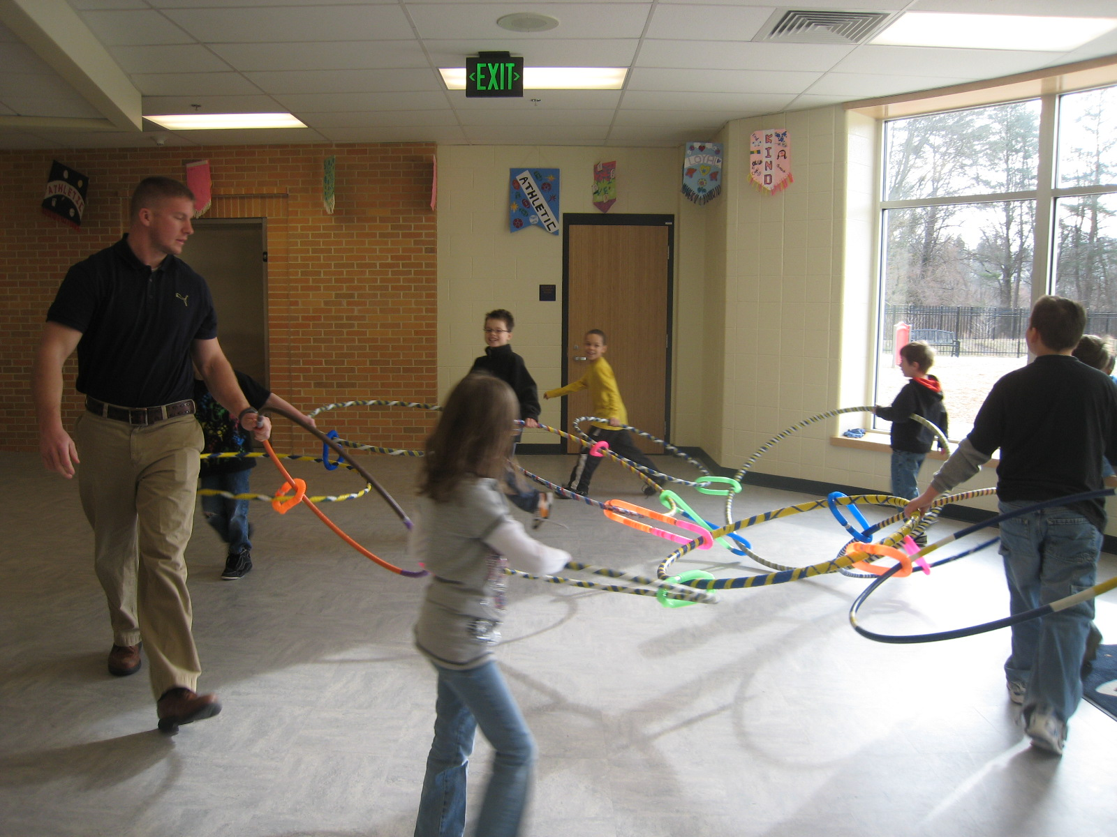
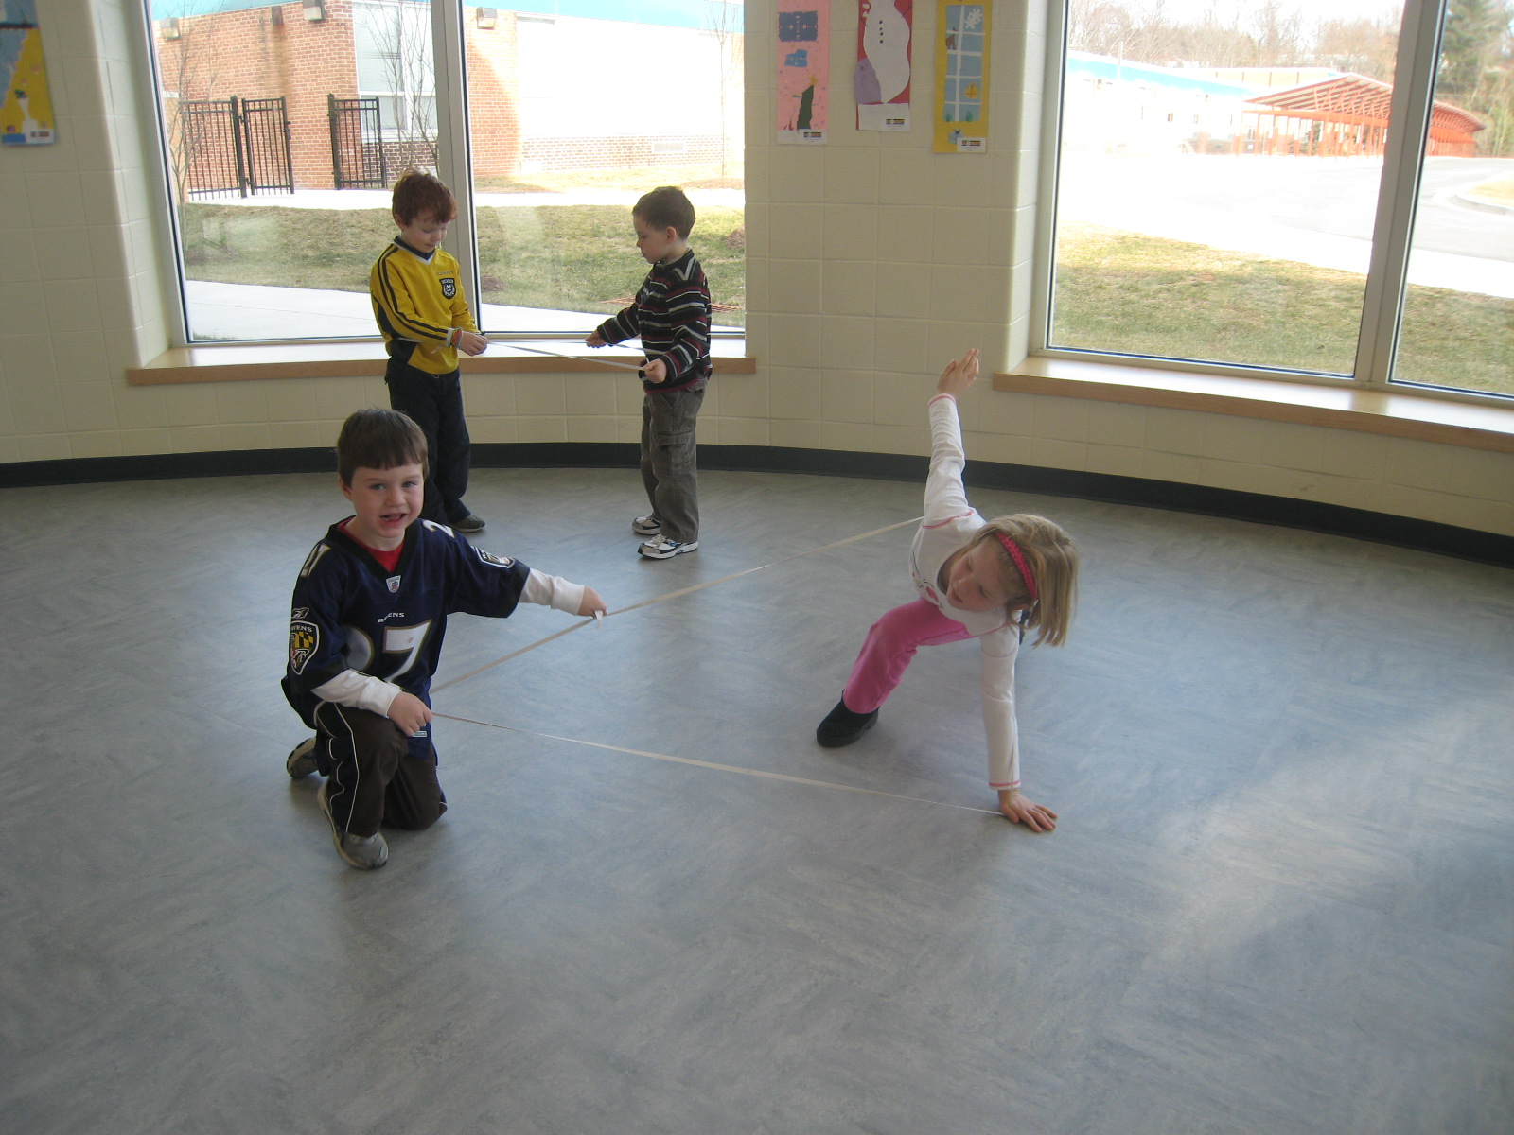
Prepared and implemented
by Karen Kuebler
in conjunction with
School Improvement Plan
performance goals.
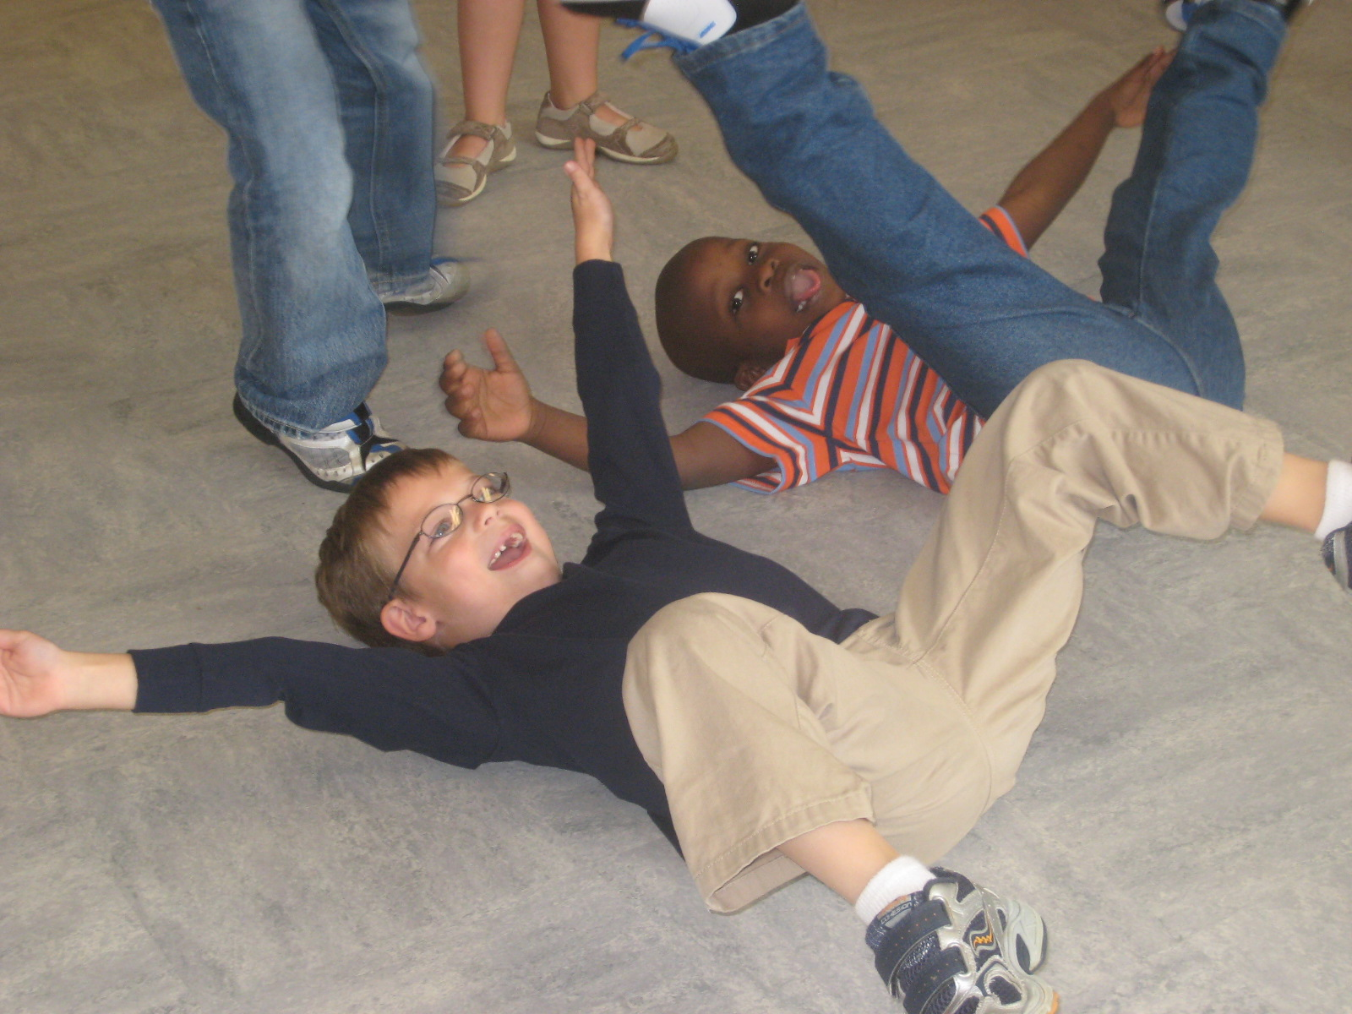
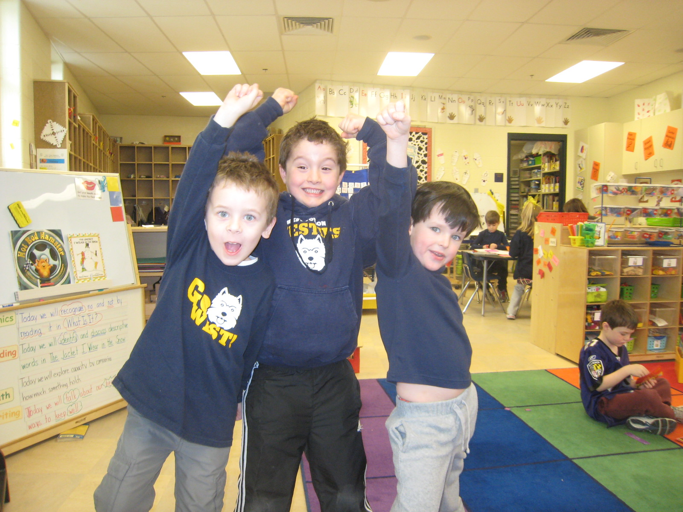
Report
completed
June 2011.
Performance Goal 1 – Reading
The following lessons were done from September 2010 – December 2010. They correlated to the Kindergarten Language Arts Curriculum. In the 1st semester of Kindergarten, lessons focused on letter identification, letter formation, rhyming, letter placement, sight words
and story structure including beginning, middle and end.
Lessons are 15-20 minutes in length and are done in the morning
during the Language Arts block of time.

The Foot Book by Dr. Seuss: The lesson focused on the rhyming, repetitive text of this Dr. Seuss classic. The movements connected to the text and were reinforced in the following examples:
- 1 foot, 2 feet, emphasized the use of singular and plural forms of a word. Students received specific movements to do for the verbal cues of foot vs. feet.
- Body awareness of left and right is highlighted in the text. This reinforces directionality in reading.
- The social/emotional connection to literature was also introduced in this lesson. Whenever the text mentioned “how many feet you meet”, students wiggled their feet at a friend and said, “Hello”. So, instead of focusing on meeting one another by face, students met one another by feet!

Name Game: Students chose a movement and said their name while performing the movement. This lesson enabled students to reinforce names with a kinesthetic connection. When several sensory/modality skills are used to reinforce information, a stronger connection is created in the brain. All students repeated the name and movement after the student demonstrated it. Name recognition is an important skill that is mastered in the first several months of Kindergarten.

Lines: This series of lessons focused on straight, curved and diagonal lines. Lines that go up and down and lines that go left to right were also highlighted. Vertical and horizontal lines were also investigated.
All of these lines were then used to form letters. These lessons reinforced the important pre-reading skills of letter identification and letter formation. Props such as circles, tubes, and pool noodles were coupled with body parts to create the various lines. The following texts were danced to reinforce the lines lessons: The Hidden Alphabet by Laura Vaccaro Seeger, Lines That Wiggle by Candace Whitman.
A PowerPoint presentation was created with photos of the students to review this series of lessons. This provided an assessment tool for the entire class. An alphabet PowerPoint was also created to review a variety of the movement experiences that were done to dance the alphabet.

Nursery Rhymes: A variety of Nursery Rhymes were danced to highlight rhyming words, play with language, and enhance sound differentiation. Once again, connecting the words to movements created stronger neural pathways for the students and alternate ways to retrieve information.

First (Beginning), Middle, Last (Ending): These words are revisited throughout the Kindergarten Language Arts Curriculum. At the beginning of the year, the words are used to identify letters and their placement in words. Numerous lessons were done throughout the year to reinforce these skills.
An autumn leaves story was done to reinforce these words. Students took turns being the narrator for the story. At the beginning, the leaves are on the tree. In the middle, the leaves are dancing in the wind. At the end, the leaves fall to the ground. The entire story was dramatized with plastic leaves. Students worked in small groups to create the trees at the beginning. Students held a garland of plastic leaves. Then, on the narrator’s cue, the leaves started blowing in the wind and the students moved around the space. Finally, students became leaves too and fell to the ground. The story then repeated with a new narrator.
The book Drumbeat in Our Feet by Patricia A. Keeler and Júlio T. Leitão was used to review the letter Tt at the beginning and end of words. This book also focused on African rhythms. Students did a letter identification activity as well as a Dance History lesson.
Sight words (High frequency words): A variety of lessons were done throughout the year to highlight and reinforce sight words. Four of the lessons were the words go, see, the, me. Numerous verbal cues were used to connect these words to movements. Students also explored the letters in the words using skills they gained in the lines lessons. Photo assessments were conducted and can be viewed in the ABC book created with Ms. Fumarola’s class.
Letter Uu: This lesson incorporated tubes and duets! Students made the tubes go up over their bodies and down under their bodies. Students also made duets and pushed and pulled the tubes. Once again the brain connections were made stronger by the multiple skills used to target the learning objective. The addition of a partner increased the learning potential. We are social beings and whenever we experience learning with others, the brain connections that are created, are stronger.
Letter Ww: The letter Ww was explored with blue plastic strips. Each student made the “water” wiggle, fall, come out of a whale, and be liquid or solid. This lesson incorporated language arts skills as well as science skills. For the solid state of matter, the water froze. This was an excellent contextualized way to incorporate the freeze dance because freezing or maintaining stillness can be a challenge for this age group!
Zoom around the world with the Nutcracker: The letter Zz took us around the magical world of the Nutcracker. We visited five different countries, performed a cultural dance from that country, and identified that country on the globe. Map reading skills were highlighted in this lesson. We also discussed the roles of the composer Tchaikovsky and the choreographer Petipa. Although students are familiar with Clara and the mice, they often do not realize the numerous cultural dance connections provided by the music and story. The story visits Spain, China, Arabia, France and Russia. There are dance vocabulary words such as sauté (jump), relevé (rise), changements (change of the feet) and port de bras (carriage of the arms), and arabesque. The vocabulary words are presented in French so this brings another element into the lesson. These vocabulary words are linked with geographical skills in this exploratory trip around the world.
Aa-Ii Alphabet Review: As a summative assessment, students did an alphabet association movement lesson. The connections were as follows: Amazing A’s turn on an Axis, lower case a’s alternate from side to side, Bumpy capital B’s, balancing lower case b’s, Curve the capital C, connect the lower case c’s, Dynamic Dancing D’s, dizzy lower case d’s, Elongate the capital E, energize the lower case e, Freeze the capital F, funny fish faces with the lower case f, Gigantic capital G’s, giggling lower case g’s, HI spells HI!...wave with your Hand, fold in Half with the capital H, hop, hop, hop with the lower case h, freeze like an Icicle for a capital I and dot on top for the lower case i.

Performance Goal 1 – Reading
These lessons were done from January 2011-June 2011.
Kindergarten students were combining their skills from the Fall to
explore and interact with a variety of texts.
Many lessons reinforced the stories students were studying during the week.
Lessons are 15-20 minutes in length and are done in the morning
during the Language Arts block of time.

Barnyard Dance by Sandra Boynton: This lesson highlighted a variety of farm animals and the hoedown they have. Students were exploring these animals in a variety of texts so it connected to the content and curricular goals. This delightful book incorporates rhyming text, repetition, and dance vocabulary such as promenade, bow, twirl, spin, wiggle, and skitter. Students also worked individually as well as in pairs as they danced this book. This developed the skill of identifying one’s personal space and then being able to share that space too.

Row, row, row your boat: I used a new twist on an old classic with this lesson. We changed the lyrics of the song to correlate with the lesson on the letter Qq. I distributed blue plastic table cloths to students so they would have water and then we sang the following: Row, row, row your boat gently down the river, merrily, merrily, merrily, merrily, the cold water makes me quiver. We explored different ways of rowing boats, had several boats tip over, and enjoyed our imaginative day trip with music and movement.
S, snow, symmetry: As students explored the letter Ss, it was in the midst of the winter season. We sang and danced the following song to the tune of Jingle Bells. Snow falls down, snow falls down, snow falls down today, I just love to stomp around in the white stuff, yeah! Repeat. We also imagined that we were slow snowflakes, silly snowflakes, and spinning snowflakes. This introduced the concept of alliteration. Again, concepts are cemented and wired more effectively in the brain when they are experienced in a variety of modalities. A variety of modalities also contributes to greater recall potential.
After this, we discussed the shape of snowflakes and their symmetry. We then created symmetrical as well as asymmetrical shapes both as individuals, partners, and in small groups. This concept was then correlated to letters of the alphabet. We discussed what letters are symmetrical and what letters are asymmetrical. This provided an excellent way to review letters.
S in the terminal position with elastics: To review previous learning and explore s in the terminal position, students were given a large piece of elastic that was knotted to create a closed shape. Students created shapes with their elastics. We discussed two and three dimensional shapes. Students worked individually and in groups to create a variety of shapes. Students also had the opportunity to be the teacher and announce symmetrical shape or asymmetrical shape. The “teacher” also turned the music on for moving shapes and off for still shapes. This lesson provided an excellent opportunity for students to do problem solving and negotiation. It was interesting to watch the leaders emerge and the decision making process. I also gave movement challenges during the lesson including level changes and spinning shapes.
The Mitten by Jan Brett: This children’s classic introduced a hidden friend to the students. I invited the students to figure out the following mnemonic device: Mr. Hobfbm. Each class was initially puzzled and then realized this was a fun, nonsense word way to remember the sequence of the story. Sequencing is an important skill for Kindergarten students.
In addition to this sequencing clue, I provided a large white piece of material for the dramatization of the story. As each animal went into the mitten, students could see how the mitten became larger. The most fun was when the bear sneezed at the end and all of the animals scattered in the space. All of the large group work that we had done throughout the year prepared the children for this movement challenge. They were literally all squished in the mitten and when the sneeze happened, they were able to move apart safely and consider how they used the space to accomplish the action.
This lesson also reviewed animal vocabulary as well as animal characteristics. It was a great opportunity to discuss details of the text. This ability to recognize and understand detailed vocabulary is continuously revisited throughout the BCPS language arts curriculum.
Red Sled by Patricia Thomas: This book was a dancing adventure! The structure of this story-poem was inspired by an ancient form of writing called chiasmus. The structure of the text creates a mirror image. So in addition to enjoying the delightful sled ride down the hill, students also paired up and did the mirror dance. One person was the leader and the other person was the mirror. This activity requires great attention to detail and concentration. Students loved trying to trick the mirror. Providing activities where students need to focus prepares them for a variety of classroom activities that require the same amount of attention.
Head, Shoulders, Knees and Toes: This childhood favorite was used as a basis for exploring body parts as well as sequencing. After students reviewed the song and dance, students worked as a group to choose four other body parts. Example: hair, arms, legs and ankles, legs and ankles, hair, arms, legs and ankles, legs and ankles, eyes and ears and mouth and nose, hair, arms, legs and ankles, legs and ankles. We did several large group versions and then students were placed in smaller groups, created, and presented their own version of the song and dance. After this movement challenge, students reversed the original song and then their own version. The final challenge was to include some type of cross lateral movement in the song. This challenge was modeled and explained as a large group and then students created their own versions. An example of a reversed and cross lateral: ankles (touch the ankles with the arms crossed), hips, elbows (need to cross arms to touch both elbows), neck, elbows, neck, ankles, hips, elbows, neck, elbows, neck, nose and mouth and ears and eyes, ankles, hips, elbows, neck, elbows, neck.
Dr. Seuss birthday celebration: The beginning of March focused on a variety of Dr. Seuss stories in conjunction with his birthday and the National Read Across America campaign. We danced in shape bags while reading The Shape of Me and Other Stuff and reviewed the sight word up while reading and dancing Great Day For Up! The notable rhyming text and whimsical nature of these texts lend themselves to fun lessons filled with learning and imagination.
The Jigaree by Joy Cowley: This repetitive tale of a boy astronaut and the imaginary Jigaree character discusses action words. Some of these action words are also dance vocabulary such as jumping (sauté). We added to the action words in the book and also did some work with Language of Dance symbols. Students learned the symbols for the following actions: jumping, staying, balancing, falling, and turning. The addition of the LOD symbols provided another way for students to practice the important skill of decoding. Students also had the opportunity to be the teacher in this lesson. They had to hold up the different LOD symbol cards and announce the correct action word.
These symbols were reviewed in a variety of other lessons too. Students mastered ten symbols this year and I look forward to adding to their dance literacy with more symbols next year.
Story Elements: Three of the different Kindergarten texts were used to explore story elements including setting, characters and action. The stories were Grandpa, Grandpa, The Jigaree, and Let’s Have a Swim all by Joy Cowley. Three more Language of Dance symbols were introduced: low level, middle level, and high level. These symbols were coupled with the other symbols and the characters from the different stories did a variety of the actions as dictated by the students. We discussed the overall action of the story in addition to the individual actions of the characters. We also explored how actions define characters. The lessons in dance enabled the students to have more information about the story when they were completing the other classroom requirements.
Transportation – Using the text Dan Goes Home by Joy Cowley and Annie Hayward, students explored modes of transportation. I revisited the Language of Dance symbols for levels with this lesson since air transportation correlates to high level, land and rail transportation correlates to middle level, and water transportation correlates to low level, or as was discussed under level! We did this lesson outside so students had more space. With one class, I used the playground equipment to reinforce the concept of different levels. For high level (air transportation) students were up high on the equipment moving around, for middle level (land and rail) students went around and through the equipment, and for low level (water transportation) students remained under the playground equipment. As previously mentioned in this report, the opportunity to link concepts to movement further enhances the wiring and recall capabilities of the brain.
Balance in Literature – The curriculum called for a discussion and exploration of balanced stories. In dance, we revisited the Language of Dance symbols for balancing and falling. We reviewed a variety of the stories we had already explored and then incorporated the symbols into our review of the texts. We discussed how the symbol for balancing is a vertical rectangle with a filled in circle under it and the symbol for falling is the same symbol except it has a line through it. So if one is not balancing, one is falling. We explored different ways of balancing and falling. Integrating the dance concepts into this lesson made a difficult concept easy to understand because the students were using concrete examples.
Rain dance, sound dance: For this series of lessons, students connected sounds and movements to create a rainstorm complete with ribbons for a rainbow after the storm! We also explored the text A Stormy Night to revisit some of the sounds we did in our initial storm lesson. Students used blue plastic tablecloth pieces to represent the rain. We revisited our Language of Dance symbols for these lessons too.
Properties of materials: This science text presented some difficult vocabulary words for the Kindergarten students. An excellent way to decode this vocabulary was to use movement and experience the words in a concrete way. Here are the vocabulary words and the movements used to solidify the learning: transparent – done with scarves, also described as see through. Students walked around the space with a juggling scarf in front of their face and repeated the words...transparent, see-through. Opaque – cannot see through. Students closed their eyes and stood still. We went back and forth with these opposite words. Rough, scratchy and smooth, shiny – these opposite words were explored with students pretending they were itchy all over their bodies, so fast, jerky movements were done and then for smooth and shiny, students moved slowly and smoothly as if ice skating. Absorbent – students had a strip of blue plastic tablecloth that absorbed (disappeared) into their hands, then the teacher said, “waterfall” and all the water spilled out. For the vocabulary words flexible and not flexible, we generated a variety of examples from the classroom and then did a freeze dance using the new vocabulary words. For flexible students would move all around and then for not flexible, students froze in a shape. Students had the opportunity again to be the teacher for this lesson.
Opposites: After exploring several opposites in the properties of materials lesson, we did a lesson that explored some more common opposites in the Kindergarten vernacular. We did this lesson on the playground and students generated both the opposites vocabulary and the accompanying movements. Some examples were up-down, high-low, over-under, straight-curved, fast-slow, and on-off. Students also acted as teachers for this lesson.
Life Cycle lessons: The lessons ended for the year with a series of lifecycle dances. These combined language arts and science concepts again. Students discussed and demonstrated the life cycles of the frog and the butterfly. After completing both dances, we also discussed similarities and differences in the lifecycles.

The next series of lessons was done with grades 1-5. Teachers received a monthly email to sign up for a dance class time on Fridays. Sign up was done on a first come first served basis. Sixty-five classes were taught throughout the year a total of eighteen different dance focused lessons. Fifteen of these lessons will be highlighted below.
Variation of Head, Shoulders, Knees, and Toes: Students reviewed this familiar song and dance and then with 1st grade classes created their own version with different body parts. This focused on sequencing and details. These skills are applicable to the Language Arts Curriculum.
second grade classes did their own versions using animal body parts. See attached PowerPoint for these examples. This connected to the Science Curriculum and also served as a vocabulary exploration.
Brain Dance: This series of eight movements was done with a variety of grade levels. This dance was developed by Anne Green Gilbert and can be adapted to limitless themes. In first grade we did the short a brain dance to reinforce the phonics skills. In third grade, we did an earth brain dance. We discussed how the core movement connects to the core of the earth and then the distal movement connects to the galaxy. This reviewed Science curriculum concepts. With both groups anatomy of the brain was also discussed. ***See separate student comments document for commentary on the lesson.***Also see There’s a fire in my head document for a story about the brain dance.***
Animal Hokey Pokey: To reinforce the animals theme and connect to the variation of HSKT, students did the animal hokey pokey which incorporated animal body parts instead of human parts. Students generated the different parts. This lesson reinforced decision making, vocabulary, and group dynamics.
Spider Dance: We discussed the anatomy of a spider. Students then divided into pairs and danced back to back. With arms counting as legs too, this made the eight legs for a spider. Student pairs then moved in the space with a variety of spider steps including spinning, jumping, sliding, and walking. Students had an extra level of concentration and communication for this dance because the only part connected was the backs! This lesson highlighted science and math objectives.
Water Dance: The water cycle was discussed and danced with blue plastic table cloths in the third grade classes. A special focus was presented that included the Chesapeake Bay. This lesson highlighted science and social studies objectives.
The fifth grade classes had just finished a weather unit. We reviewed the water cycle to coincide with this science unit and then took it several steps further including a Dance History and social studies lesson. Students learned about world famous choreographer Alvin Ailey and his signature piece Revelations. We discussed his inspiration to dance and then danced a version of Wadin’ in the Water. We also discussed how Ailey’s Revelations has been seen by more people worldwide than any other dance. Alvin Ailey American Dance Theatre represents Americans throughout the world. **See separate student comments document for commentary on the lesson.**
Monet’s Japanese Footbridge: In conjunction with the art curriculum, second grade classes learned about Claude Monet, his home and lily pad pond in Giverny, and his famous Japanese Footbridge. In dance we created bridges and reviewed details about the pond and the artist’s inspiration.
Jazz Dance History: All the fourth grade classes received a two lesson whirlwind visit through jazz dance history from the Ringshout in the late 1800’s to the Hip Hop/Freestyle of present day. These dances revealed social connections to the students. The dances were explored by decade and included Ringshout, Cakewalk, Charleston, Swing, Rock’n’Roll, Twist, Disco, Break Dancing, and Hip Hop/Freestyle. Students received an overview page of the different decades and steps. This connected to the social studies curriculum as well as the reading curriculum. In reading students learn how to create timelines. This lesson gave students a dancing timeline through the 20th century! ***See Jazz Dance History document for the student handout of these lessons.***
Star Climbing by Lou Fancher: This adventure story with amazing illustrations and rhyming text served as an introduction or review of the solar system for students. The Star Lab visited West Towson and this book and the dancing of the text brought the information into the student’s minds so they were better prepared and informed for their visit. Students also learned a song about the solar system to provide them with another way to remember this science information. ***See Learn About the Universe document for the song.***
Living Maps: This lesson done with first and second graders reviewed objectives from physical science. Students created living maps and with their bodies became land, mountains and (with the help of my handy blue plastic table cloths) water. I also included a white sheet for snow capped mountains. After the initial movement exploration, we chose specific places to explore. We traveled to the Caribbean and created a living map of the island of Martinique. We discussed why the sand is black in the northern beaches of the island. Students dramatized the volcanic eruption that caused the black sand and prompted this island to move its capital. Students also had the opportunity to choose locations and create their own living maps.
Elastics: This lesson was done with first through third grade students. It reviewed geometry concepts as well as a variety of math vocabulary including symmetrical, asymmetrical, and two and three dimensional shapes. This lesson also enabled the students to work individually, in pairs, and in small groups to create shapes. During the lesson students were given a variety of movement challenges including changing level shapes, moving shapes, and using different body parts to create shapes. Third grade teachers commented how wonderful my timing was because this geometry information is included in the MSAs and the dance connection would enable students to hook the information and retrieve it easier for testing the next week. ***See elastics PowerPoint for photos of students during this lesson.***This PowerPoint was printed and used as a bulletin board in the Rotunda to highlight geometry and its connection to dance.
Shape Bags: This lesson was done with first through third grades too. It connected to the geometry theme that was introduced with the elastics lesson, but now students created abstract shapes. Amazing results happen with lessons that incorporate props because students who have inhibitions forget them and simply focus on making the prop move. **See shape bags pictures**
Ribbon Dance: To celebrate Spring we went to the Hard Top outside and discussed the colors of Spring and then created a rainbow throughout the space with ribbons. We discussed what Spring colors we would see in high level such as blue birds, yellow sunshine, blue skies; in middle level pink bushes, tree buds and blossoms; in low level green grass, etc. Students generated a variety of color statements about Spring. Students then explored each level with a variety of movements. My personal favorite was seeing the beautiful ribbons fly through the sky. Students commented that this lesson was “great fun”!
Guyku/Girlku poem dances: To continue the celebration of Spring, students explored five different Haiku poems outside. They learned the syllabification rules for Haiku and counted out the syllables for each of the five Spring poems. This lesson was inspired from the book Guyku by Bob Raczka. The book is divided by seasons. The themes of the Spring poems included flying a kite, catching a grasshopper, building a rock dam, fishing, and splashing in puddles. Students had a delightful time exploring these actions and doing it in Haiku form! One second grade class was so inspired that they wrote their own poems. ***See PowerPoint Guyku, Girlku poems Caughey.***
Twist and Swim: Our final dance lesson of the year took us back to the 1960’s. We learned the Twist by Chubby Checker and the Swim. For the Twist, I designed a “Twist on the Twister” activity. Each student had a large circle that they held to Twist high, Twist low, or Twist in a circle. Then, students placed the circle on the floor and it became a Twister game board. We did a variety of body parts on the circle including head, arm, knee, elbow, back, nose, etc! When students answered a Twist trivia question, they were given the opportunity to be the teacher.
We then did another dance from the 1960’s called the Swim. We used this part of the lesson to review swim strokes in preparation for summer pool time. Students had the opportunity to be the teacher for this part of the lesson too.

The third section of this report contains lessons that were done with the
Behavior and Learning Support (BLS) classes.
Classes included students in grades 1-5 at varying academic levels.
Since some of the lessons are repeats of
previously described lessons, I will not repeat descriptions.
I divided this section into three categories including:
- Dancing Books where movements were dictated by the text
- Exploring Movement Skills with and without props
- Curricular Connections Lessons
Finally, I wanted to make a statement about the social/emotional skills that were a part of each and every lesson. These students have daily challenges with skills that other students do naturally. Some of these skills include: being able to focus on a learning objective, maintaining one’s personal space, speaking properly to others (including turn taking in conversations and lessons), continuing to participate throughout the lesson, and interacting with others in appropriate ways. Then, there is the skill that we all need to practice: patience!
Students also worked throughout the year on appropriate audience skills.

- Dancing Books where movements were dictated by the text:
The Foot Book by Dr. Seuss
If You’re Happy and You Know It by Anna McQuinn and Sophie Fatus
Giraffes Can’t Dance by Giles Andreae
Oh, The Thinks You Can Think by Dr. Seuss
Hipponotamus by Tony Payne
Vincent Van Gogh’s Cat written and illustrated by the second grade students of East Washington Academy in Muncie, Indiana
Matisse: Dance For Joy by Susan Goldman Rubin
Drumbeat In Our Feet by Patricia A. Keeler and Júlio T. Leitão
Star Climbing by Lou Fancher
Snow by P.D. Eastman
My Many Colored Days by Dr. Seuss
Twist with a Burger, Jitter with a Bug by Linda Lowery
Guyku by Bob Raczka
Knockin’ on Wood: Starring Peg Leg Bates by Lynne Barasch: We explored tap dance basics with this lesson! Since tap dance involves making noise and stomping, this is an excellent form of dance for BLS students.
Cook A Doodle Doo by Janet Stevens and Susan Stevens Crummel

- Exploring Movement Skills with and without props
2a - Straight/Curved Lines
2b - Isadora Duncan broke the rules – Students explored watercolors of modern dancer Isadora Duncan and copied these shapes on their bodies. Students then did locomotor transitions between the different shapes. We also discussed how the movement of Isadora Duncan was different. Many people did not accept her and her style of dance. Since she could not dance in the United States with success, she went to France where she was accepted. We talked about the rules Duncan broke including bare feet and wearing a loose fitting tunic. We discussed how certain rules are acceptable to break, but other rules are not. Students did an incredible job with this lesson.
2c- Adjustable tube prop and exploration of up, over, down, under, and unison.
2d – Elastics
2e – Hoops and tubes to explore positive and negative space.
2f – Scarves explore tossing, turning, tilting, right, left. Discussion of eye hand coordination and the brain connection of the optic nerve and its location in the back of the head.
2g – Tunnels: Students explored the space in and out of six foot long and two foot diameter tunnels. Each student had their own. This was an excellent way to understand space and how props use it.
2h – BEST – This lesson was an exploration of the elements of dance. These are used throughout the BCPS Dance Curriculum. They include Body, Energy, Space, and Time. As the choreographer, one uses these elements to construct dances. Students explored the different elements and then shared their dances.
2i – Language of Dance (LOD) symbols with sports.

- Curricular Connections Lessons
3a – Autumn Leaves, Science and Language Arts, created a dance with Beginning, Middle, End and included customized narration.
3b – Pumpkins and Gourds Life Cycle, Science
3c – Spider Dance, Math and Science
3d – Slide, Flip, Turn, Math
3e – Twos and Pairs, Math
3f – Skeleton Dance, Health and Science
3g – Decimal Dance, Math
3h – Circulation Dance, Health and Science
3i – Study of Rr dance words including rap, rhythm, repeat, remember, reverse, and reach.
3j – Water habitat exploration in conjunction with field trip to National Aquarium in Baltimore. Lesson included movements of octopus, anemone, sharks, fish, turtles, sting rays. Students generated the water animals. Science
3k – Symmetrical and Asymmetrical Snowflakes, Science and Math
3l – Heart Healthy Dance, Health and Science
3m – Painting Rainbows with Ribbons, Science
3n – Guyku - dancing poems, Language Arts and Science
3o – Animal Habitats to coincide with STEM Fair project, Science
3p – Water Cycle Dance, Science

