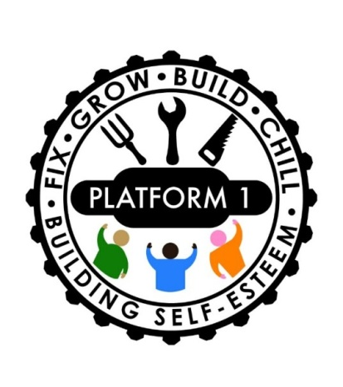

Platform 1 Referral Process

This process is designed to ensure that Platform 1 can provide a safe and healthy environment for all our service users. The completion of this process allows us to better cater to individual needs and enables to carefully consider what we do and how.

1. Professional referrals – a professional must complete a Platform 1 referral form with or on behalf of their client and submit it with the consent of the client. The professional must complete all questions that they can to the best of their knowledge
2. Self-Referrals – men wishing to use Platform 1 must complete a platform 1 referral form, if support is requires on the completion of the referral form, please make contact with a member of Platform 1 team on 01484421143
3. Assessment of the Applicant – the referral will be assessed by a member of the Platform 1 team. If going by the information you have provided; we feel we are able to meet the referrers needs, they would be invited in for a one to one meeting with one of our key workers. If we do not feel we are able to meet your needs from the information provided we may request further information.
4. One to One meeting – During the one to one meeting you will be asked further questions regarding medical issues and lifestyle choices, this will support the team and the key workers in ensuring we are able to facilitate the applicants needs and ensure the safety of all Platform 1 users. You will be asked to sign a document which outlines the terms and conditions for the use of Platform 1, if you are agreeable to the ground rules you will be provided with a tour of platform 1 and its facilities
5. Risk assessment – upon completion of the one to one meeting and using the information provided on your referral form a risk assessment will be carried out to ensure that the use of platform 1 can safely meet your needs; your membership can then be confirmed. If we feel that we are unable to support your needs you will be informed either in person at this time or contacted at a later time. They may also offer support and advice and potentially signpost you to other organisations that may be better suited to your needs
6. Membership is agreed – an official induction for the use of our facilities will be offered.