Corowa to host NSW Landcare and Local Land Services conference in 2026

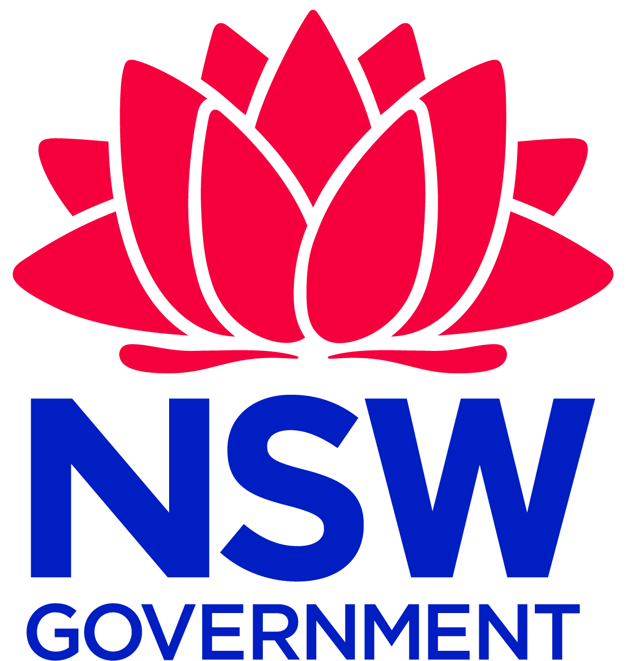
17 December 2025

Landcare NSW and Local Land Services are excited to announce the NSW Landcare and Local Land Services Conference will be held from 26 to 29 October 2026.

Themed ‘The Sum of It All’, the conference will celebrate collaboration, collective impact and the vital connection between land and community.
Located on Bangerang Country along the Murray River, Corowa has a strong Landcare presence thanks to Corowa District Landcare and the Murray Landcare Collective, a community alliance of agricultural, environmental and not-for -profit groups.
With its diverse landscapes, from rivers, creeks and wetlands to box and red gum woodlands and mixed farming systems, Corowa provides the perfect backdrop for an event focused on celebrating and shaping the future of Landcare in NSW.
Landcare NSW Chair Gareth Johnston said the conference was an opportunity to bring people together to share knowledge and strengthen partnerships.
“We look forward to seeing you on Bangerang Country in beautiful Corowa for the NSW Landcare and Local Land Services Conference 2026,” Mr Johnston said.
“This is an opportunity to celebrate the work of our Landcare community and continue to strengthen partnerships that support our land, our people, and our future.
“It’s also a moment for us to come together, learn from one another, and connect across the diverse landscapes we care for. At a time of significant environmental and community challenges, the way we show up for each other has never been more important.”
Local Land Services’ Landcare Enabling Team Leader Delivery, Marien Stark, said the conference would provide practical insights and foster collaboration across the state.
“It’s a great opportunity for anyone passionate about sustainability to connect with others and take ideas home that make a difference,” Ms Stark said.
“Whether you’re a volunteer, a farmer, or part of an environmental group, this is your chance to share and be inspired.”
Delivered in collaboration with Corowa District Landcare, Murray Local Land Services, and Landcare groups across the region, the event promises to be vibrant, inclusive and forward-thinking.
Save the date and keep an eye for updates and registration details at Corowa to host NSW Landcare and Local Land Services conference in 2026 - Landcare NSW.
Media Contacts:
Landcare NSW
Kimberly Omodei, Communications Coordinator | 0424 095 029 or komodei@landcarensw.org.au
Local Land Services
Georgia Osland, Media & Public Affairs Officer | 0418 258 159 or georgia.osland@lls.nsw.gov.au
Media Release: https://landcarensw.org.au/wp-content/uploads/2025/12/Media-release-Corowa-to-host-NSW-Landcare-conference-in-2026.pdf

