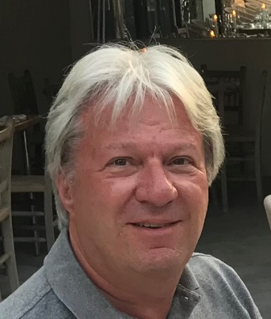
Chairman:
Mark Garius, BSc(Hons)
A vastly experienced executive professional with a portfolio spanning four decades and encompassing multiple C-Suite positions across both large and small enterprises. Having personally delivered 30 acquisitions across four businesses, I have a breadth of knowledge and understanding not only of running businesses but, in particular, in the realm of M&A preparation, fund-raising, transacting and integrating. My ethos has always been to work with acquired business owners and their businesses to achieve a “win-win” for both and that has stood me in good stead for many years
NON-EXECUTIVE / Advisory ROLES
Chairman ▪ Celebrate Life Group Ltd May 2022 – Present
CLG’s mission is to build a highly successful group of the most reputable, independent Funeral Director businesses, focussed in the south of England. The company is currently targeting funeral acquisitions in the south east of England and is ultimately looking to build to a £40m business over 5 years.
Non-Executive Director ▪ Prosell Learning Ltd Sept 2021 – Present
Prosell are an international skills development & performance consultancy. They were established 35 years ago and have worked with leading companies from the Post Office to O2 and also many hundreds of smaller businesses from the UK to Asia pacific, America to Eastern Europe. They work with over 200 consultants globally and are headquartered in Twickenham.
M&A Consultant ▪ Automated Systems Group Ltd (“ASL”)/Others Aug 2021 – Present
Acquired ASL in 2009 as the vehicle for a UK-wide “buy & build” strategy to create one of the largest managed print solutions (MPS) providers – which we achieved over 12 years. Having completed 14 acquisitions at ASL, with me taking the lead in all of them (including raising the funding), I stepped down from the Board in August 21 and now support ASL’s M&A strategy as a consultant, allowing me to take on other roles outside of ASL.
EXECUTIVE ROLES & EXTENDED CHRONOLOGY
Managing Director | CEO ▪ Automated Systems Group Ltd (“ASL”) 2009 – 2021
Joint Managing Director ▪ Ethos Ltd 2008 – 2009
Business Development Director ▪ Annodata Ltd 2005 – 2007
Managing Director ▪ Toshiba Tec UK Ltd 1999 – 2005
Senior Vice President ▪ Danka PLC 1996 – 1999
Assistant General Manager ▪ Toshiba Information Systems UK Ltd 1990 – 1996
Marketing Manager ▪ Alcatel PLC 1988 – 1990
Marketing Planning Manager ▪ Xerox Ltd 1981 – 1988
Marketing Assistant ▪ Unipart Ltd 1979 – 1981
Marketing Graduate ▪ Waitrose & British Gas 1976, 1978
PERSONAL
Fitness fan; major rugby union fan; 3 grown up children and one grandson

