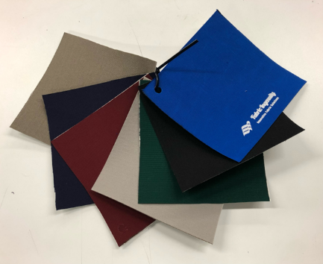
sunpatch - acrylic
Solution Dyed Acrylic Fabric Patch
for Marine/Awning/Umbrella Applications

- Made using 9.25 Sq. Yd. Sunbrella Solution Dyed Acrylic Fabric
- Pressure Sensitive Adhesive Backing
- Release Liner
- 6” x 6” Individual/Sample Patch
- 6” x 36” Standard Patch
- 6” x 60” XL Extra Long

Applications:
  - Tears in Fabric
  - Holes in Fabric
  - Reinforcements
  - Moisture Barrier
  - Frame/Bow Wraps
8 solid colors –01 Pac. Blue; 08 Black; 30 Gray; 31 Burgundy; 37 Forest Green; 46 Captain Navy; 48 Taupe; 54 Linen Tweed
Sunpatch-Acrylic is a 9.25 oz. solution dyed acrylic fabric with an extremely adhesive backing and release liner. It is ideal for repairing tears in awnings, boat tops and covers, umbrellas, (and more) made out of Sunbrella and other woven fabrics. Some have used it to wrap awning and boat top frames to prevent capillary action.
Prior to applying Sunpatch, surfaces should be clean and free of debris. For best results, Sunpatch should be applied using heat. (See detailed instructions.) The acrylic repair patch will adhere immediately but will take 24 hours to fully cure. For stronger patching, or where there is a larger hole in the fabric, use Sunpatch on both sides of the material, cut 1” beyond the outside edge of the hole. It is recommended that you round cut the corners of your patch. This will prevent sharp corners from getting caught on something and lifting/curling. The standard size is 6" wide by 36” long. Custom widths and lengths are available, minimum 2 yards (60” width) of fabric.
Request a quotation for additional colors and custom panel (2 yard minimum).
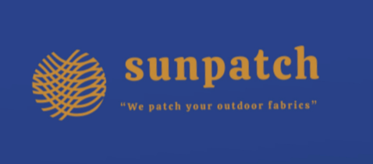
Fabric Ingenuity LLC
www.FabricIngenuity.com
mike@fabricingenuity.com
derek@fabricingenuity.com
Phone 336-380-5939

