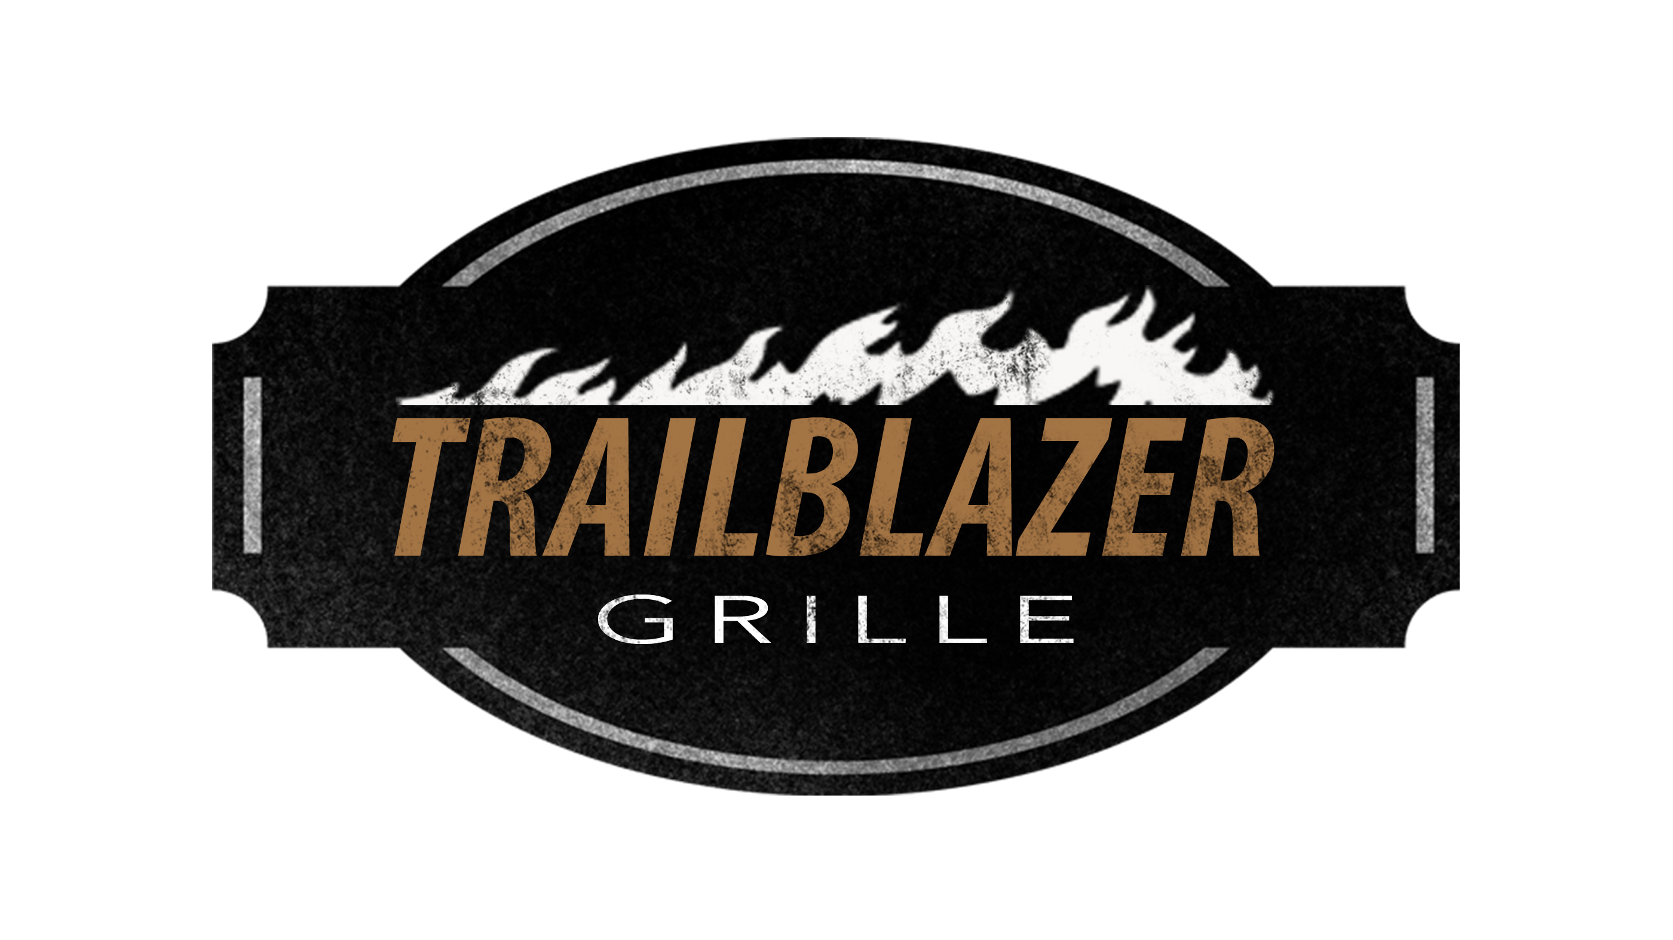
512.756.7636 216 S. Main st Burnet, TX 78611
Breakfast Menu
7:00am – 10:00am Monday – Saturday
(Served with Toast or Biscuit)
Texas Two Step - 2 eggs, 2 buttermilk pancakes, choice of meat $7.99
The Hunter Plate – 2 eggs, hash browns, choice of meat $7.99
The Roundup – 2 eggs, 4oz sirloin, hash browns $13.99
Chicken Fried Steak & Eggs - with hash browns & 2 Eggs $12.99
Biscuits & Gravy - 2 buttermilk biscuits & cream gravy $5.99
(Meat Options: bacon, ham, smoked sausage)
3 Egg Omelets:
(Served with Hashbrowns. Choice of Toast, Biscuit, or 2 Tortilla’s)
Main Street Omelet – choice of meat & cheddar cheese $8.99
Veggie Omelet - tomatoes, spinach, mushrooms, onions, bell pepper, cheese $8.99
South of the Border - jalapenos, meat, bell pepper, onion, cheddar cheese $9.99
Hill Country Omelet – choice of meat, cheddar cheese, onion, bell pepper $9.99
Queso Omelet - meat, mushroom, bell pepper, topped w/ our homemade queso $9.99
Pancakes: 2 stack - $4.99 3 stack – $5.99 Gluten Free 2 stack - $5.99 (add Blueberry, Strawberry, Chocolate Chip or Nutella with Whip $1.99)
Kids Pancakes $2.99

Breakfast Biscuit – egg, cheese, bacon on our buttermilk biscuit $4.99
Chicken Biscuit – fresh fried chicken breast on buttered biscuit $3.99
Trailblazer Sandwich – egg, ham, cheese on Texas toast. Served with hash browns $5.99
Gluten Free Sandwich – egg, cheese & bacon on our gluten free bun $5.99
Trailblazer Breakfast Bowl – Hash browns, meat, egg topped with cheddar cheese or gravy $6.99
Migas – egg, sausage, tomato, onion, crisp tortillas, cheddar cheese, w/salsa. side of hashbrowns $6.99
French Toast – 2 slices of Texas Toast battered, with cinnamon & powdered sugar $5.99
On the Trail - Tacos $2.69
Created with cheddar cheese & egg
(each additional ingredient $.50)
Smoked Sausage Hash browns
Ham Bacon
Jalapenos Grilled Onions
Tomatoes Bell pepper
Spinach Mushrooms
Add -ons
Egg $1.50 Bacon (2) $1.99
Ham $1.99 Toast $.50
Hash Browns $1.00 Jalapenos $.50
Flour Tortillas (2) $1.00
Smoked Sausage $1.99
Buttermilk Biscuit $.75

Waffle Love Affair!
Belgian Waffle $5.99
Blueberry Waffle with Whip $8.99
Strawberry Waffle with Whip $8.99
Chocolate Chip Waffle $8.99
Nutella Waffle $8.99
Gluten Free add $1.00
Beverages:
Orange Juice $1.99 small $2.79 large Apple Juice $1.00 small $1.99 large
Milk $2.50 Chocolate Milk $2.50
Iced Tea $1.99 Hot Tea $1.99
Coffee $1.99 Sodas $2.79

*Consuming raw or uncooked meats, seafood, shellfish, or eggs may increase your risk of food borne illness

