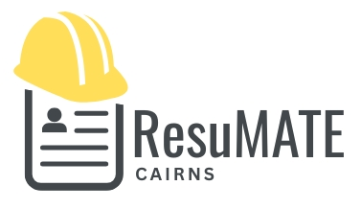

PRIVACY & CONFIDENTIALITY POLICY

ResuMATE Cairns is committed to protecting your privacy and handling your personal and business information with care, confidentiality and respect.
What information is collected
Depending on the services you engage, ResuMATE may collect and store information you provide, including (but not limited to):
- Name and contact details
- Employment history, qualifications and work experience
- Licences, tickets and certifications
- Previous resumes, cover letters or job application documents
- Information required to assist with job applications or interview preparation
- Information provided for life or small business admin support, such as:
  - Forms, templates or documents
  - Business details and contact information
  - Website, social media or online profile content
  - Licence, compliance or admin-related records
Only information relevant to the agreed services will be collected.
How Your Information Is Used
Your information is used solely to:
- Prepare, update and edit resumes and cover letters
- Assist with job searching, applications and interview preparation
- Provide life or small business admin support as requested
- Create templates, documents or admin systems for your use
- Retain past documents or information so they can be updated efficiently in the future at your request
Your information will never be used for marketing or any purpose outside the services you engage.
Storage of Information
- Information and documents are stored securely in digital format
- Documents or records may be retained for future use unless you request deletion
- Reasonable steps are taken to protect your information from unauthorised access
Confidentiality
- Your personal or business information will never be shared, sold or disclosed to third parties
- Employers, recruiters, suppliers or other third parties will not be contacted or provided with your details unless you explicitly request this
- Any access to third-party platforms (e.g. websites, portals or systems) will be for the sole purpose of completing agreed tasks
Your rights
- Request access to your stored information at any time
- Request corrections to inaccurate or outdated information
- Request deletion of your information at any time
Consent
By engaging ResuMATE Cairns’ services, you consent to the collection, storage and use of your information in accordance with this policy.

Client Name: _______________________________

Signature: _________________________________

Date: _____________________

