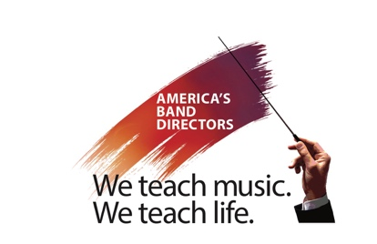

Saluting America’s Band Directors
Dr. Dan Ross, Scholastic Outreach
1204 Harkers Ct.
New Albany, Ohio 43054

Carl Coles – Superintendent
Bonita Unified School District
115 W. Allen Ave.
San Dimas, CA 91773

October 1, 2022

Dear Mr. Coles,

I hope this letter finds you well and your school year proceeding very smoothly. I am contacting you concerning an opportunity that has arisen for your band director Mr. Coles. He has applied for a once in a lifetime chance to march in a band of band directors from across the country in the 2026 Tournament of Roses Parade in Pasadena, California. We have accepted his application and offered him a spot. This is a great opportunity for band directors to participate in an amazing and world-renowned parade.

As you are aware, band directors and coaches are often the most influential and inspiring teachers and role models in a student’s life. They not only teach music and their sport but teach many of the life lessons that will assist their students in becoming successful adults. Setting goals, hard work, teamwork, getting knocked down in any fashion and choosing to get back up, winning and losing with grace and class, and experiencing the rewards of community service are just a few. Especially in the music world, they give so much back through concerts at public events, visiting senior citizens and nursing homes, and performing at many community events to help the school and community shine.

Personally, I have spent 24 years as a high school principal and school superintendent. I have witnessed and experienced the value of the instrumental music program and the impact of the directors in the lives of their students. There is no Hall of Fame for band directors. This event is designed to salute band directors for their years of service to the students under their guidance and care.

The experience the band directors who are involved in this project will gain will be an asset to their students in many ways. The use of novel techniques to reach out to their students, new ideas for teaching music and new resources available to keep their instruction fresh and relevant are just a few of the assets Mr. Coles will gain from this experience. He will interact with four hundred band directors from great programs all over the country to learn how “they do it” and bring that information and those techniques back to Bonita Unified Schools. CEU credits will be available for participation in the event from Bowling Green State University.

This is a “bucket list” item for many band directors in the country. Mr. Coles’ participation in this event will be a dream come true. He will be a great model for his students who will gather around their TVs with great excitement to watch him perform in front of millions of viewers. I believe his participation will bring a real sense of pride and inspiration to his students and the community. Any assistance you or the community could afford him would be greatly appreciated.

Band directors give so much of their time, their hearts, their souls and their careers to the students and the community they serve. This is an exquisite way for the whole community to rally around Mr. Coles and thank him for a job well done.

This project is an undertaking of the Michael D Sewell Memorial Foundation. Michael Sewell was that band director that touched the lives of our community. While I served as his superintendent, I saw the impact that a band director has on students and the community.

If you need any additional information you can email Craig Orr at craig@banddirectorsalute.org or visit our website BandDirectorSalute.org

Thank you in advance for any assistance you may provide or arrange for Mr. Coles. If you have any questions for me, feel free to contact me at (614) 378-9068.

Respectfully,



Dan Ross, Ph.D.

