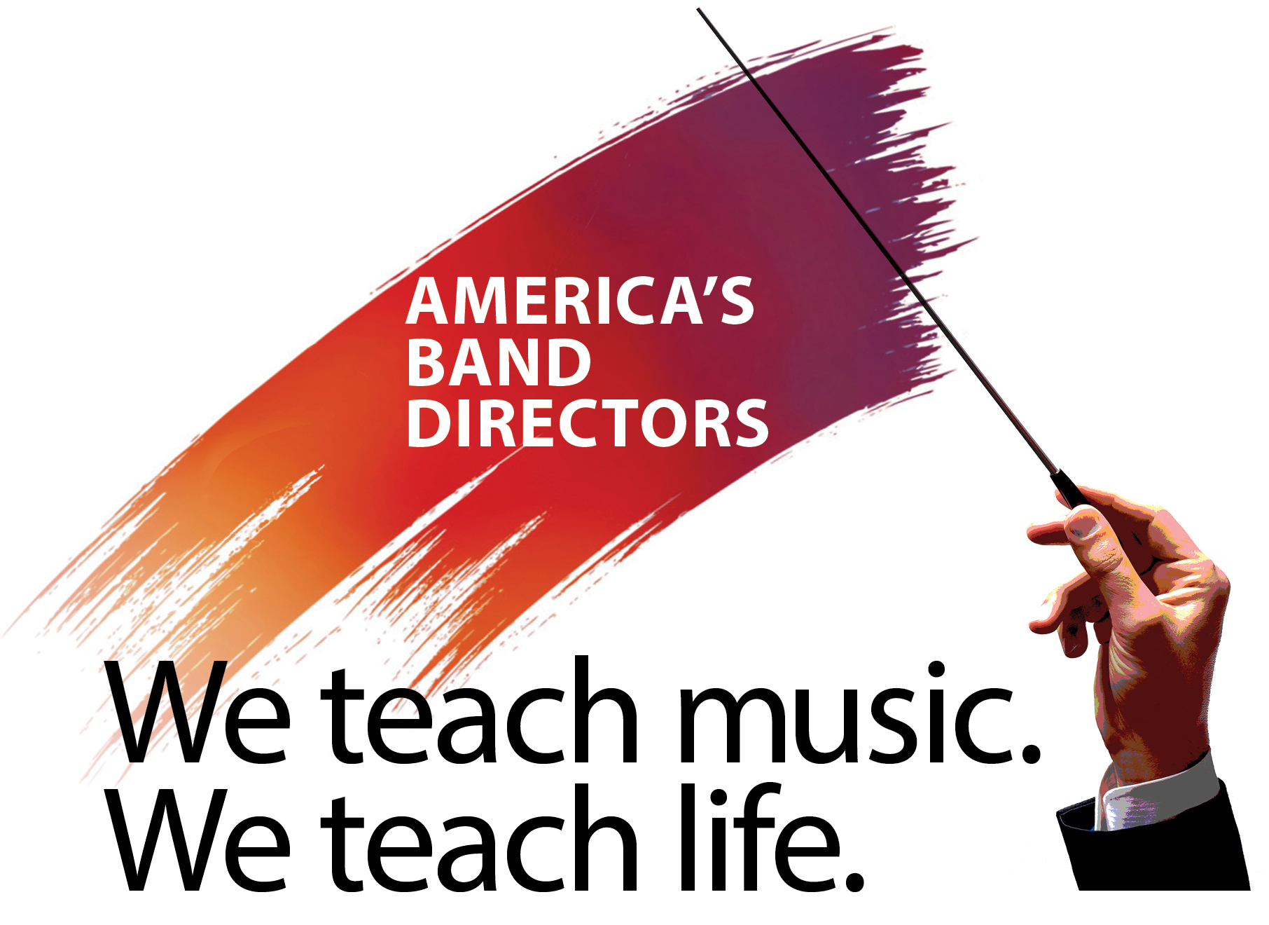

Saluting America’s Band Directors Contact: [your name]
A project of the Michael D. Sewell Memorial Foundation Phone: [your phone number] Email: [your email address]
‬

[Date]

For immediate release
[Your Name] to march in 2021 Rose Parade®
Local band director to join others from across the country to march in unprecedented marching band

[Your Name], band director for the [name of school or district], will join band directors from across the country next January 1 in the annual Pasadena Tournament of Roses® Rose Parade.
A custom-designed animated float will lead a “marching band of band directors” up to 300 strong from across the country. The Michael D. Sewell Memorial Foundation, based in Pickerington, Ohio, is the sponsoring organization behind the project. The foundation was created to recognize and carry on the work of the late Mike Sewell, who dedicated his life to the school and community music programs in Pickerington and the Central Ohio area for more than 38 years.
The parade entry will convey the theme, “We teach music. We teach life.” The extraordinary dedication and accomplishments of band directors are well known to their students, to parents and to school teachers and administrators. No matter where they teach and work—public and private schools, colleges and universities, the military, community bands—dedicated music educators and leaders work long hours to not only teach and direct music, but to teach life itself. Student lives in particular are positively changed by a motivational leader who taught, inspired and mentored them.
[Insert individual’s details here, eg. how long a band director, education background, etc.]
Complete details on the project are available on the Saluting America’s Band Directors website, BandDirectorSalute.org.
# # #

Rose Parade® and Tournament of Roses® are official trademarks used with permission by the Pasadena Tournament of Roses.® This promotion is in no way sponsored, endorsed, or administered by the Tournament of Roses Association.

