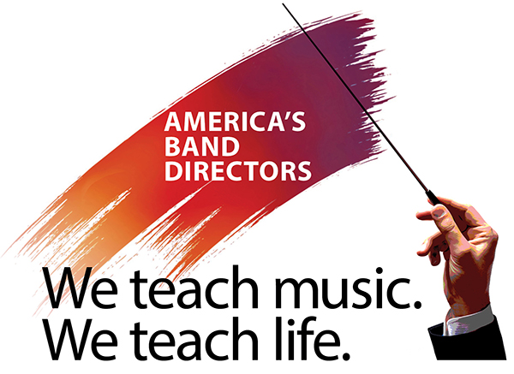

News release
Contact: Sanford Meisel, Director of Marketing
Saluting America’s Band Directors
614-329-4792
sandy@banddirectorsalute.org
BandDirectorSalute.org

[Your full name] to march in 2023 Macy’s Thanksgiving Day Parade® with the Band Directors Marching Band

Following its amazing inaugural appearance in the 2022 Rose Parade,® Saluting America’s Band Directors project is bringing together band directors from across the country to New York City on November 23, 2023 under the theme, “America’s band directors: We teach music. We teach life.”

[Your first and last name], a [your title] in [your school or school system], has been selected to join a marching band of 400 band directors from across the country in the historic Macy’s Thanksgiving Day Parade® on November 23, 2023.
The Saluting America’s Band Directors parade entry will again convey its theme, “America’s band directors: We teach music. We teach life.” to recognize the extraordinary dedication and accomplishments of band directors and music educators everywhere. Throughout their careers, the music educators in this band have collectively mentored and taught hundreds of thousands of students. These professionals not only teach and direct music, they teach about life itself.
According to [your last name here], “[optional—insert your own short quote here]”
The band will be directed by nationally known music educator and innovative band director Jon Waters.
The sponsoring organization behind the Saluting America’s Band Directors project is the Michael D. Sewell Memorial Foundation, based in Pickerington, Ohio. The foundation was created to recognize and carry on the work of the late Mike Sewell, who dedicated his life to the school and community music programs in Pickerington and the Central Ohio area for almost 40 years.
# # #

