**Video of event:**

<https://www.youtube.com/watch?v=69QW642mLQc&feature=youtu.be>

**Notes from event:**

<https://docs.google.com/document/d/1Gz7ct1VkMcB8XU_xd2qtGVBVGB5iFbYfe4hn6idN3jo/edit>

**Photos of event – Emma and Mackenzie introducing:**

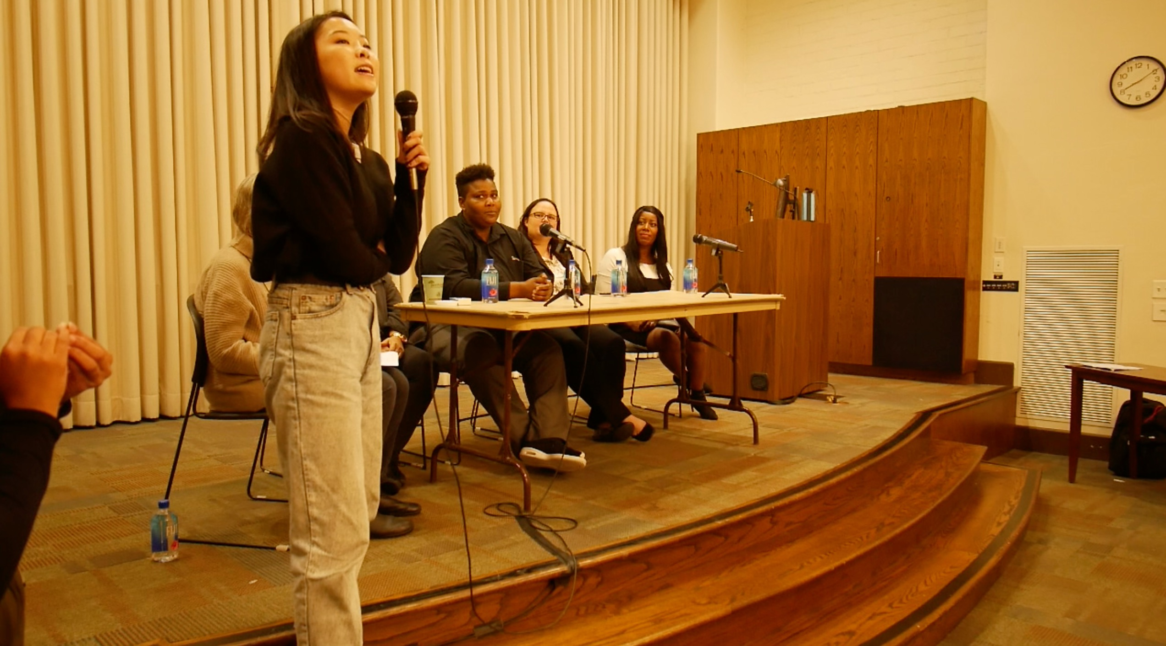

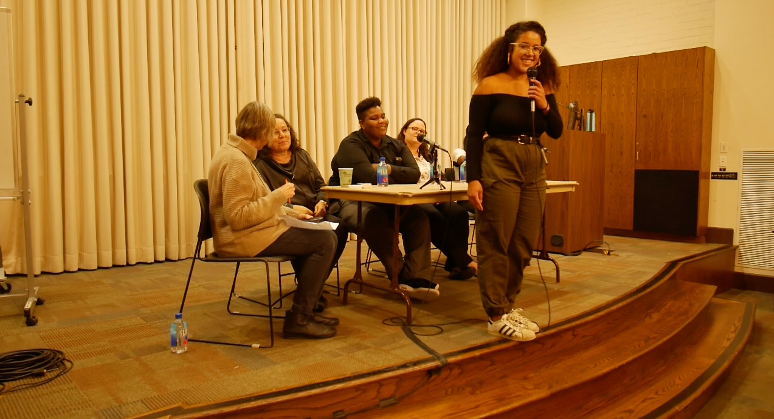

**Planned Script for Panel:**

Mackenzie and Emma: Welcome to panel, thank our sponsors (Scripps Core III, Intercollegiate Department for Asian American Studies) Last event of the series! Thank you to everyone

Sue: introduce self and allow speakers to introduce themselves. (answer this in introduction: **As you all have had different experiences/relationships with the re-entry process, could you explain your experience? What organizations have you been a part of? )**

~~~~~~~~~

Questions:

1. **What would have helped you or the people you work with avoid entering the prison system?  (This could be resources, support systems, etc)**
2. **What are the most challenging things for people who are getting out? Are the challenges of re-entry different or more complex for women? What issues, specific to women, femmes, and gender nonconforming folks, within the prison and in re-entry are failing to be addressed?**
3. **Being a "woman" means different things if you are Latinx, or Black, or Asian, or Native, or mixed race, or if you are white---how do you think these differences impact re-entry? (How does race impact women’s experiences with re-entry?)**
4. **Many women inside are mothers and a number had been the primary caregivers of children.  How could recognition of that fact change the way we consider and practice criminal justice?**
5. **What would you like more of from your communities help those within the re-entry process? (This could be your immediate community/surroundings, general society, women and femmes, etc) We want to finish w/ this question!\*\*\*\*\*\*\*\*\*\***
6. **What is feminism to you? Is prison abolition/reform a feminist issue? How? (May not have enough time to get to this question)\*\*\*\*\*\***
7. **Potential question about the role of commutations for women who are victims of domestic violence, if time permits\*\*\*\*\*\***
8. **CoreCivic/CCA question, if time does not permit, ask during Q&A!**

~~~~~~~~~~~

Open up for Q&A

Student: Thank you for coming to the last event of Abolition Series! Plug the Crossroads fundraiser coming up on Dec 3rd