Client name: |  |  |  |  |  |  |  |  |  | Today’s date:
Date of birth: |  |  |  |  |  |  |  |  | Age:
Cell phone: |  |  |  |  |  |  |  |  | Home phone:
Home address:
Email:
Emergency contact: |  |  |  |  |  |  |  | Emergency contact phone:
How did you hear about us?

Current Medical Conditions
Medical Condition | Start Date (approx.)

Recent Surgeries and/or Procedures (in the last 5 years)
Type of Surgery or Procedure | Date

Current Medication(s) (Including Supplements) & Dosage:
Medication Name |  | Dosage
Are you currently under the care of a physician?
Physician name:

Do you suffer from pain? |  |  |  | Is the pain acute or chronic?
Location:
How long have you had the pain?
How would you rate the intensity of your pain today (scale of 0 to 10):
How would you rate the intensity of your pain on average (scale of 0 to 10):

Using the diagram below, write an X where you feel pain:

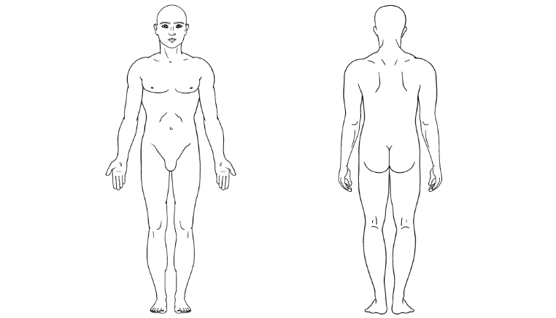

Do you suffer from anxiety and/or depression?
How long have you suffered from symptoms?
How many days a week do you experience symptoms?
How would you rate the intensity of your symptoms today (scale of 0 to 10):
How would you rate the intensity of your symptoms on average (scale of 0 to 10):

Do you have dietary restrictions (food allergies, lactose intolerant, etc.)?
If yes, please explain:
How would you describe your diet?
If other, please explain:

What physical activities do you practice?
Running: |  | Frequency:
Walking: |  | Frequency:
Biking: |  | Frequency:
Swimming: |  | Frequency:
Weights: |  | Frequency:
Yoga: |  | Frequency:
Qigong: |  | Frequency:
If other, list: |  | Frequency:

What spiritual practices do you incorporate in your daily life?
Church: |  | Frequency:
Meditation: |  | Frequency:
Prayer: |  | Frequency:
Pendulum: |  | Frequency:
Rituals: |  | Frequency:
If other, list: |  | Frequency:

Which of the following services have you had before?
Massage: |  | Date last received:
Reiki: |  | Date last received:
HeartMath: |  | Date last received:
Emotion Code: |  | Date last received:
Bio-Well: |  | Date last received:
Sound Healing: |  | Date last received:

List areas of concern that you would like the practitioner to focus on:

Are you sensitive to perfumes, fragrances or essential oils?
If yes, please explain:
Are you allergic to any essential oils, jojoba oil, coconut oil, arnica or ravensara?
If yes, please explain:
Are you sensitive to touch?
If yes, please explain:
Are you sensitive to sound?
If yes, please explain:

It is my choice to receive services from Foundations Holistic Center LLC which includes massage, reiki, HeartMath, emotion code, bio-well and/or coaching. I understand that during or after my service I may experience some of the following symptoms, but not limited to: increased pain, tingling, emotional releases, bruising, redness, fatigue, muscle aches, dizziness, etc. These symptoms are normal and will subside. Since massage should not be performed under certain medical conditions, I affirm that I have stated all of my known medical conditions and answered all of the questions asked of me, honestly. I agree to keep the massage therapist updated as to any changes to my medical conditions. I understand that there will be no liability on the therapist’s part, if I fail to update the therapist to any changes to my medical conditions.

I understand that I am paying for a treatment and not a result and that there will be no returns, refunds or exchanges for services and/or product given/received. If at any time there are changes in the information I have given, or in my condition, I will notify my therapist and update this form before receiving additional massage services.

If I am unable to make a scheduled appointment, I agree to cancel the appointment 24 hours in advance by phone unless I have an emergency. In this case, I will call as soon as possible to reschedule my appointment. If I miss a scheduled appointment without giving 24-hour notice, I agree to pay the missed appointment fee. Client Initials: ____________

I understand that any illicit or sexually suggestive behavior, remarks or advances made by me will result in the immediate termination of the session and I will be liable for payment of the scheduled service. In addition, I understand Foundations Holistic Center LLC reserves the right to refuse to administer services at their sole discretion. I have read and fully understand this form in its entirety. I hereby release the practitioner, their insurers, their respective officers, directory, stockholders, successors, employees, franchisor, and agents from all liability of any nature whatsoever, whether past, present or future for injury or damage which may occur to myself or my family as a result of receiving massage, reiki, HeartMath, emotion code or bio-well services.

I understand that I am free to disrobe to my comfort level, but certain clothing items may interfere with effectiveness. Client Initials: ____________

I hereby confirm that the information that I have provided is accurate and true.

Client Signature: ___________________________________ Date: ________________

Consent to the treatment of a minor: By my signature provided below, I authorize Foundations Holistic Center LLC to offer services to my minor child or dependent as they deem necessary or proper.

Legal Guardian Signature: ___________________________________ Date: ________________

