Breakaway West Board of Directors Meeting
July 14, 2025, at 5:00pm MT

Call to order at 5:14pm by Andrew Cuomo
BOD Attendees:
President Andrew Cuomo – In Attendance
Treasurer Scott Payant – In Attendance
Secretary Mark Maglio – In Attendance
Director Gail Avgeris – In Attendance
Director Chris Hagie – In Attendance
Director Chris Watson – In Attendance

Manager's Report
Steve reported the elevator is not usable. Waiting for Schindler to provide an estimated cost to repair. Steve will get another company to bid repair.
Boilers are scheduled to be serviced.
Parking is very tight, especially on weekends.
Andrew asked can AD miller to remove the fence until the permit is approved. Steve will remove it.
Andrew asked for the cost of the roof replacement for the 500 building. Steve is waiting for an estimate. The cost is already in the budget. Andrew will provide Steve with another vendor to bid the job.
President's Report
Andrew reported HOA does not have an approved TOV demolition or building permit.
Eric and Eddy from OAC reviewed the high level project timeline (see attached). Started Sep 2022 remove replace pool/spa/deck. Nov 2022 structural concerns were discovered. Jan 2023 we hired Martin & Martin to do analysis on the condition of the garage structure. July 2023 M&M reported their concerns with the structure. The TOV was notified. The BOD requested an RFP to repair or replace the Garage. The BOD voted to repair based upon the cost. Sent bid to 23 contractors and received only 3 responses. M&M then removed their opinion that a repair was feasible. The BOD requested other structural engineers for their opinion, and they also did not think a repair was an option. Design drawings were submitted Nov 2024. Final DD submitted Apr 1, 2025. TOV permit submitted Apr 8, 2025.
AD Miller Phase 1 is $900,000 over their original estimate due to updated costs after final design data plus the additional TOV requests. Delaying to Apr 2026 will cost an additional $700,000.
The initial schedule was 8.5 months, but now that we have completed final design drawings the estimate is 10.5 months including winter.
Potential TOV approval could be 2 weeks, but nothing is definite.
We opened the discussion to homeowners:
Chris W asked, why did we wait to submit the permit until April? OAC needed the design Drawings prior to submitting. Once the request was submitted the TOV lacked returning timely.
A homeowner asked HOA is holding 4.5 million for the assessment. Scott called the bank a month ago to invest in a better rate.
There was multiple Q&A between homeowners, OAC and the BOD.

Next steps:
AD Miller will provide a detailed cost of working through the winter. The next project meeting is Tuesday July 15, 2025.
Provide homeowners the TOV contacts to send the letter to (Town manager). Also provide a template for homeowners to use.
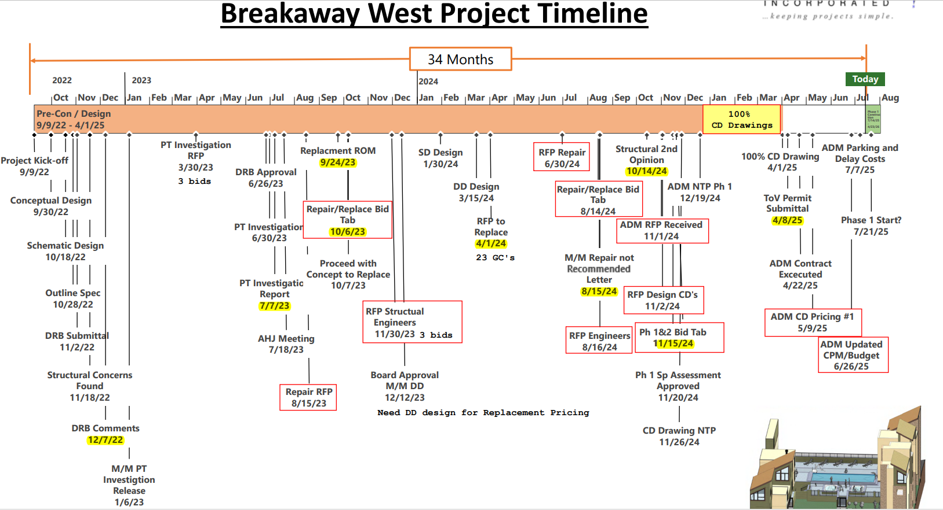

Treasurer Report
Spaeth accounting will increase the charge from $500 to $600 for processing and sending out the Right Of First Refusal ROFR. Andrew Cuomo motioned to approve; Chris Hagie seconded. All were in favor, none opposed. The motion carried.
Financials are $20,000 under budget which was planned to recover owners’ equity.
Secretary Report
Mark stated the minutes from the BOD meeting on 4/14/2025 need to be approved. Scott Payant motioned to approve, Chris Watson second. All were in favor, none opposed. The motion carried.
New Business
Gail Avgeris unit #111 is selling her condo and is scheduled to close Aug 29th, 2025. She will remain as a board member until her closing.

Owners in attendance
Megan, Erik Peterson, Hadary, Andy, Kuyoth, Brad Smith, Kira, Doug W, Ann, Kevin/Mollie Knapp, Mike Stein, Bessie Conty, Christin Boblick, Sgeoghan, Bill W, Don Conty, Neilson,
The meeting was adjourned at 6:36 MT. July 14, 2025

