Breakaway West Map
Building 100 & 200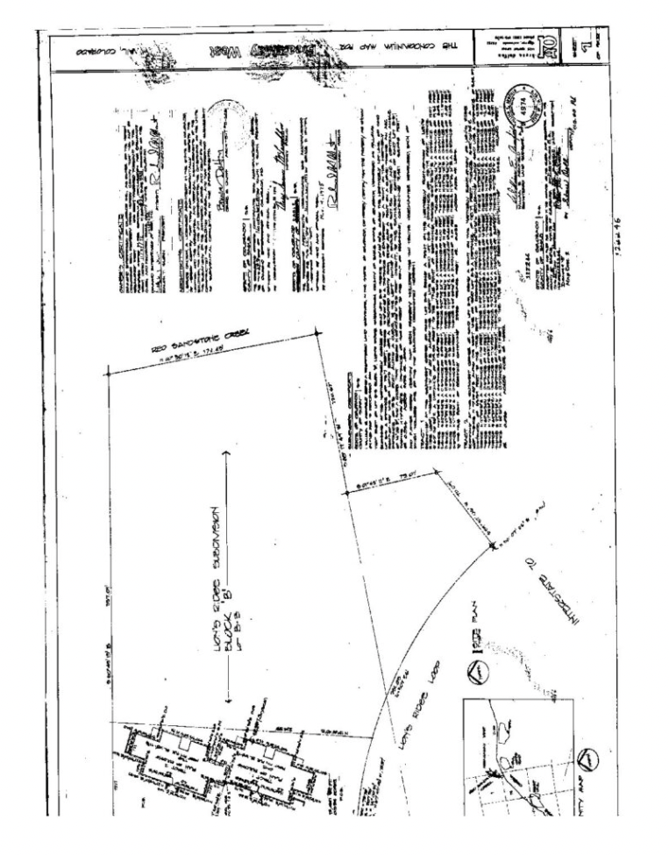
Building 300 & 400
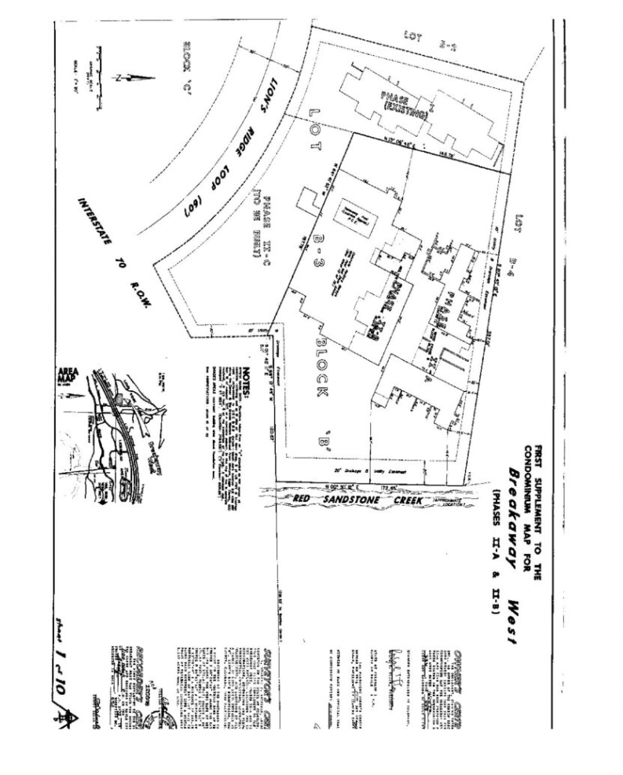

Building 500

