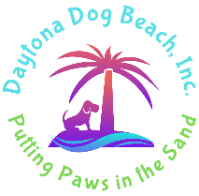
Daytona Dog Beach, Inc.
Ormond Dog Beach
Dog Bag Dispenser Sponsorship Form

NAME | Click or tap here to enter text.
ADDRESS | Click or tap here to enter text.
CITY | Click or tap here to enter text.
STATE | Click or tap here to enter text.
ZIP CODE | Click or tap here to enter text.
PHONE # | Click or tap here to enter text.
DOG BAG DISPENSER OPTIONS
These are the current sponsors. If you wish to renew, you have first option on the spot previously selected. For those who do not renew, those spots will open to new sponsors on July 1, 2025. If you wish to request a new spot, we will approve if it is open. Beachside and Ramp Dispensers - $250/year Parking Lot Dispensers - $150/year
1☐ Beachside - Taken | 8☐ Rockefeller PL $150 | 15☐ Beachside - Taken | 22☐ Cardinal PL - Taken
2☐ Beachside - Taken | 9☐ Rockefeller PL - Taken | 16☐ Cardinal PL - Taken | 23☐ Cardinal Ramp - Taken
3☐ Beachside - Taken | 10☐ River Beach Ramp - Taken | 17☐ Cardinal PL – Taken | 24☐ Beachside - Taken
4☐ Beachside - Taken | 11☐ Beachside - Taken | 18☐ Cardinal PL - Taken | 25☐ Beachside - Taken
5☐ Beachside - Taken | 12☐ Beachside - Taken | 19☐ Cardinal PL - Taken | 26☐ Milsap Ramp - Taken
6☐ Rockefeller Ramp - Taken | 13☐ Beachside - Taken | 20☐ Cardinal PL - Taken
7☐ Rockefeller PL - Taken | 14☐ Beachside - Taken | 21☐ Cardinal PL - Taken

Sponsorships will begin on July 1, 2025 and will be valid for 1 year from date of payment or July 1, 2025 whichever is later.
TOTAL SPONSORSHIP COST $ Click or tap here to enter text.
☐ | CASH | Amount $Click or tap here to enter text.
☐ | CHECK | CHECK #Click or tap here to enter text. | PAYABLE TO: DAYTONA DOG BEACH, INC |  | FOR:  DISPENSER SPONSORSHIP | MAIL TO:  DAYTONA DOG BEACH, INC.  1288 BEL AIRE DRIVE  DAYTONA BEACH, FL 32118
☐ | CREDIT CARD | CARD # Click or tap here to enter text. | EXPIRATION - Click or tap here to enter text. |  | CODE - Click or tap here to enter text. | BILLING ADDRESS IF DIFFERENT THAN ABOVE:Click or tap here to enter text.
☐ | ZELLE | Amount $Click or tap here to enter text. | PAYABLE TO: DAYTONA DOG BEACH, INC  info@daytonadogbeach.org |  | FOR:  DISPENSER SPONSORSHIP

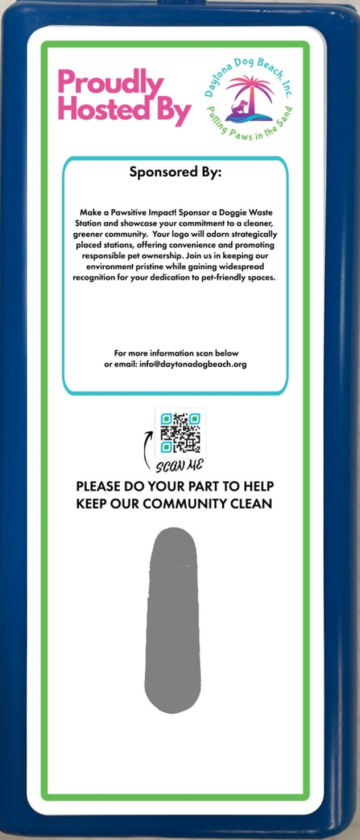
      - SUBMIT IMAGE & APPLICATION TO INFO@DAYTONADOGBEACH.ORG
      - IMAGE WILL BE SENT TO VOLUSIA COUNTY FOR APPROVAL.
      - DAYTONA DOG BEACH INC WILL HAVE IT CREATED AND APPLIED TO THE DOG BAG DISPENSER.

IMAGE DETAILS
Please send a high resolution jpeg or pdf file at 300 dpi.
The space will accommodate a logo that is 4.5" w x 5" tall.

Volusia County authorized Daytona Dog Beach, Inc. to solicit sponsors for the dog bag dispensers on designated dog beach areas. Daytona Dog Beach, Inc. is a 501(c)(3) Florida nonprofit corporation, Reg. # CH65781. A copy of the official registration and financial information may be obtained from the division of consumer services by calling toll-free 800 435-7352. Registration does not imply endorsement, approval or recommendation by the state.

