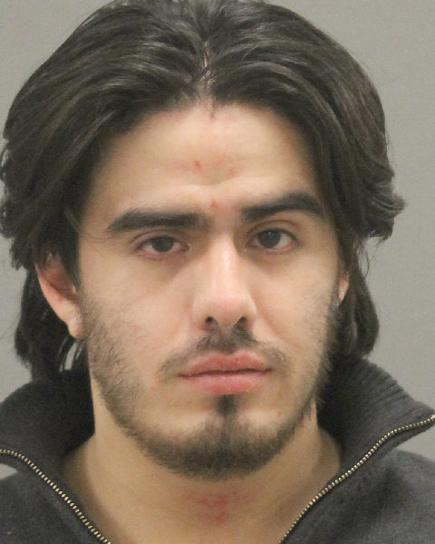
PRESS RELEASE
October 18, 2021
State’s Attorney J. Hanley

Winnebago County State’s Attorney J. Hanley announces that on October 18, 2021, William Arzate (DOB: 6/14/1997) was sentenced to Natural Life plus a consecutive term of five years in the Illinois Department of Corrections. He was previously found guilty on July 1, 2021 of First Degree Murder and Concealing a Homicidal Death after a jury trial before Judge Joseph McGraw.

William Pickering’s remains were found in a field June 20, 2019 almost a month after he was murdered in Rockford on May 25, 2019. An autopsy revealed that Pickering died from blunt force trauma and multiple points of impact were observed on his bones. Dakota Graff and Colton Kennicker were also charged in connection to the murder of William Pickering. Dakota Graff previously pled guilty to First Degree Murder in connection with the murder of William Pickering. Colton Kennicker’s case remains pending.

William Arzate willfully had failed to appear for trial and his trial was conducted in his absence. Arzate also willfully failed to appear for his sentencing and like his trial, his sentencing was also conducted in his absence. William Arzate is currently wanted on an outstanding No Bond bench warrant for his failure to appear in court as well as an original warrant for Harassment of a Witness. If you have any information on the whereabouts of William Arzate please contact the Rockford City Police Department at 815-966-2900 or Rockford Area Crime Stoppers 815-963-7867 so he can be taken into custody.

The Rockford Police Department conducted the investigation in this case with the assistance of the Rockford Fire Department Arson Investigators and The Bureau of Alcohol, Tobacco, Firearms and Explosives. Winnebago County Assistant State’s Attorneys Kirstin Krivanec and Ken LaRue handled the prosecution.

CONTACT PERSON:
J. Hanley, Winnebago County State’s Attorney
815-319-4700

