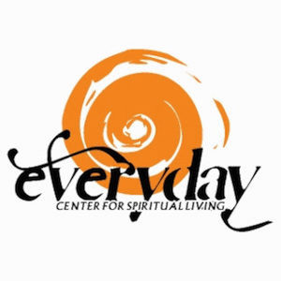
2022 CONSCIOUS GIVING COMMITMENT FORM

I offer my monetary gift to Everyday Center, Consciously Giving to where I am Spiritually fed. Recognizing that I am participating in an energetic exchange, I imbue the activity with love, gratitude and my desire that it benefits the health and expansion of this Center and its good works.

_____ YES! I am renewing ____ or establishing ____ conscious giving commitment for 2022!

I agree to contribute the following amount each (please circle one) week/month/year: $_________

I plan to contribute on Sundays ____.
I plan to contribute automatically using my Credit/Debit Card ____, starting date:_________
Please fill-in your credit/debit card information below

Check one: MasterCard _______ Visa ________ American Express _________

Card # __________________________________________ Exp. Date_______________

Billing Address for card: _____________________________________ Zip Code _______________

Signature (for card) ___________________________________________________________________

I look forward to receiving a Birthday Blessing from Rev. Ann. Please add me to her list!
Birth month___ day ____

NOTE: This form is not legally binding document. It is a statement of your intention to support Everyday Center for Spiritual Living during 2019. If your circumstances change, you can notify the Center of any change in your intended amount at any time during the year. We support you as a prosperous person living in an abundant universe! Thank you for your support.

