MFA Questionnaire 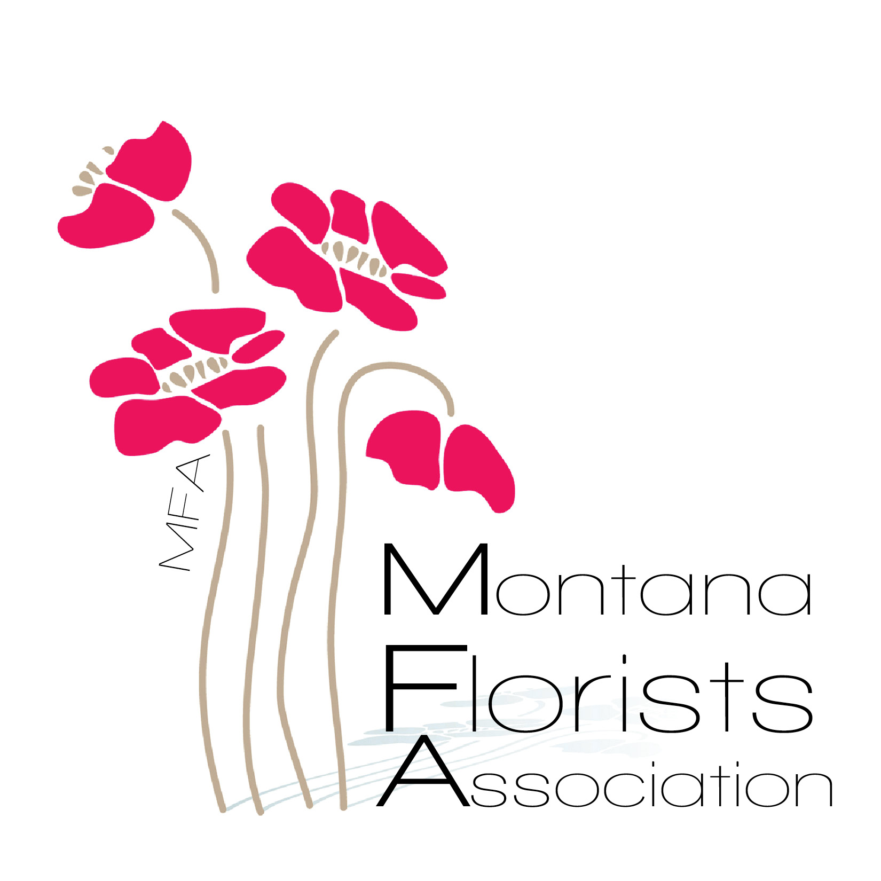

New Member General Information

**(These questions are not required for membership. We would like to learn more about you. Please mark all that apply.)**

**\* I would describe my business and its affiliation to the floral industry as:**

**\* Number of years in operation: ___________________________________**

**\* I have a retail store front:______________________________________**

**\* I do mostly event work: _____________________________**

**\* I am involved in the industry by farming or growing flowers: _________**

**\* I am a wholesaler of flowers/ fresh product: ____________________**

**What is the area of your distribution? _______________________**

**\* I work out of a studio or a home (ie: non retail storefront)___________**

**\* I am affiliated with a floral wire service ( which one(s)?)**

**Please let us know how you heard about MFA and if you have any specific connections with the organization. How can MFA help you? What are you hoping to gain by joining MFA?**

**\*\*\*On behalf of the Montana Florists Association we would like to thank you for your interest. Please don't hesitate to reach out with any questions.** *** **Montanafloristassociation.com mtfloristassc@gmail.com**