2025 Application for MFA Membership 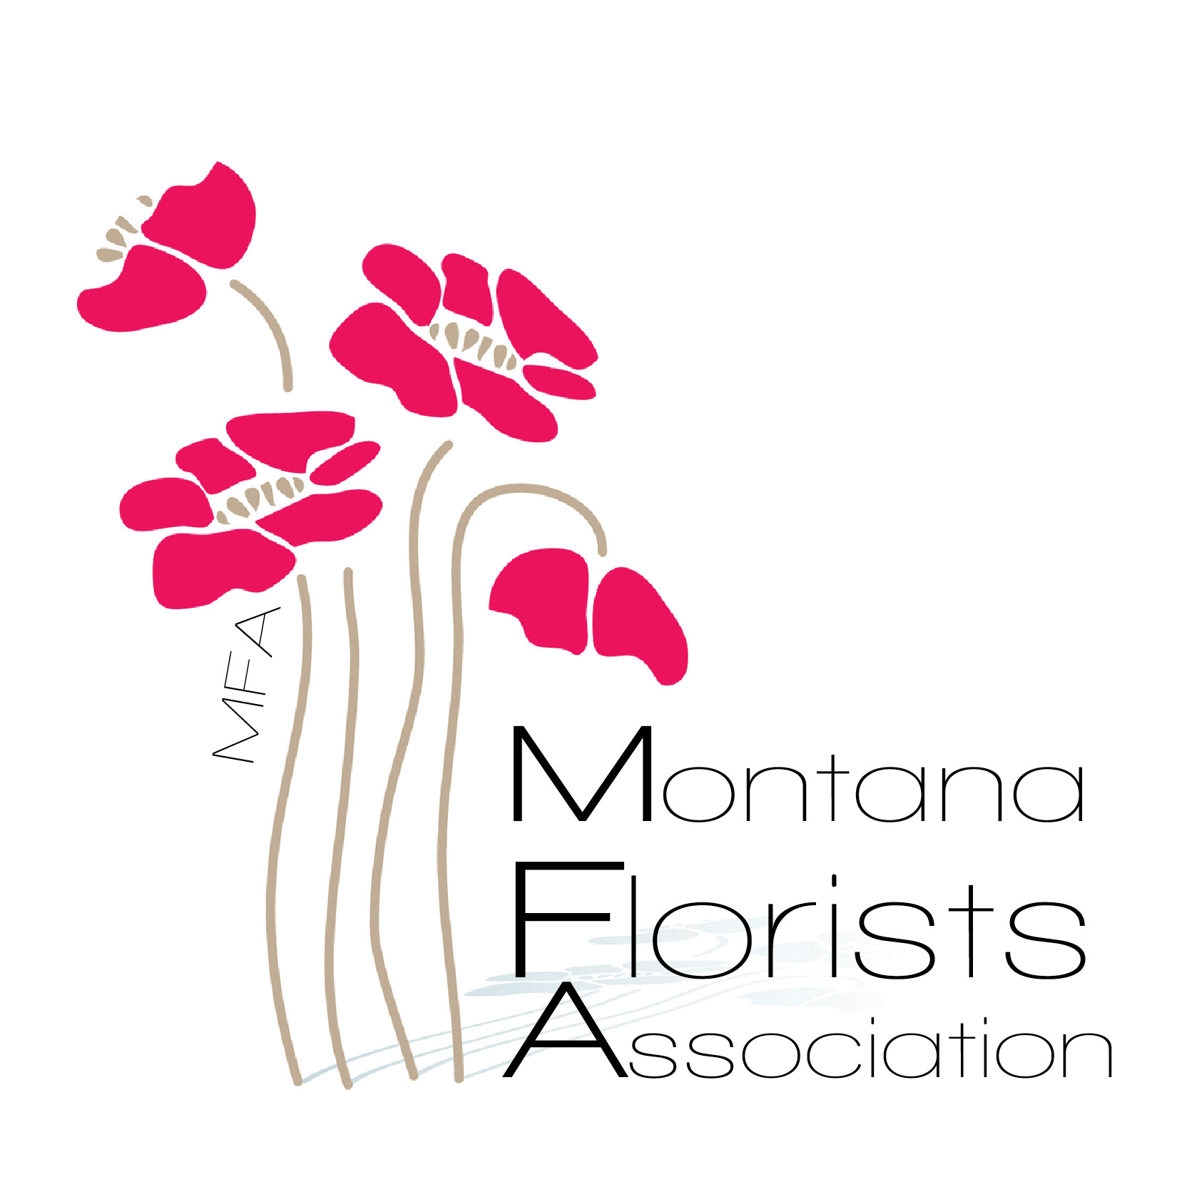

The Montana Florist Association is an organization with the common purpose of supporting and promoting the floral industry in Montana and surrounding areas. MFA membership is open to any individuals in the floral industry that meet the below guidelines.

**\*** All members must be an active professional in the floral industry ( ie: florist, store owner, event planner, wholesaler, grower,vendor, educator….)

**\*** All members must have a current state business licence and be able to provide MFA with a current state tax id#. Please include a copy with this application.

Fees : Membership fee is $75 per year. Dues are billed every January and due by April 15th.

Shop/ Business Name:___________________________

Owner(s) Name:_______________________________

Address:_________________________Zip code:______

Phone #__________________________

Email:_________________________________

Website:_______________________________

Please complete this application and send with a copy of your business licence or state Tax ID# to: Bev Or Lindsay

Bev Luedtke Lindsay Irwin

Bev’s Bloomers Bitterroot Flower Shop

34951 Creekside Ln. #8745 811 S. Higgins Ave.

Ronan, MT 59864 Missoula, MT 59801

MFA Treasurer MFA Secretary

**\***Please make checks payable to Montana Florists Association.

Payments are also accepted through our website: **Montanafloristassociation.com**

Please don’t hesitate to reach out with any questions or concerns.

[**mtfloristassc@gmail.com**](mailto:mtfloristassc@gmail.com) **Lindsay Irwin MFA Secretary**

**406-542-0309**