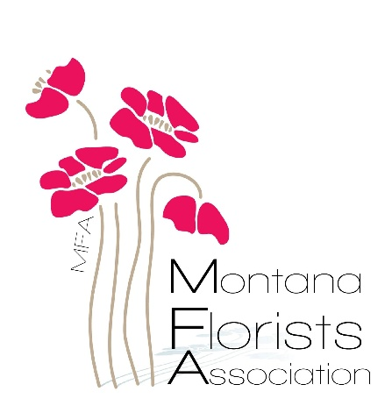
MFA 2025 Member Renewal
Date:_____________
Shop Name:______________
$75.00
1 year renewal to the Montana Florists Association
Due by April 15th, 2025
Remit Payment to: OR
MFA Treasurer Visit our website at
%Beverly Luedtke montanafloristassociation.com
34951 Creekside Lane to pay online.
Ronan, MT 59864 Thank you!

MFA 2025 Member Renewal
Date:_________________
Shop Name:______________
$75.00
1 year renewal to the Montana Florists Association
Due by April 15th, 2025
Remit Payment to: OR
MFA Treasurer Visit our website at
%Beverly Luedtke montanafloristassociation.com
34951 Creekside Lane if you would prefer to pay online.
Ronan, MT 59864 Thank you!

