**SIMPLE SELF-KINESIOLOGY TECHNIQUES FOR ANSWERS OR TO HELP MAKE DECISIONS**

We all at times aren’t sure if something is helpful to us or not. Self-kinesiology (SK), or muscle testing is a simple way to find the answers. For instance, perhaps you are trying to determine which supplement is actually good for your body. SK can help determine the answer quickly and simply. Or perhaps you need to know if a particular food is good for you or not; same thing. Or should you go out with someone you’ve not met before; try SK. Basically in self-kinesiology, you become your own dowsing device. Get answers for yourself, just like you do with a pendulum, dowsing rods, or any other tool of divination. Below are a few techniques:

Finger Technique:

A simple single hand kinesiology (also called muscle testing) technique you can use easily, and in any location, is to touch the tips of your index finger and thumb together to form a circle. Use the other hand’s index finger to see if you can break the connection. A positive response is when you can’t break the connection and a negative response is when you can. It can take a bit of practice to get the pressure right but it is quite affective, and very simple.

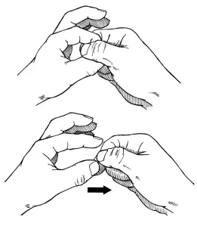

Arm Technique (to be done with a partner):

Another, and probably the most well-known method you can try is to hold your dominant arm straight out, and stiffly, from your side. A second person will be the ‘tester’. Ask a question. The second person will stand in front of you, one hand gently on your opposite shoulder, then gently try to push down your arm. If the arm stands firm, the answer is ‘yes’. If the arm is easily pushed down the answer is ‘no’. The pressure used to push the arm down is light and gentle, but firm and steady. Remember to hold the arm stiffly. Occasionally the arm doesn’t respond, and if too many questions, will become tired, at which time you might as well try another technique.

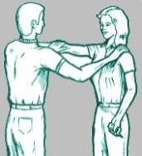

Full Body Pendulum Technique:

Standing still, with feet slightly apart and firmly planted, relax. Enter a quiet mindset if possible. Breathe a few times to ‘settle’. Close your eyes and say, ‘My name is (your name).’ Note, which way your body slightly sways, forward or backward. This direction should be your ‘YES’. Then to test it say, ‘My name is (someone else’s name). Your body should slightly sway in the opposite direction. This is how you get your ‘Yes and No’ directions to assess your answers. This should be done before each session (not before each question, but before each series of questions).

Now all you have to do is ask your questions. If the question is about a product or item, you can also hold that item to your solar-plexus to get a more-quick answer. Or if about a person, a picture to the solar-plexus might also help. Neither is necessary though, as in asking the question your intent will be upon the thing you are asking about. In all questions though, hold your hands to your solar-plexus area.

**Dragon Wings LLC 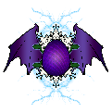 JamesMcChesney.com**