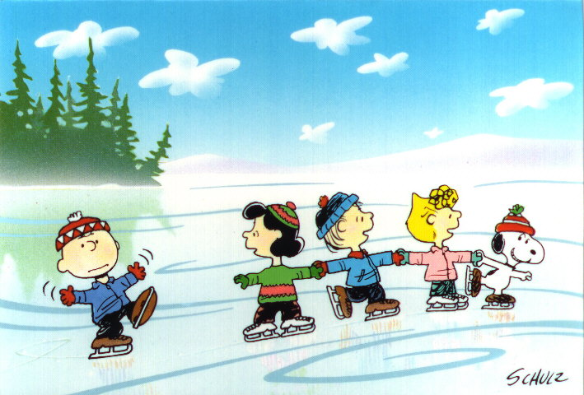Thur. Dec. 31 6-9 p.m. (New Year’s Eve skate, music prizes, etc.)

**Public Skating**

**At the Centennial Center**

**Admission $2.00**

**Skate rental $2.00**

**Schedule 2022**

**Wed. Jan 12th 1 p.m. – 3 p.m.**

**Wed. Feb 9th 1 p.m. – 3 p.m.**

**Thur. Feb 24th 1 p.m. – 3 p.m.**

**Fri. Feb 25th 1 p.m. – 3 p.m.**

**Thurs. Mar 3rd 1 p.m. – 3 p.m.**

**Fri. Mar 4th 1 p.m. – 3 p.m.**

**Wed. Mar 9th 1 p.m. – 3 p.m.**