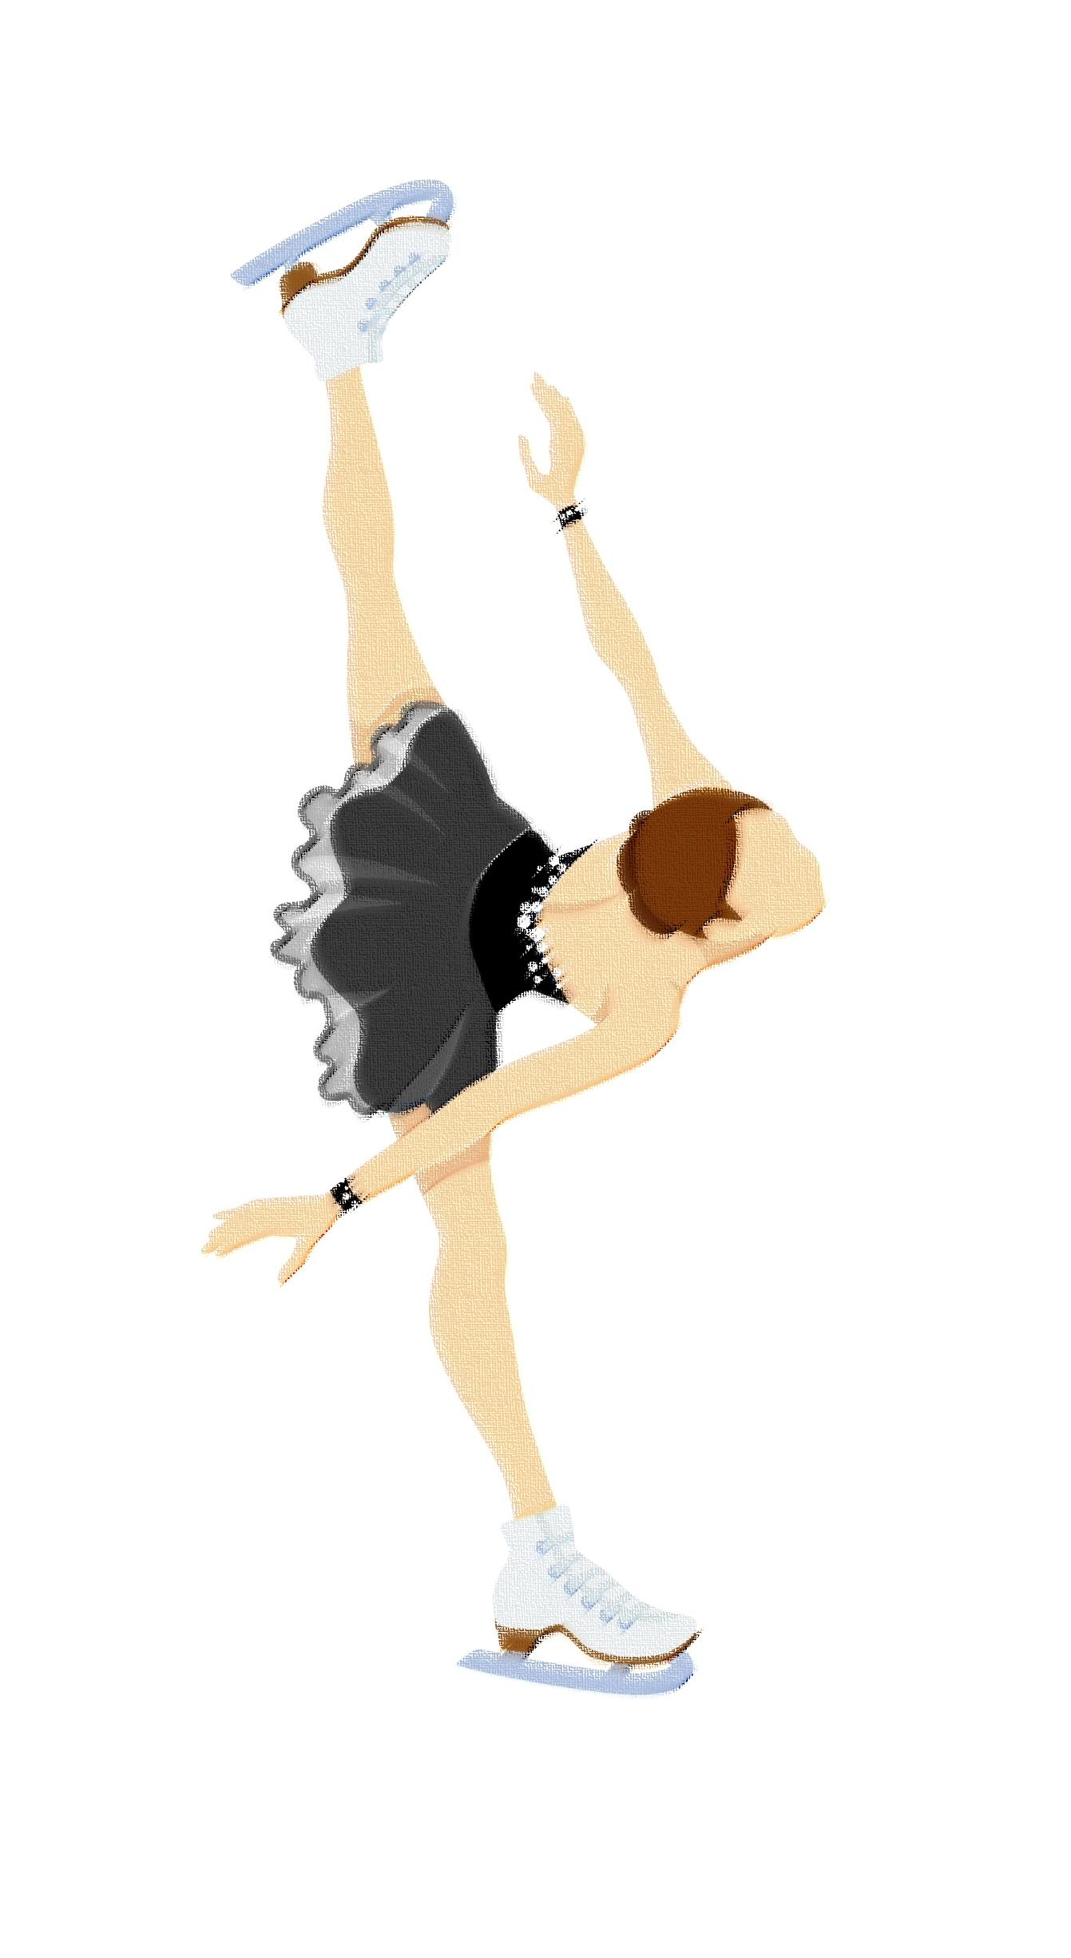
Grafton Figure Skating
ASPIRE (formerly Bridge) Program FAQ

What is the Learn To Skate Aspire Program?
The Learn To Skate (LTS) Aspire Program is a way for LTS skaters to try out skating on a more individual basis. Skaters in the Aspire Program purchase ice time for Saturday mornings only. During this time they can practice their skating skills and will have a private lesson with a certified United States Figure Skating Association (USFSA) coach. They also have the option to be able to compete in different events at LTS Competitions which are held in various cities in the region. These competitions offer events from Snowplow Sam all the way through Freeskate levels.

When can/should my skater be in the Learn To Skate Aspire Program?
The LTS Aspire Program is mainly meant for skaters working on LTS Badges (Basic 2 and above) who have an interest in developing their skating skills during one-on-one coaching time, and/or who are interested in competing in competitions for LTS Levels. Skaters in the Aspire Program are encouraged to participate in LTS Group Lessons.

What kind of lessons are given during the Learn To Skate Aspire Program?
Skaters take one-on-one lesson(s) from a USFSA Certified coach, in the skating world this is referred to as a private lesson. Private lessons are given during the Aspire Program Saturday morning ice time.

When does my skater practice?
When a skater is in the Aspire Program, they purchase Saturday morning ice time ($175 for 2021-2022). This time is available for your skater to practice and is when private lessons take place.

What are the fees for the Learn To Skate Aspire Program?
The yearly fees for the Aspire Program are: Learn To Skate USA Membership approximately $55*/skater (only if not enrolled in LTS Lessons through Parks & Rec – if skater has a Learn To Skate number membership through Parks & Rec, the fee is $25); and ice time $175*/skater. There are additional fees when registering for competitions. Coaches will share their private lesson rates.

Why does my skater have to be a Learn To Skate USA member?
All skaters on the ice need to be a member of Learn To Skate USA or USFSA (private advanced) for liability reasons. Also, in order to participate in LTS sanctioned exhibitions (Grafton Ice Show) and LTS sanctioned LTS Competitions, you need to be a member of LTS. (Skaters enrolled in Grafton LTS Group Lessons will receive a slight discount from Grafton Parks and Recreation IF membership will be taken care of through Border Blades – typically the membership will be provided through Parks & Rec.)

How do I sign up for the Learn To Skate Aspire Program?
Learn To Skate membership can be purchased on the BBFSC website (borderblades.org). Ice may be purchased on the Grafton page of the BBFSC website (borderblades.org). A portion of Ice Fees may be fundraised that option is chosen. Registration for Parks and Rec Learn To Skate Lessons can be found on the Grafton Parks and Recreation Website. Deadline for registration is September 15th – enrollment after this date dependent on availability.

When should I let someone know my Skater would like private lessons on Saturdays through the Aspire Program?
Right away. Coaches put together the schedule in early October so as soon as you know you want to be part of the LTS Bridge Program, let the group coordinator (Michelle Shereck) know and Grafton Coaches will plan for your skater when making a lesson schedule.

Grafton Learn To Skate Aspire Program Coaches
Caylee Tibert Laurel Peabody
Ellie Vonesh Tara Carson

*membership prices are for the 2021-2022 skating season and are subject to change for subsequent skating seasons

