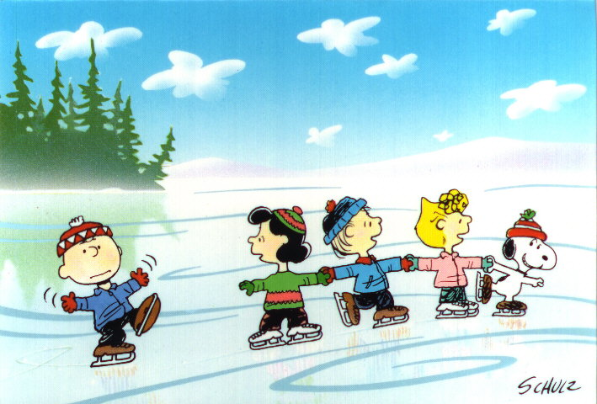
Thur. Dec. 31 6-9 p.m. (New Year’s Eve skate, music prizes, etc.)
Public Skating
At the Centennial Center
Admission $2.00
Skate rental $2.00
December Schedule 2021
Wed. Dec 8th 1 p.m. – 3 p.m.
Thur. Dec 23rd 1 p.m. – 3 p.m.
Fri. Dec 24th 1 p.m. – 3 p.m.
Mon. Dec 27th 1 p.m. – 3 p.m.
Tue. Dec 28th 1 p.m. – 3 p.m.
Wed. Dec 29th 1 p.m. – 3 p.m.
Thur. Dec 30th 1 p.m. – 3 p.m.
Fri. Dec 31th 1 p.m. – 3 p.m.

