Nell’s Pool

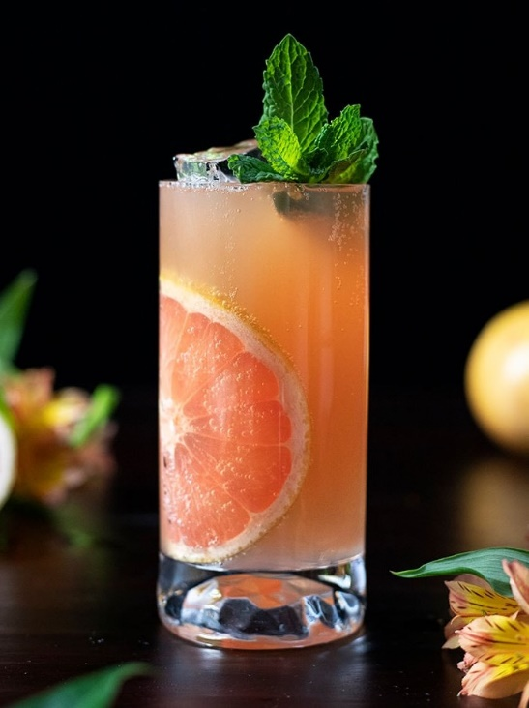

Super cold and slightly sludgy with a leafy garnish, you won’t see this served at Schepp’s, but it’s a favorite of (4-legged) Towne locals. Best if slurped.

Fresh mint leaves
2 oz Whistle Pig Farmstock Rye
<.25 oz mezcal
1 oz fresh lime juice
.5 oz fresh grapefruit juice
.5 simple syrup or agave
3 dashes of bitters
3 dashes tabasco, optional (Nell needs heat!)

Salt and chili mix for rim (A tasty allusion to our salty author and her love of surfing)
Build this cocktail in a shaker. Muddle mint until it resembles fall leaves gone mucky. Add the rest of the ingredients and shake well with ice. Strain into a rocks glass

