PatterPaws Mini Aussies

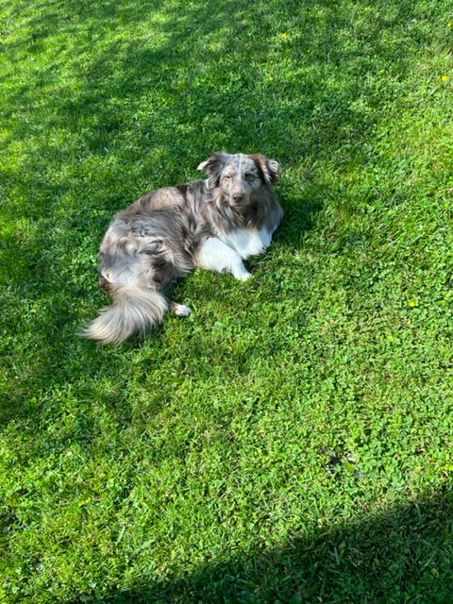

We have outstanding bloodlines of Miniature Australian Shepherds bought from loving and dedicated breeders. We uphold the high ethical and moral standards of our breeders and endeavor to continue in their grand tradition. We truly treasure this wonderful breed and seek a matching forever home for each of our puppies.

We desire to stay in touch with our puppy buyers to see our “grand-puppies” become part of their new loving families and mature into beautiful adult dogs. We assist puppy buyers with questions and support our buyers throughout the life of their puppy to adult dog.

Though this breed is a smaller version of the standard size Australian Shepherd, they contain the same energy, personality and characteristics of the ''big'' brother. This breed is not for everyone. While Aussies are very active, they are not hyper dogs.

As breeders, we ask anyone interested in the Aussie do their homework in regards to temperament, health issues, and time management with getting a puppy and what to expect in general. There are far too many animals, including Aussies, that are placed in homes that are not a match for the breed.

Please understand, as responsible breeders and true enthusiasts of the breed, we need you to do a thorough investigation to see if a Mini Aussie is right for you and your family. Aussies are obviously a beautiful breed, however, a puppy is a long-term commitment. Unfortunately, as Aussie popularity rises, so too does the number of rehomed or sheltered puppies.

Filling out this questionnaire will help us ensure proper matches and ensure you are placed on a waiting list / deposit list for a desired litter or puppy.

We seek some of this information in an effort to get to know you and determine if you are a match for one of our puppies. There will be many who will sell you a puppy for profit only without regard for finding the correct match. We love our dogs, including our puppies, and are dedicated to making the right match for every puppy and for every puppy-buying family.

PatterPaws Mini Aussies – Potential Buyer Questionnaire

Help us get to know you and why would like to own a Miniature Australian Shepherd:

Name and full address:

phone(s): email:

1. Do you currently own or have previously owned a dog? How about an active breed of dog? What breed(s) and how many dogs?
2. Do you have kids? If yes, how many and what age(s)?
3. Why are you interested in owning a Mini Aussie? How have you learned about this breed?
4. What are your hobbies?
5. Why did you choose PatterPaws Mini Aussies as a prospective breeder to buy from?
6. What are you planning to do with your dog?
7. Do you rent or own your home? If renting, are there dogs allowed?
8. How much research have you done on this breed? What appeals you?
9. What are some of the challenges you expect and how will you deal with those challenges?
10. Do you know that other costs are upcoming to your immediate purchase? ( next set of shots, food, toys, leash, collar & microchip registration...)
11. Will your puppy be crate trained? Why or why not?
12. How long is time period the puppy will be confined in his crate daily?
13. What is your preference male or female? Why?
14. What Color do you wish to get? What would be second choice if the first is not in born litter?
15. Is your yard fenced?
16. Are you planning on getting help with training, like puppy classes etc.?
17. Name Veterinary reference and 2 personal references (name & phone #)