**About your Speaker, Wayne Olson**

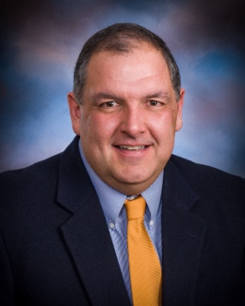

Wayne Olson is an author, planned giving mentor and speaker and trainer to nonprofits and for-profit organizations worldwide. Wayne is the Chief Development Officer for *The Washington Times* and the Washington Policy Institute.

He has served as the head of planned giving for the Shriners Children’s Hospital system as well as Intermountain Healthcare Foundation, two of the largest healthcare systems in the world.

He has served as a consultant to corporations and charities where he advised them on fundraising, sales, customer service and building stronger relationships with customers and constituents. He is a leading expert on planned giving and donor relations. An attorney with more than 25 years’ experience, he has worked with donors on hundreds of millions of dollars in donations and helped countless nonprofits build effective and dynamic fundraising and planned giving programs.

He is a sought-after trainer, consultant and speaker on motivation, customer service and leadership. In 2014 *Fundraising Success Magazine* honored him by awarding Wayne “The Most Inspirational Speaker of the Year.”

Wayne is the author of six books including: *Fundraising for Nonprofit Board Members*, which is available on Amazon and at Wayneolson.com. His other works include: *The Disney Difference*, *How to Give a Great Speech or Presentation*, *Big Gifts, Small Effort*, and *Think Like a Donor.* His newest book*, Words of Encouragement*, is now available*.*

Wayne has worked as a consultant or trainer for dozens of charities in Canada and the U.S. Hundreds of charities depend on Wayne to broaden and grow their fundraising. They use his writing in their websites, magazines, brochures and newsletters. He has been published in many periodicals including *Planned Giving Today*, *Advancing Philanthropy*, *Nonprofit Times*, *256 Magazine*, and has twice been featured in the *Chronicle of Philanthropy*.

Wayne has spoken to AFP International Conferences, Mensa, NASA, AFP Congress Toronto, Space and Missile Defense, Synovus Bank, Leadership Huntsville, Rotary conferences, Nonprofit University, National Philanthropy Day and many more.

Wayne has served on the boards of three charitable organizations and volunteers for several more. Wayne earned his undergraduate degree from the University of Florida and his law degree from Stetson University College of Law. He is an Eagle Scout and the father of two Eagle Scouts.

To contact Wayne:

Wayne Olson

wayne@wayneolson.com

wayneolson.com

(256) 924-9223 (cell)