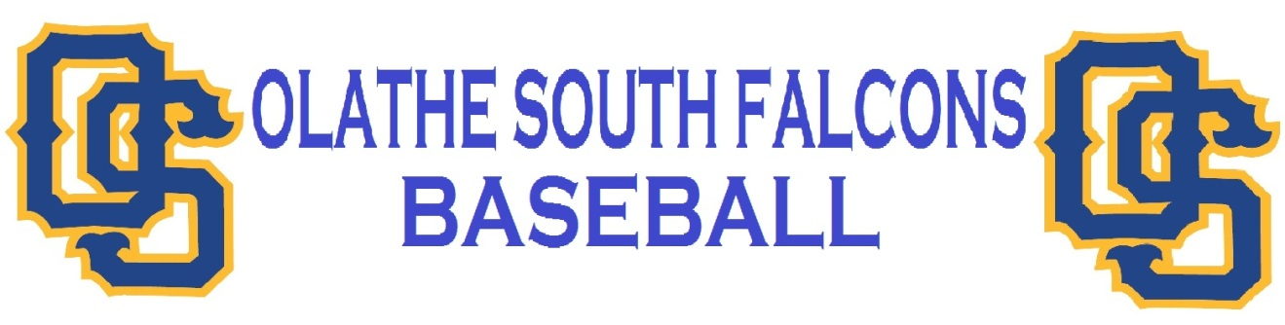

**TRYOUTS –**

* **Monday, February 25th – Friday, March 1st** 
  + First cuts will be made on Wednesday, February 27th
  + Final cuts will be made after the practice on Friday, March 1st
* **Physicals and Concussion Forms**: Each player needs to make sure that there is a **physical and concussion** form turned in to **Jenessa Gonzales** in the front office. If your son played a school sport in the fall or is currently playing a winter sport, then their physical and concussion form is already on file and they do not need to receive another one.
* **Impact Testing:** Olathe has made it free for the players to undergo impact testing for concussions. There will be an opportunity for spring sport athletes to take the impact test. The time and location of the testing will be decided at a later date. I strongly recommend your son take the impact testing.
* **Transportation –** There will be a bus that takes non-drivers to ODAC or Black Bob park for practices. The bus will leave at 3:07 from the bus depot between Olathe South and Indian Trail.
* **Players Equipment Storage** – During tryouts, players may keep their bags in their cars, sports lockers or in the closet behind the training room. The closet behind the training room will be open at 7:45 am and close at 7:55 am. After school, the room will be open for them to get their bags and get to the bus stop. Once players are selected for the team, they will be given a locker in the Varsity locker room to store their equipment. For players that will be on the shuttle bus, there will not be time to change at school. They will need to grab their equipment bag and school backpack and get on the bus. There are bathrooms at Blackbob Park and ODAC for the players to change before practice.

**Practice Plan** – Monday**:** Freshmen– at ODAC 3:30-5:00

Sen.-Soph. – at ODAC 4:45-6:30

Tuesday: Freshmen– at ODAC 3:30-5:00

Sen.-Soph. – at ODAC 4:45-6:30

**Evening: Freshmen and Sophomore pitchers and catchers from 7:30 to ?????**

Wednesday: Freshmen– at ODAC 3:30-5:00

Sen.-Soph. – at ODAC 4:45-6:30

\*\*\*\*\*\***First cuts will take place at the field after each practice\*\*\*\*\*\***

Thursday: Freshmen– at ODAC 3:30-5:00

Sen.-Soph. – at ODAC 4:45-6:30

**(Depending on Weather) Evening: Juniors and Seniors pitchers and catchers from 7:00 - ???**

Friday: Everyone – at ODAC 3:30-5:30

\*\***Indoor Practice times**\*\* **Freshmen: 6:30-8:00 pm**

**Groups will meet in commons to stretch Senior-Sophomores: 7:45-9:15**

**\*\*If rain or weather brings us inside to practice, the indoor practice times will be the same as listed above. Basketball sub-state tournaments are held this week as well. If our basketball teams host a sub-state tournament, it could change the starting times for indoor practice. The players will know the new schedule on Monday, February 25th if there have been any changes. \*\***

**CONDITIONING –**

* There are still a few conditioning dates (Tuesdays and Thursdays).

**SPRING BREAK –**

* This year spring break is from March 11th – March 15th. The players will not practice on Friday, **March 8th**. **Varsity players only will need to meet on Thursday, March 14th. This year the Varsity is taking a trip to Owasso, OK Thursday through Saturday. The JV-Freshmen players will have the entire spring break off.** In the upcoming seasons we will treat the break the same way.

**COMMUNICATION –**

* The first line of communication is from coach to player and then player to parent. Talk to your son first before talking to a coach about situations that come up during the season. Please have your son talk to the coach with issues that involve that player.
* What coaches will not talk about with parents:
  + Playing time
  + Players other than your son
  + **After tryouts, a coach will not communicate with a parent for 24 hours after the cut has been made**.

**APPAREL –**

* Once a player has made the team they will receive an apparel handout showing them what they can order.
* Players will be expected to wear the practice uniform (practice t-shirt or their baseball jacket, white or gray baseball pants). They will be expected to provide their own pants to practice in.
* Baseball Pants, Royal blue socks, royal blue belt, and royal blue under shirts (long or short sleeve) will **NOT** be given to the players, they will need to purchase their own for the season.

**EXPECTATIONS IN THE CLASSROOM –** A reminder that all players will be expected to be passing ALL classes at ALL times. With the new gradebook technology, I can monitor player’s progress in all classes throughout the 3rd and 4th quarter. I will not be monitoring students until the team is decided after tryouts, but I don’t want players falling behind in January and February.

**SUBSTANCE ABUSE POLICY –** I will follow the districts substance abuse policy. This policy includes the use of tobacco, alcohol and illegal substances used at any location, not just on school grounds. The first offense is a 2-week suspension from games. The player will still practice, but they cannot compete in games at any level. The second offense will result in the suspension of the player for the rest of the season, the player will be removed from the team. A third offense is a 365-day suspension from ALL sports associated with the school.

If you have questions please do not hesitate to ask. Listed below is my email address and phone number for the school.

Josh Perkins

[jperkinsos@olatheschools.org](mailto:jperkinsos@olatheschools.org)

913-780-7160