**Save the Date**

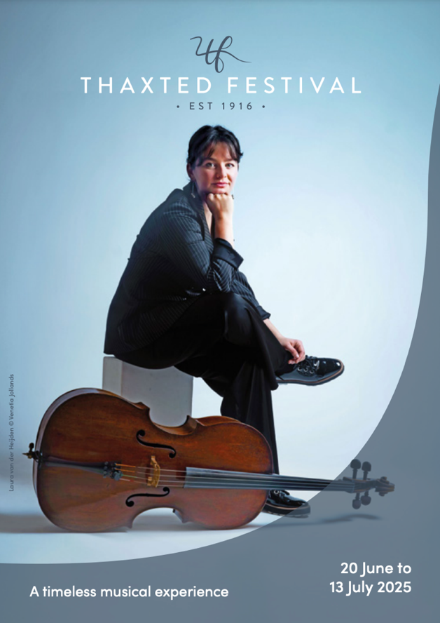**Thaxted Festival announces its 2025 festival from 20 June to 13 July**

**Thaxted Festival** announces its 2025 Festival from **20 June to 13 July 2025**. The Festival welcomes stellar performers including **Nicky Spence**, **Doric Quartet**, **Gesualdo Six** and the Choir of St George’s Chapel, Windsor Castle, and the newest **winner of the Leeds Piano Competition Jaeden Izik-Dzurko**. Resident orchestra **London Mozart Players** opens the festival with Beethoven’s ever popular Violin Concerto with soloist **Charlotte Saluste-Bridoux**. Summer opera lovers will be well served too, with **Wild Arts’ *Eugene Onegin*** and a **jazz offering from Mighty Like the Blues**.

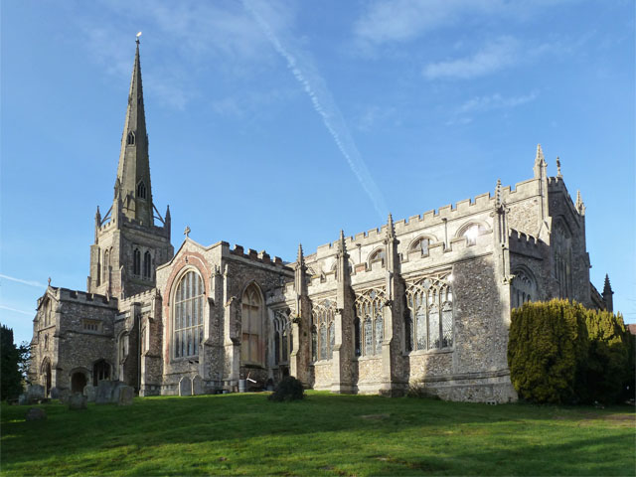

Thaxted Parish Church amidst the rolling Essex countryside near Saffron Walden has been described as the finest parish church in the country, and provides the perfect venue for the Thaxted Festival. **With its origins in** **Gustav Holst’s 1916 Whitsun Festival**, Thaxted Festival attracts outstanding British and international musicians in genres ranging from orchestral, chamber and vocal music to jazz, folk, big-band and swing, from early music to contemporary styles.

**Weekend One – 20 to 22 June**

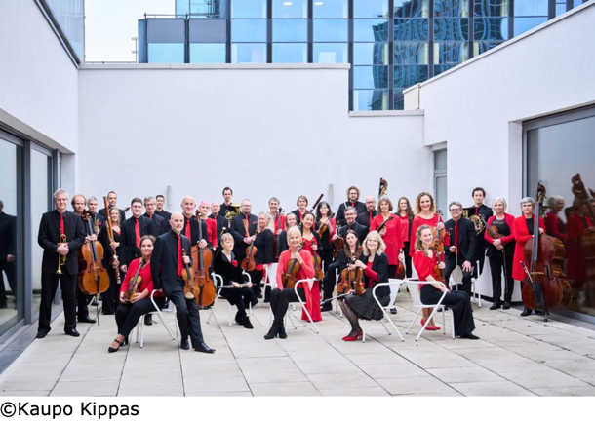Orchestra in-Residence, the **London Mozart Players**, will join with rising star **violinist Charlotte Saluste-Bridoux** in Beethoven’s monumental violin concerto. Charlotte has been part of Thaxted Festival’s Developing Artists Programme over recent years. The Marriage of Figaro opens the concert, which ends with the joyful ‘Jupiter’ - his last, and probably his most popular symphony. The following day, the **Doric Quartet** perform Beethoven and Haydn String Quartets. On Sunday afternoon, a screening of the film *Quartet* (2012), a British comedy film, takes place at Saffron Screen . This first weekend of the Festival also features **tenor Nicky Spence** and **pianist Dylan Perez** in a programme entitled *My Father’s Son* featuring songs by Schumann, Howells, Previn and others.

Nicky says about curating the programme *My Father’s Son*:

“I wanted to reflect on experiences which are both personal but perhaps also universal. My Father's Son is semi-autobiographical in that it looks at my own path to fatherhood and the emotions provoked by some of my own childhood. This narrative recital uses the words of others but is fairly close to my own perceived experience.”

**Weekend Two – 27 to 29 June**

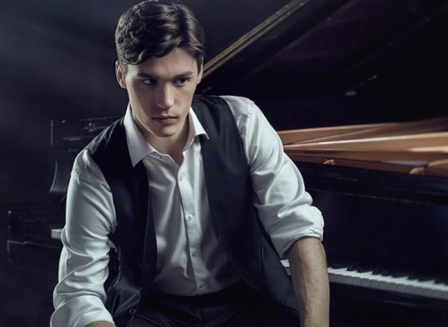A trio from the **Young Classical Artists Trust** opens the second weekend of the Festival, and Craig Ogden and the London Tango Quintet are set to bring the excitement of South America to Thaxted, alongside **Neil Balfour** and **Christopher Pulleyn** performing Love is a Spectrum: songs by Schumann, Esmail and de Falla. **Pianist Jaeden Izik-Dzurko** closes the weekend in his first UK recital since winning the Leeds International Piano Competition.

In a review of Jaeden’s performance with the RLPO, Bachtrack said:

“the structure became evident, not intrusively but as in the design of a great building, as satisfying as it was beautiful. Time seemed stretched almost to breaking point.”

**Weekend Three – 4 to 6 July**

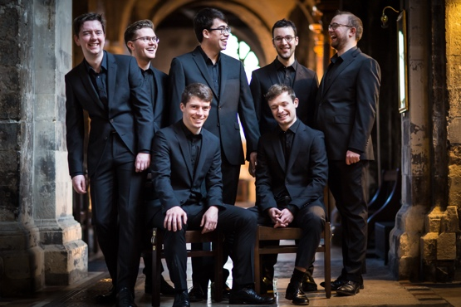 The third weekend opens with award-winning British vocal ensemble **The Gesualdo Six** present a varied programme from Thomas Tallis to Judith Bingham. **Saxophonist Rob Burton** and **pianist Mark Rogers** present a recital of Debussy, Clara Schumann and Brahms followed by an evening performance by **cellist Laura van der Heijden** with **pianist Jâms Coleman** in a programme of Debussy, Clarke and Franck. Sunday brings a **relaxed family event** at the Audley End Miniature Railway followed by an evening of choir music by Holst, Howells, Vaughan Williams and Duruflé Requiem with the **Choir of St Geroge’s Chapel, Windsor**.

**Weekend Four – 11 to 13 July**

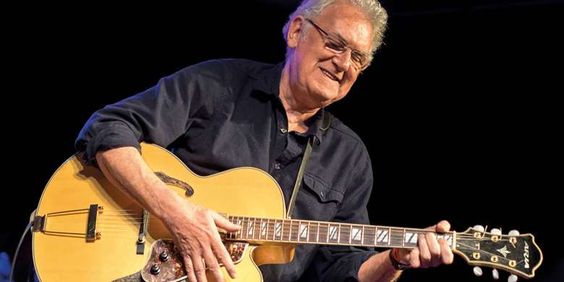 The final weekend of the 2024 Festival features **an evening of blues in all styles with guitar legend Jim Mullen**. The following day, **Wild Arts Opera** returns to present Tchaikovsky’s Eugene Onegin.

The **London Mozart Players** bring this year’s Thaxted Festival to a close with **Purcell, Handel, Bach and Vivaldi’s four seasons**.

**"Holst could only have been pleased to think that, in these times when access to live opera is so limited in Britain, it turns up at Thaxted. Courtesy of his surviving Festival. And making people very happy in the process."**

Catholic Herald

**_________________________________________________________**

**2025 Festival Listings**

**Weekend One**

**Friday 20 June, 19:30**

Thaxted Parish Church

**Mozart** *Le Nozze de Figaro*: Overture

**Beethoven** Violin Concerto in D Major

**Mozart** Symphony No 41 in C Major ‘Jupiter’

**Charlotte Saluste-Bridoux** violin

**London Mozart Players**

**Jonathan Bloxham** conductor

**Saturday 21 June, 15:00**

Thaxted United Reformed Church

**Let’s Do It! Songs by Coward, Gershwin, Berlin, Kern, Porter, Swift and Weill**

**Clare McCaldin** mezzo-soprano

**Paul Sheehan** bass-baritone

**Stephen Dickinson** piano

**Saturday 21 June, 19:30**

Thaxted Parish Church

**Haydn** String Quartet Op. 20 No. 4 in D Minor

**Beethoven** String Quartet Op. 135 No. 16 in F Major

**Haydn** String Quartet Op. 64 No. 3 in B Flat Major

**Doric String Quartet**

**Sunday 22 June, 18:00**

Thaxted Parish Church

***My Father’s Son:* Schubert, Howells, Faure and more**

**Nicky Spence** tenor

**Dylan Perez** piano

**Sunday 22 June, 21:00**

Thaxted Parish Church

**Alexander Chance** countertenor

**Toby Carr** lute

**Weekend Two**

**Friday 27 June, 19:30**

Thaxted Parish Church

**Paul Schoenfield** Trio for Clarinet, Violin and Piano

**Bartók** Romanian Folk Dances, Sz 56

**Khachaturian** Trio for Clarinet, Violin and Piano Op 30

**Bartók Rhapsody** No 2 for violin and piano, Sz 89

**Bela Kovács** Shalom Aleichem

**Bartók** Contrasts for Violin, Clarinet and Piano, Sz 111, BB 116 (1938)

**Jonathan Leibovitz** clarinet

**Charlotte Saluste-Bridoux** violin

**Jonathan Ware** piano

**Saturday 28 June, 12:00**

Thaxted Parish Church

**Thomas Trotter** organ recital

**J S Bach** Pièce d’Orgue BWV 572

**Russell** Voluntary in A minor;

Voluntary in G major

**Holst** Three Pieces, arr. Trotter

**Matter** Fantaisie on ‘Une jeune fillette’

**Farrington** Raggle Taggle Tunes

**Saturday 28June, 19:30**

Thaxted Parish Church

**An evening of Tango**

**Piazzolla, Albéñiz, Reinhardt etc.**

**Craig Ogden** guitar

**London Tango Quintet**

**Sunday 29 June, 15:00**

Thaxted United Reformed Church

**Fauré** Cinq melodies

‘de Venise’

**Manuel de Falla** Siete canciones

populares españolas

**Reena Esmail** Rosa de Sal

**Robert Schumann** Frauenliebe

und Leben

**Neil Balfour** baritone

**Christopher Pulleyn** piano

**Sunday 29 June, 29:30**

**Bach** Partita No 4 in D major, BWV 828

**Chopin** Sonata No 3 in B minor, Op 58

**Scriabin** Fantasie in B minor, Op 28

**Rachmaninoff** Preludes, Op 23

**Jaeden Izik-Dzurko** piano

**Weekend Three**

**Friday 4 July, 19:30**

Thaxted Parish Church

**Works from the Tudor era to today**

**Gesualdo Six**

**Matilda Lloyd** trumpet

**Owain Park** director

**Saturday 5 July, 15:00**

Thaxted United Reform Church

**Works by Debussy, Ravel, Clara Schumann, Robert Schumann, Brahms, and Jules Demersseman**

**Rob Burton** saxophone

**Mark Rogers** piano

**Saturday 5 July, 19:30**

Thaxted Parish Church

**Debussy** Cello Sonata

**Rebecca Clarke** Rhapsody

**Mel Bonis** Cello Sonata in F major

**Franck** Violin Sonata (arr. Delsart for cello)

**Laura van der Heijden** cello

**Jâms Coleman** piano

**Sunday 6 July, 18:00**

Thaxted Parish Church

**A programme of English song**

**The Choir of St George’s Chapel, Windsor Castle**

**James Vivian** Director of Music

**Luke Bond** piano

**Morwenna Del Mar** cello

**Weekend Four**

**Friday 11 July, 19:30**

Thaxted Parish Church

**Mighty Like the Blues**

featuring **Jim Mullen** guitar

**Saturday 12 July, 17:00**

Thaxted Parish Church

**Tchaikovsky** Eugene Onegin

**Timothy Nelson** Eugene Onegin

**Galina Averina** Tatyana

**Dominic Dromgoole** director

**Wild Arts**

**Sunday 13 July, 18:00**

Thaxted Parish Church

**Purcell** Abdelazer Suite

**Handel** Concerto Grosso Op 6 No 11 in B flat

**Bach** Double Concerto

**Vivaldi** The Four Seasons

**London Mozart Players**

[**thaxtedfestival.co.uk**](https://www.thaxtedfestival.co.uk/)

**_________________________________________________________For more information on any of the above, please contact**

**Nicky Thomas Media**

Unit 12 The Stableyard, Broomgrove Road, London SW9 9TL

+44 (0)20 3714 7594 | +44 (0)7768 566 530

[**info@nickythomasmedia.com**](mailto:info@nickythomasmedia.com)

[www.nickythomasmedia.com](http://www.nickythomasmedia.com)