****Summer Bonanza with Barokksolistene:**

***Alehouse Sessions* UK tour and *Dido & Aeneas***

**Alehouse Sessions**

**Rebel soundtrack to prohibition England: ballads, sea shanties, folk tunes alongside Purcell & Playford**

**“*It’s just old pop music*”**

**Bjarte Eike**

**3 June – BRISTOL** Lost Horizon Arts Centre

**5 June – SHEFFIELD** Peddler Warehouse

**6 June – LONDON** Koko

**7 June – CAMBRIDGE** Junction

**8 June – LEEDS** Belgrave Music Hall

**4 August – EDINBURGH FESTIVAL** – Ross Bandstand – (*Ceilidh Sessions*)

**6 August – ALDEBURGH** Snape

**8 August – PROMS** - From Dark till Dawn

***“Rip-roaring music making effortlessly melds ancient and modern”***

**The Strad (on The Playhouse Sessions CD)**

★★★★★ The Telegraph (The Alehouse Sessions) ★★★★☆ De Volkskrant

 ★★★★☆ The Scotsman ★★★★☆ BBC Music Magazine

**Purcell’s *Dido & Aeneas***

**26, 27, 29, 31 July & 2 August – Longborough**

From Edinburgh to the Proms, **Bjarte Eike** and the bad boys of the baroque - **the Barokksolistene** - are back for a UK tour of the ***Alehouse Sessions*** this summer bringing their trademark fleet-footed fiddling, devilish improvisation and intoxicating revelry. From 26 July to 2 August, they divert to Longborough Festival for a 5-night run of Purcell’s ***Dido & Aeneas*** in a new production.

For Longborough Opera, **Eike** and Norwegian director **Erlend Samnøen** have developed a new production of Purcell’s *Dido and Aeneas,* the first English opera. After *Dido’s Lament*, there will be a rousing wake for the Queen of Carthage. Giving the limelight to Longborough Emerging Artists, the title roles sees **Camilla Seale** as Dido, **Sam Young** as Aeneas and **Lydia Shariff** as the Sorceress.

Capturing the rebellious sound world of London under Oliver Cromwell’s draconian laws abolishing the capital’s lively arts scene, the Alehouse Sessions celebrates the hypnotic folk melodies and sea-shanties, bawdy ballads and cheeky ditties alongside ayres and dances by Purcell and Playford, as seen in the BBC TV documentary in 2023.

This August they will be joined by Norwegian folk dancers/singers Silje Onstad Hålien and Silje Risdal Liahagen, bringing a Nordic flavour to their performances.

For their re-invitation to Edinburgh Festival, they will create a Ceilidh-inspired *Alehouse Session*. At the Albert Hall, they will join the first all-night Prom *From Dark to Dawn*.

When 17th-Century England went into lockdown with Oliver Cromwell and the Puritans closing playhouses and theatres and banning all excess, musicians and performers sought refuge in backrooms of taverns and alehouses to vent their anarchy. Following their best-selling recordings *The Alehouse Sessions* and *The Playhouse Sessions*, **Bjarte Eike’s virtuosic Barokksolistene** and **soprano Mary Bevan** took to the stage of the Battersea Arts Centre and the 17th-Century George Inn in Southwark for the 2023 BBC documentary the Alehouse Sessions.

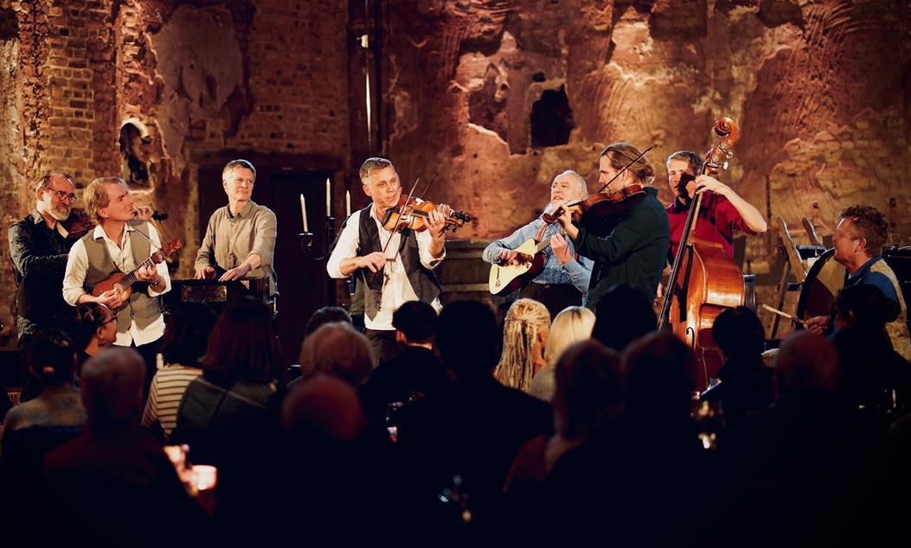

**Produced in collaboration with the award-winning director Dominic Best**, the film captured the energy, sheer joy and raw beauty of folk ballads, traditional ayres and dances annotated by Playford alongside the refined simplicity of Purcell’s vocal music. The music lives and breathes down the ages, free of later conventions of published music.

**Watch the promo video below**

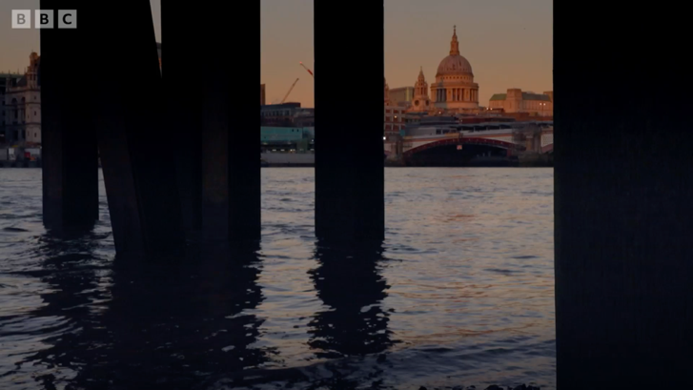

Norwegian Baroque violinist Bjarte Eike is the artistic director of Barokksolistene. One of their innovative concepts have included *The Alehouse Sessions* which has a broad, unifying approach to music, as well as a desire to curate exhilarating new experiences for audiences.

Bjarte Eike & Barokksolistene’s performanceshave been hailed as ‘irresistible’ (*The Times*) and ‘fabulously unrestrained’ (*The Guardian*). Their latest album on Rubicon *The Playhouse Sessions* features Eike’s arrangements of music from Purcell’s *The Fairy Queen*, his own original compositions on words from Shakespeare’s *A Midsummer Night’s Dream*; popular songs and ballads such, as ‘*The Irish Washerwoman*’, ‘*I often for my Jenny strove*’ and ‘*The Three Ravens*’.

Reviews of their *The Playhouse Sessions* disc

***“******Ricochets from Purcell to folk music, from vocals to instrumentals, in intoxicating style”***

**BBC Music Magazine**

***“******Bjarte Eike and his Barokksolistene*** ***approach this music and its cultural context with open hearts and minds”***

**Gramophone**

***“the anarchic atmosphere of after-hours sessions in Restoration pub backrooms”***

**The Guardian**

Gramophone Editor’s Choice

**Bjarte Eike**

Baroque violinist Bjarte Eike pushes boundaries in classical music, constantly looking for new projects in the borderland of genres and is reaching out to new audiences with his infectious playing and style.

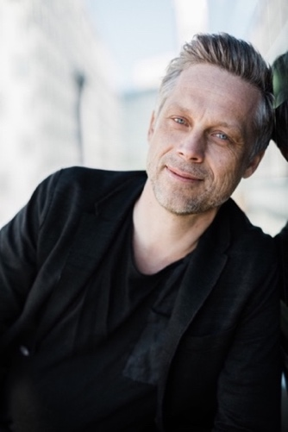As a freelance violinist he explores alternative ways of approaching classical music. Although rooted in historically-informed performance practice, he strives to include other artistic aspects in his performances, using visual arts, dance, storytelling and improvisation. Major collaborations include Handel’s *Alcina* at the Norwegian National Opera, *Vespertine* with choreographer Liam Scarlett, a staged *Messiah* with Netia Jones at the Bergen International Festival and recordings and concerts with jazz pianist Jon Balke, including as part of the Siwan project which explores the links between North African Arabic, Andalusian and baroque music.

**Barokksolistene**

Founded by Bjarte Eike in 2005, Barokksolistene is now recognised as one of the world’s most dynamic and exciting groups working in the field of historically-informed performance, fusing virtuoso musicianship with flawless ensemble playing.

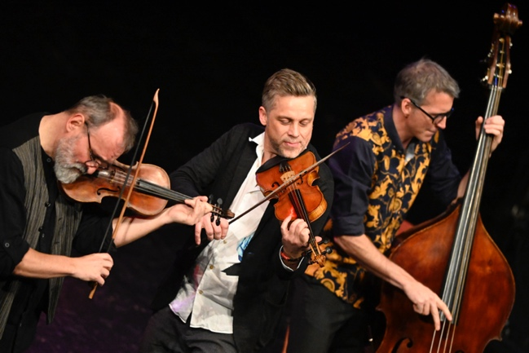

Constantly striving to reach out to new audiences, their passion to engage with folk and experimental music, improvisation, visual arts, dance and story-telling has led them to create unique concert experiences which play to sold-out audiences worldwide.

Nowhere is this more evident than in their signature project *The Alehouse Sessions.* Curated and devised by Bjarte Eike, this project is an ever-changing and evolving look into the music of the English 17th century tavern, with the group diverting away from the traditional concert model to create an evening that is “*innately theatrical, genre bending and suffused with great musicianship*” (The Strad).

An album of the project was released on Rubicon Classics in 2017 and immediately made the UK top 10 classical charts. Since then, Barokksolistene has toured the project throughout the UK, Germany, Austria, Switzerland, Slovakia, Scandinavia, the US and Ireland, and it continues to return season-after-season, each time with new ideas. In 2018 the album received the Opusklassik Award in Germany. *The Alehouse Sessions* was filmed for the BBC and premiered in April 2023, attracting a large TV audience. It has since been aired in Norway and across Europe.

On stage their collaborations have found them working with artists as diverse as choreographer Liam Scarlett on his ballet *Vespertine* and Norwegian jazz musician Jon Balke, whose Siwan project explores the links between North African Arabic, Andalusian and baroque music. Further concerts have included performances of the Malcom Bruno reconstruction of Bach’s *St Markus Passion* and a series of major opera productions, including a staged *Messiah* with Netia Jones at the Bergen International Festival and Handel’s *Alcina* and Purcell’s *Dido and Aeneas* for Den Norske Opera in Oslo. In 2019 they returned there for a new production of *Dido and Aeneas*. Baarokksolistene has recently premiered their new production *The Dancers’ Brew*, a collaboration with female dancers from Mamelukk Dance Company.

Bjarte Eike and Barokksolistene are based in Norway and were established in 2005 and celebrate their 20th anniversary in 2025. They are very grateful to receive support from the government via Arts Council Norway as proud ambassadors of Norwegian culture.

**For more information on any of the above, please contact:**

**Nicky Thomas Media**

2-6 Baches St, London N1 6DN

+44 (0)20 3714 7594 | +44 (0)7768 566 530

[**info@nickythomasmedia.com**](mailto:info@nickythomasmedia.com)

[www.nickythomasmedia.com](http://www.nickythomasmedia.com)