**Nikita Lukinov, featured on BBC Radio 3’s Classical Live, opens the St Magnus Festival on 20th June**

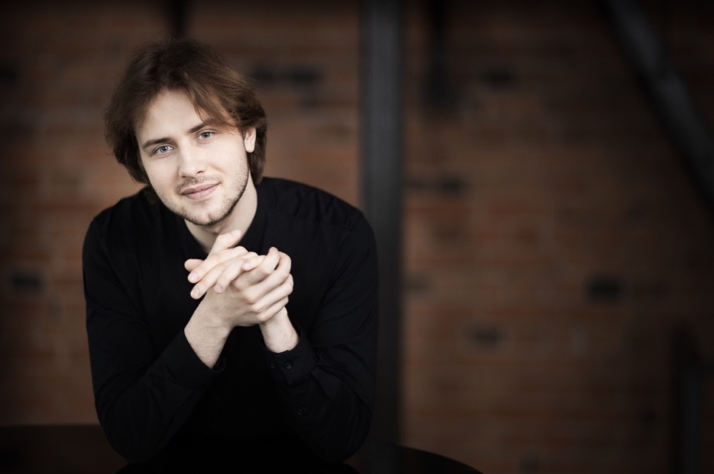

**Tuesday 27, Wednesday 28 and Friday 30 May**

**Broadcasts across BBC Radio 3 Classical Live**

**Friday 20 June, 7.00pm**

**St Magnus Cathedral, Kirkwall**

[**stmagnusfestival.com**](https://stmagnusfestival.com/festival-programme-2025-draft/1-nikita-lukinov-resol-string-quartet)

**J.S. Bach** Prelude and Fugue in C# Minor BWV849

**Johannes Brahms**Six Pieces Op.118**Arno Babajanian** 6 Pictures for Piano

**Ludwig van Beethoven** Piano Concerto No. 4 in G Op.58

**Nikita Lukinov** Piano

**Eliette Harris** Violin

**Annabel Kidd** Violin

**Raphael Chinn** Viola

**Chloe Randall** Cello

**Monday 23 June, 11.00am**

**Stromness Town Hall, Stromness**

**Piotr Tchaikovsky** “May” and “June” from Seasons *Op.37a*

**Franz Liszt** Sonetto 104 del Petrarca

**Franz Liszt** Transcendental Study No.8 "Wilde Jagd"

**Claude Debussy** Reflets dans l’eau, Ondine

**Modest Mussorgsky** Pictures at an Exhibition

**Nikita Lukinov** Piano

**17 May, 2025**

**Edinburgh Society of Musicians**

**24 May, 2025**

**London Maxability Concert Series**

**“An extraordinary breadth of freedom of imagination”**

Gramophone

With support from the City Music Foundation, pianist **Nikita Lukinov**, named a **2023 BBC Music Magazine Rising Star**, will culminate his 40+ concert tour of Scotland on **Friday 20 June** at the St Magnus Festival. Lukinov will perform a programme of Bach, Brahms, Babajanian and a Beethoven piano concerto arranged for piano quintet. On **23 June**, Lukinov presents a programme entitled Pictures and Reflections featuring solo piano works.

The Scottish-based, Russian-born pianist will be **featured on BBC Radio 3 Classical Live on Tuesday 27, Wednesday 28 and Friday 30 May**. The broadcasts will feature **live recordings** from Lukinov’s performance at **Perth Concert Hall** this past March featuring a pictorial programme of Arno Babajanian’s Six Pictures, Debussy’s Images Book I and Mussorgsky’s Picture at an Exhibition.

Nikita is senior piano tutor at Royal Conservatoire of Scotland, running a class for first-study pianists where he specialises in overcoming technical challenges.

For his extensive Scottish tour in close collaboration with Live Music Now, Nikita has been offering various solo and chamber recital programmes alongside Beethoven’s Piano Concerto No.4 with a string quartet and his own cadenzas. As part of the tour, Nikita visited care homes and schools at many of the locations, bringing music to socially-disadvantaged communities.

Nikita explains his passion for taking music to these small, intimate venues in far-flung locations across the country he now calls home:

“Scottish promoters jumped at the idea of bringing Beethoven’s Piano Concerto No.4 to smaller venues. I improvise my own cadenza for this, as I grew up watching my father run the Jazz Province Festival in Russia, and while at home I was listening to the greatest names in jazz – Keith Jarrett, Michel Petrucciani, Oscar Peterson, Herbie Hancock and Jacky Terrasson. Depending on the piano to hand, I improvise some Scottish folk tunes, other times *Somewhere over the rainbow*, a bit of Frank Sinatra, anything that helps me to connect with the audience that day. It is an unbelievable feeling when people’s eyes sparkle so joyfully and sincerely after the performances, and I know I contributed something truly valuable.”

**Nikita Lukinov**

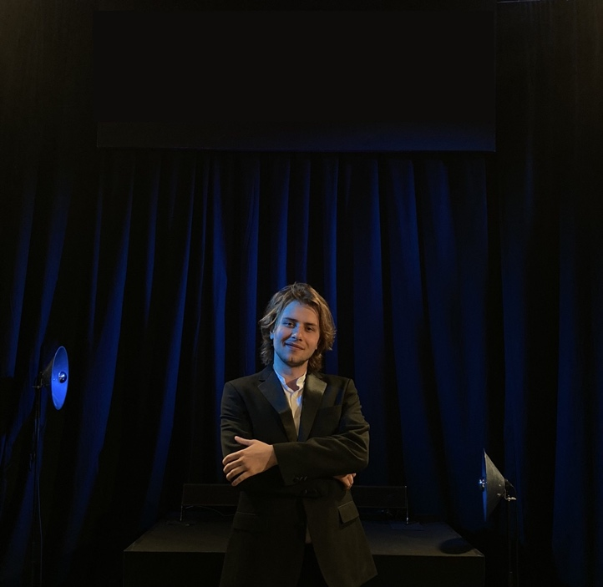A disciple of the Russian Piano School, Nikita Lukinov started his musical education at the age of six in Voronezh, Russia. At 14, he won a full scholarship to study at the Purcell School in London, followed by a full scholarship at the Royal Conservatoire of Scotland for his BA, MA and Artist Diploma Degree under Prof. Petras Geniusas. In June 2023, Nikita was awarded The Governors Recital Prize for the most outstanding end-of-year performance at the Royal Conservatoire of Scotland, culminating in the completion of his Master’s Degree. The same month Nikita’s debut CD was released with the KNS Classical label. He has now become the youngest senior staff member at his alma mater.

Nikita Lukinov has performed as a soloist in prestigious venues across the United Kingdom, Italy, Spain, Switzerland, France, Poland, Croatia, Germany and Russia. He has captivated audiences as a soloist in venues such as Wigmore Hall, Usher Hall, Southbank Centre, Palau de la Música, Fazioli Hall, Verbier Festival and JTchaikovsky Conservatoire in Moscow. Additionally, both his live and studio performances have been broadcast by BBC Radio Scotland, BBC Radio 3 and Scala Radio.

In recent years, there were other notable performances at Steinway Hall London, National Liberal Club in London, Hastings International Piano Series, Verbier Festival 2021 and 2022, Jorquera Pianos in Barcelona, Girona Town Hall, British Institute in Florence, Steinway Hall Berlin and Vaduz Rathaussaal in Liechtenstein.

[lukinoff.com](https://lukinoff.com/)

**For more information on any of the above, please contact**

**Nicky Thomas Media**

Unit 12 The Stableyard, Broomgrove Road, London SW9 9TL  
+44 (0)20 3714 7594 | +44 (0)7768 566 530

[info@nickythomasmedia.com](mailto:info@nickythomasmedia.com)

[www.nickythomasmedia.com](http://www.nickythomasmedia.com)