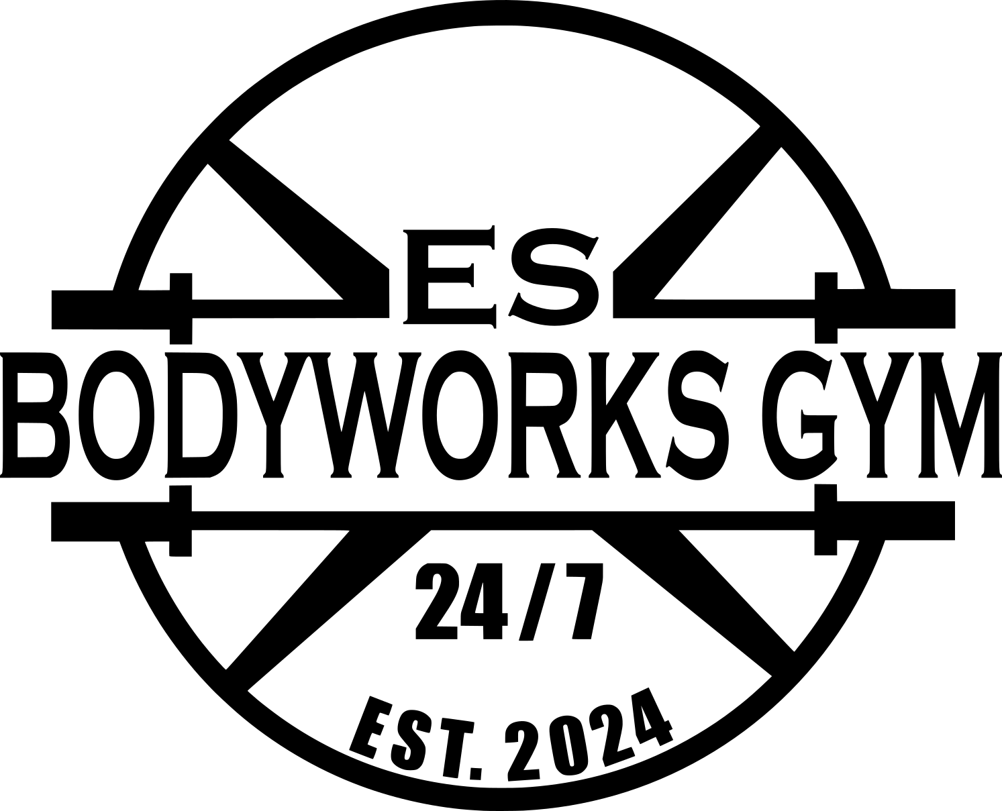

EZ PAY AUTO DRAFT

Authorization Agreement for ES BODYWORKS GYM, LLC
ELECTRONIC TRANSACTION AGREEMENT

I hereby authorize ES BODYWORKS GYM, LLC to automatically draft my bank account described below at the depository financial institution named below in reference to my monthly gym membership fees. All such entries must comply with all provisions of the law.

I understand this automatic draft will recur each month for the amount due in accordance with the terms of my membership with ES BODYWORKS GYM, LLC. I am aware that it can take ten (10) days for the automatic draft to begin processing. I may terminate or change account information for this automated payment authorization at any time with ten (10) days’ written notice to ES BODYWORKS GYM, LLC at the address identified below.

If your payment is returned as insufficient funds two consecutive times your auto draft will be terminated, and you will no longer be able to choose auto draft as your choice of payment.

Member or Authorized Signature: _______________________________________ Date: ____________________

DEPOSITORY INFORMATION

Select one: □ Checking ◻ Savings

Please attach a voided personal check/deposit slip or provide proof of routing/account number.

Name on Account: __________________________________ Bank: _____________________________________

City, State of Bank: ___________________________________

Routing #: _________________________________ Account #: _________________________________

Draft Date (Circle One): 1ST 5TH 10TH 15TH 20TH 25TH

FOR OFFICE USE ONLY:

Member Name: ____________________________________ Account Number: _____________

First Draft on: ______/______/______ Draft Date: ________ Amount: $________.00

ES Bodyworks Gym, LLC
707 N. Perkins Rd., Stillwater, OK 74075 – (405)624-0944

