Castle Colchester MCC Adventure Bike Group
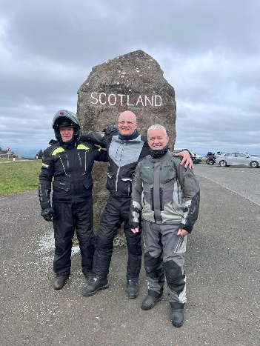
Well, it’s been a very busy year for adventure bikes and touring. Monthly outings are still going strong with members making a regular appearance on both monthly ride outs and touring run by the club. Conversations and communication is very good, but plenty of ribbing as well.

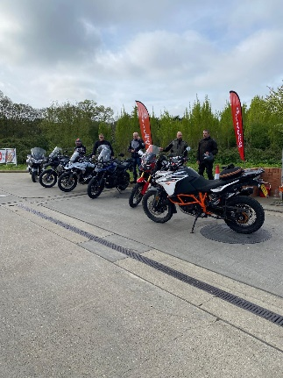
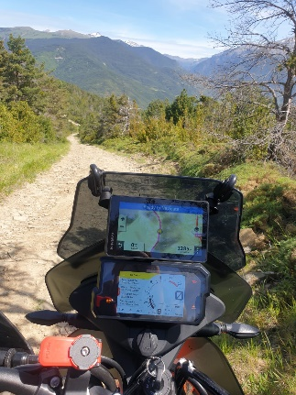
The group seems to be growing from strength to strength with all members sharing ideas, rides and advice. Members have been as far away as the Pyrenees on separate rides, but keeping us up to date with whats going on via WhatsApp and info on potential tours for next near. A very good group!
Trips for next year…
I myself am looking at Picos, Pyrenees, Morocco and Portugal next year, so watch this space for space if you would like to join me!

I will be plotting further club tours which will be including the Wild Atlantic Way in Ireland & Scotland and possibly Spain. Germany is an absolute must and I have started working on a route already.
Alister and Owen managed to get away to the Isle Man TT this year for racing and camping and quite obviously had some fun on the brand new 1250 GS. An absolute stonker of a bike. The same can be said for Tonys new 1300 GS, another cracking bike.
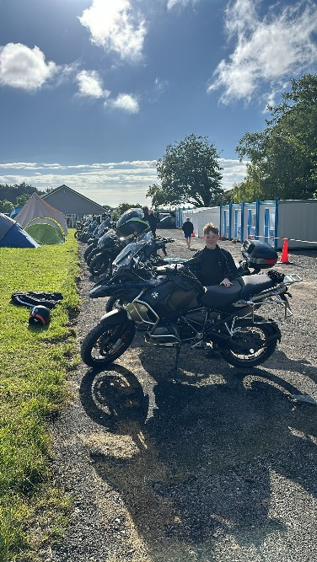
Any club members that would like to be involved with the Adventure bike group, then please feel free to make contact, as you are always welcome if you would like to know more.
We have potentially two new club members who are interested to joining this month, so we will welcoming them once joined.

