Castle Colchester MCC Green Laning Group
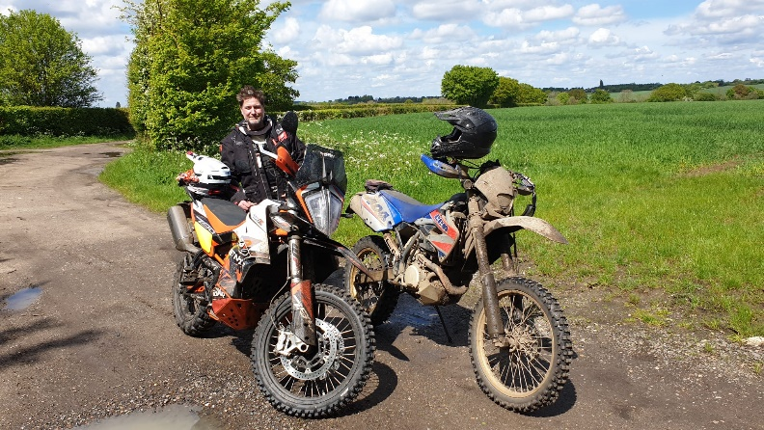
Been a little bit of a slow start to the year what with the amount of rain we have had and how badly the lanes have been trashed. But we have been out in dribs and drabs with members sort of not planning rides, but doing them when they can. Some are riding during the week and some at weekends subject to weather conditions.
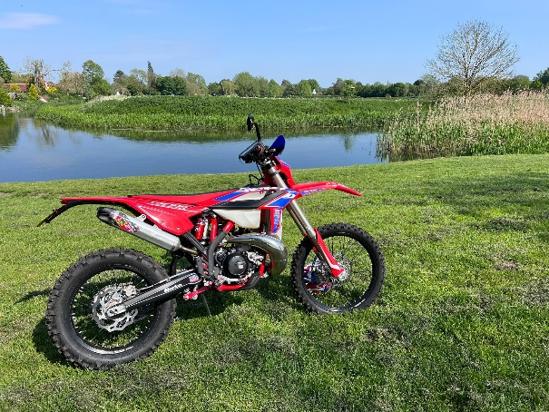

What with the weather and lanes improving more rides shall be posted over the coming weeks. Official rides are the second Saturday of the month as and when it ties in. Let’s get plotting and scheduling some more rides in before we can’t again.
Everyone in the group is welcome to post a ride out to all members
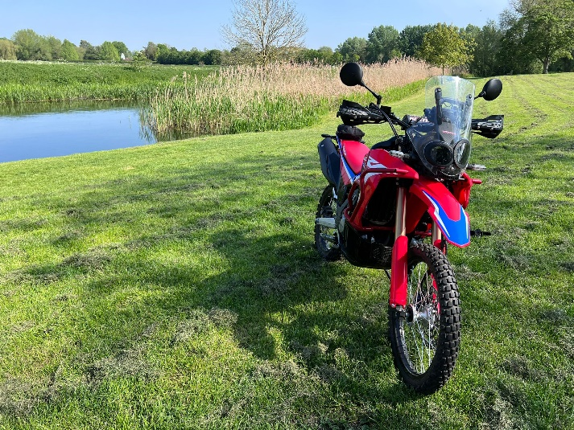
John, Paul and I went out a couple of weeks ago and had a blinder of a ride. John was absolute mustard on hie new Honda CRF 300. Outstanding ride! I was a little concerned the lanes were a bit rough, but he ploughed on through!
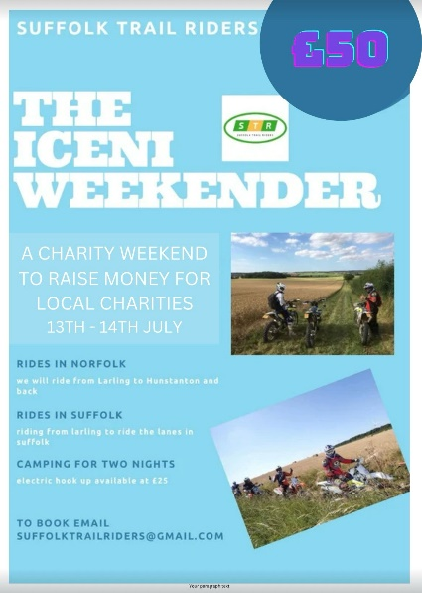
Don is running a route for the Iceni Ride this year 13th / 14th July and has been practicing with the route for the STR group. So good luck Don and please a full report when you get back.

Les has been away to Wakes to the Farm this year with a group, and plenty of fun was had. The videos look amazing albeit a little cold looking I do not have any images to post unfortunately only video..

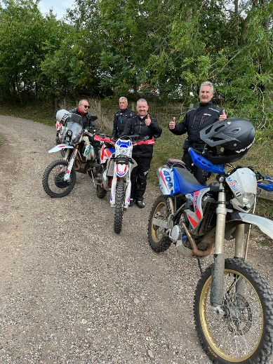
Any club members that would like to be involved with the Green Laning bike group, then please feel free to make contact, as you are always welcome if you would like to know more.

