Group Conscience Minutes 11.16.25

Secretary Report: Sara S. Approval of 8/17/25 Group Conscience Minutes posted on Website (Under More/Group Conscience) after last meeting.
- Amended treasurers report was not included in minutes. They are updated in this meeting’s notes.
- No further changes discussed

Password Requests & Meeting Confirmations – Sara S

Totals | 2025 Passwords | 2025 Confirmations | 2024 Passwords | 2024 Confirmations | 2023 Passwords | 2023 Confirmations | 2022 Passwords | 2022 Confirmations
01 January | 9 | 8 | 10 | 7 | 25 | 15 | 31 | 16
02 February | 12 | 8 | 15 | 6 | 12 | 15 | 29 | 13
03 March | 13 | 4 | 9 | 4 | 26 | 17 | 21 | 29
04 April | 6 | 10 | 12 | 8 | 9 | 23 | 29 | 22
05 May | 3 | 5 | 18 | 9 | 8 | 28 | 11 | 40
06 June | 12 | 9 | 22 | 5 | 3 | 19 | 24 | 36
07 July | 11 | 4 | 10 | 8 | 6 | 20 | 18 | 30
08 August | 7 | 8 | 9 | 8 | 2 | 15 | 21 | 16
09 September | 7 | 9 | 6 | 10 | 8 | 10 | 11 | 20
10 October | 9 | 10 | 6 | 9 | 4 | 12 | 12 | 27
11 November | 8 | 6 | 4 | 13 | 9 | 15 | 20 | 20
12 December |  |  | 7 | 10 | 5 | 3 | 19 | 19
 | 97 | 80 | 128 | 97 | 117 | 192 | 246 | 288
 | Incomplete total
Year | Passwords | Confirmations
2022 | 246 | 288
2023 | 117 | 192
2024 | 128 | 97
2025 | 97 | 81

- Questions/Discussion: No further discussion

Treasurer Report: Kelley C
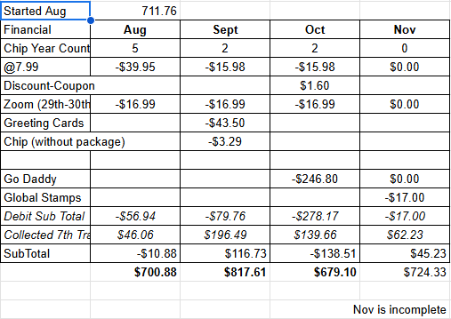
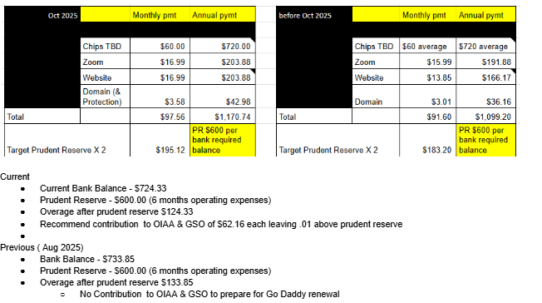

- Questions/Discussion/Approval:
  - Motion to round to nearest $ on Treasurer - passed
  - Motion 124 split between OIA AA - passed.

Web Servant Report: Nona C
- Web Report:
  - Chairs and Cohosts are listed for November 2025.
  - Speakers are up to date through December 5, 2025.
  - Group Conscience is posted for 8/17/2005.
  - Visits to our Website:
    - 4727 in the last 12 months
    - 429 in the last 30 days
- Emails:
  - 11/3/25 – Request for 2-month chip from a Fayola L, Serbia:
  - Thank you very much and thank you for the work you do. You are saving lives, healing people and giving second chances.
  - Thank you very much for reaching out! I wasn’t even sure this was real. I also found a 24-hour meeting, so I am very motivated about that.

- Our data goes back to May of 2022 when we began to use cookies and analytics.
  - We have received 232 Chip requests since May 2022
- Questions/Discussion:
  - Website is in update in process to make things more readable and to protect anonymity
  - Nona gave a visual tour of changes for the group
  - No further discussion

Chair Report: Kelly M
- Self-support through service. We are staying sober, carrying the message and helping newcomers, and it would be great if we had more members participating with group service.
  - Current meetings require 8 members per month to chair and cohost 4 meetings and if one of them can’t make it, we often scramble to find coverage.
  - We have a steering committee comprised of 5 members which are included in the 8-10 members who chair and cohost, to be a 501c3 and have a bank account to practice the spirit of rotation. At some point, we will need other members to rotate into these service commitments.
  - Why is service important? I owe a debt of gratitude to Alcoholics Anonymous which I pay back by giving back what has so freely been given to me, and I can’t keep it unless I give it away. It’s my responsibility, when possible, to be of service.
  - I remain grateful for the opportunity to be of service, understanding that this helps me stay sober and sane. Thank you!
  - Questions/Discussion: No discussion

Member Services – Donna M
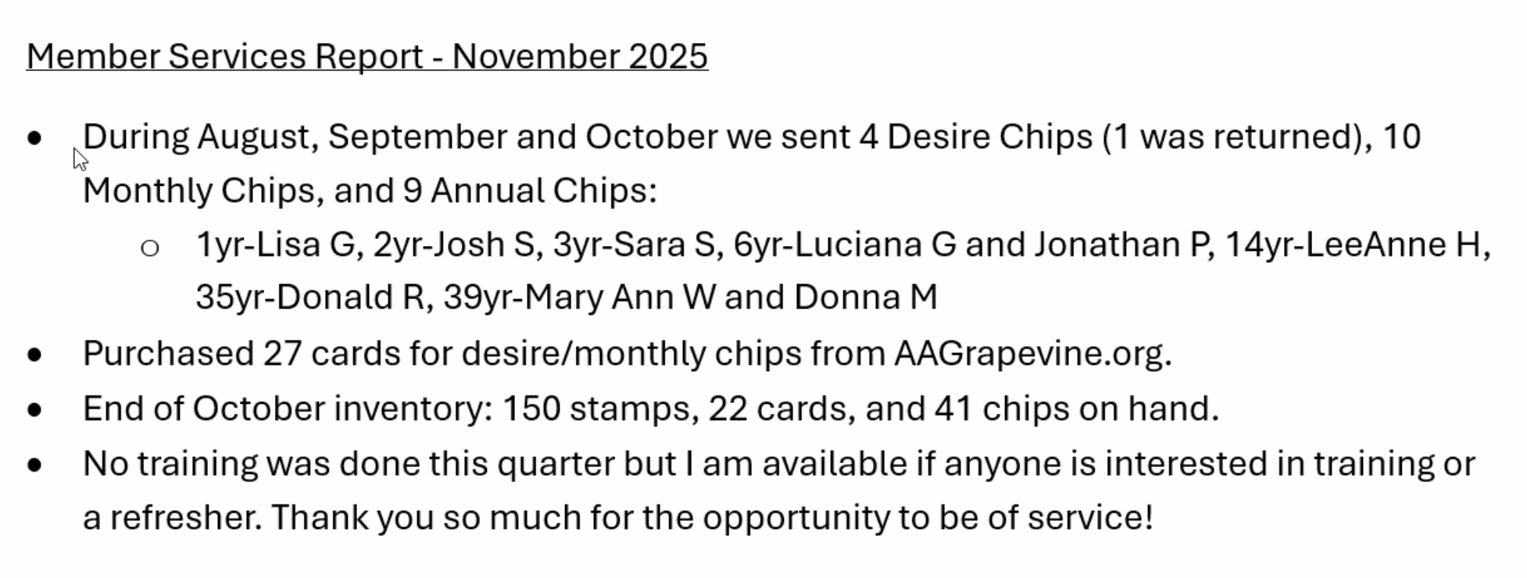
- Questions/Discussion/Approval: Above reflects amended report for discussion as of today
  - Report approved

Speaker Seeker Report: Kelli T (working on dates past 12/12)
11/14/2025 | Ashley S | Clean Air North - Addison, TX | 1/1/1990
11/21/2025 | George L | Friday Night Lights-Santa Rosa Beach, FL | 5/31/1989
11/28/2025 | Ellen D | Clean Air North - Addison, TX | 1/20/1992
12/05/2025 | Stephanie | AA Unity | 5/7/2022
12/12/2025 | Richard R | Perry Street Group

- Questions/Discussion?
  - No discussion

Old Business: N/A
New Business:

Monthly: Chairs and Cohosts:

November

Meeting | Chair | Cohost
Monday 7PM Discussion (1st Mon Tradition topic) | Kelly M | Diane P
Wednesday 7PM Discussion | Nona C | Kelley C
Friday 7PM Speaker Meeting | Donna M | Sara S
Sunday 10AM Spiritual Meeting | Don R | McCaleb B

December
Meeting | Chair | Cohost
Monday 7PM Discussion (1st Mon Tradition topic) | Sara S | Karen H (Kelly M 12/15)
Wednesday 7PM Discussion | Kelley C (Nona 12/24) | Diane P
Friday 7PM Speaker Meeting | Donna M | Stephanie G (Sara 12/5 covered-Stephanie is speaking)
Sunday 10AM Spiritual Meeting | Kelly M | Nona C

Closed meeting at 1:00PM

