Group Conscience Agenda 5.17.26
Attendance:
Secretary Report: Sara S
- Approval of 2/15/25 Group Conscience Minutes posted on Website (Under More/Group Conscience) after last meeting.
- Password Requests & Meeting Confirmations

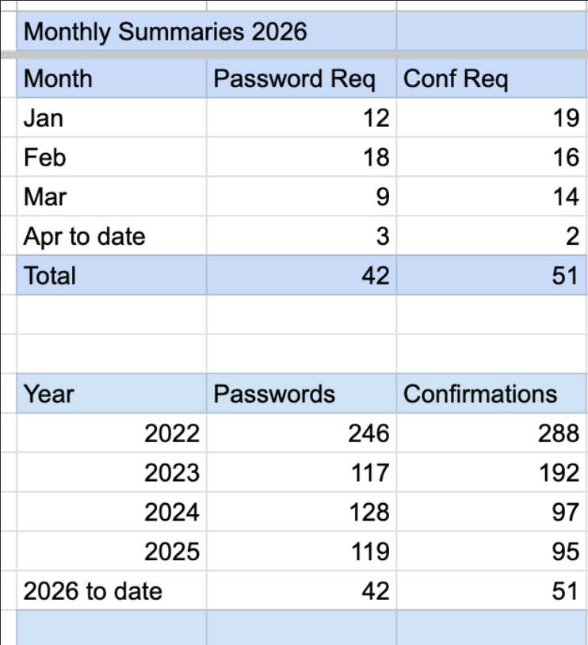

- Questions/Discussion:

Web servant Report – Nona C.
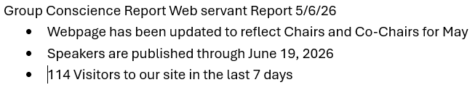
  - Questions/Discussion:

Speaker Schedule:
05/15/2026 | Peter G | Third Edition | 8/21/89
05/22/2026 | TBD | Ashley or Sue
05/29/2026 | Karl | Forest Lake 8AM | 2/20/20
06/05/2026 | TBD | Ashley or Sue
06/12/2026 | Glenna | Language of the Heart | 1/15/91
06/19/2026 | Dan M | Come as You Are | 7/17/85
  - Questions/Discussion:

Treasurer Report – Kelley C
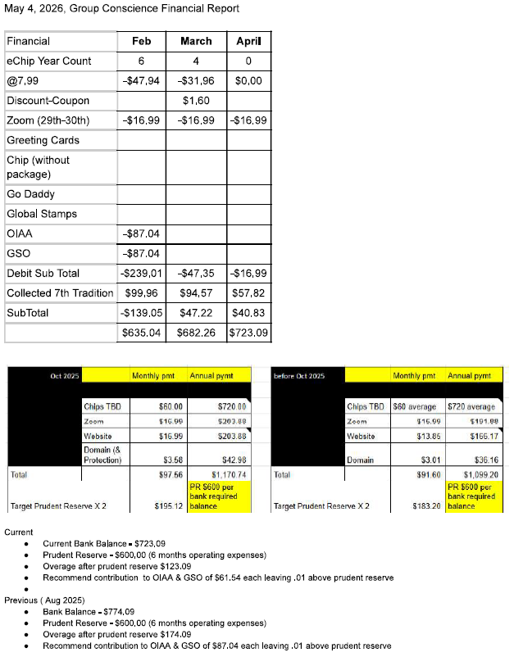

- Questions/Discussion/Approval:

Donna M. Member Services Report
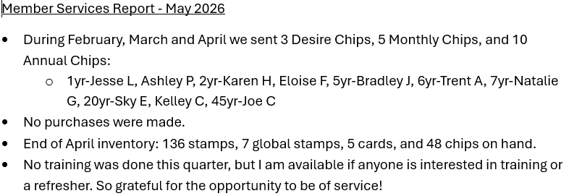
- Questions/Discussion/Approval:

Chair Report: Kelly M
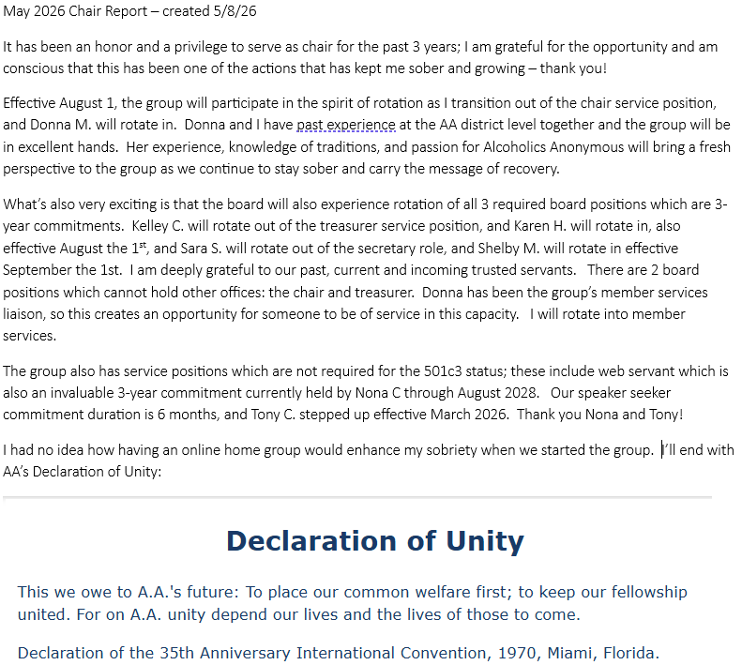

  - Questions/Discussion:

Old Business:

New Business:
Monthly: Chairs and Cohosts:
May
Meeting | Chair | Cohost
Monday 7PM Discussion (1st Mon Tradition topic) | Donna M | Sara S (Diane 5/25)
Wednesday 7PM Discussion | Nona C | McCaleb B
Friday 7PM Speaker Meeting | Shelby M (Stephanie G 5/15) | Karen H (Kelly M 5/1 & Donna M 5/8)
Sunday 10AM Spiritual Meeting | Kelley C | Kelly M

June
Meeting | Chair | Cohost
Monday 7PM Discussion (1st Mon Tradition topic) | Kelly M | Karen H
Wednesday 7PM Discussion | Sara S | Shelby & Kelley C
Friday 7PM Speaker Meeting | Donna M | Kelly M
Sunday 10AM Spiritual Meeting | Nona C | Kelley C

