Group Conscience Minutes 8.17.25

-Last meeting minutes approved.

Secretary Report: Sara S. Approval of 5/18/25 Group Conscience Minutes posted on Website (Under More/Group Conscience) after last meeting.

Password Requests & Meeting Confirmations – Sara S
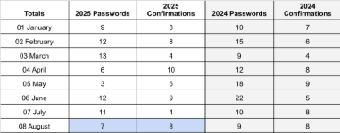
- Questions/Discussion: No discussion

Treasurer Report: Kelley C
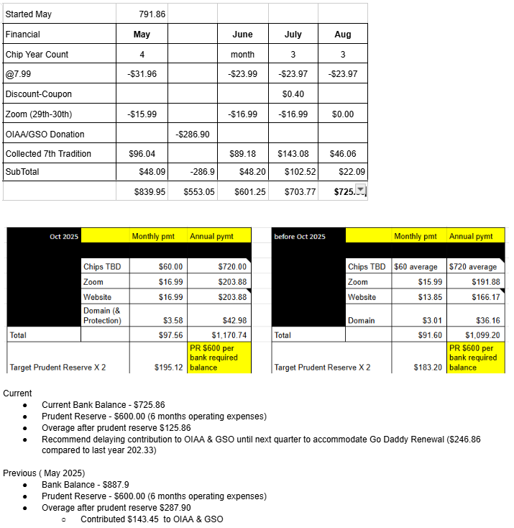

Questions/Discussion/Approval:
- Nona motioned not to make contributions at this time in support of the treasurer’s recommendation. Passed.
- Donna noted a possible discrepancy in chip count. Take off-line and report on next meeting.

IGR/Report: Craig H
- Questions/Discussion:

Web Servant Report: Newly filled by Nona C – thank you for your service!
- Web page has been updated to reflect Chairs and Co-Chairs for August and September 2025, and speakers through October 24, 2025
- 401 site visitors in the last 30 days
- Motion for a vote:
  - Meeting formats have been updated and need approval.
    - To chat with the host or co-host you will need to select the intended recipient by starting a new chat. The chat disabled message does not pertain to messaging the host or co-host.
- Questions/Discussion:
    - Friendly changes: To chat with the host or co-host, you will need to start a new chat and then select the host or co-host. The chat disabled message does not pertain to messaging the host or co-host.
    - Motion to approve friendly changes: approved.

Chair Report: Kelly M
- Self-support through service. While we are staying sober, carrying the message and helping newcomers, we need more group service support including chairs and cohosts.
  - Current meetings require 8 members per month to chair and cohost 4 meetings and if one of them can’t make it, we often scramble to find coverage.
  - We have a steering committee comprised of 5 members which are included in the 8-10 members who chair and cohost, to be a 501c3 and have a bank account to practice the spirit of rotation. At some point, we will need other members to rotate into these service commitments.
  - Why is service important? I owe a debt of gratitude to Alcoholics Anonymous which I pay back by giving back what has so freely been given to me, and I can’t keep it unless I give it away. It’s my responsibility, when possible, to be of service.

Member Services – Donna M
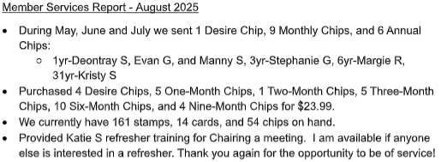

Questions/Discussion/Approval:
- Donna indicated the card count might not be accurate. She will recount and adjust all counts next meeting.
- Approved

Speaker Seeker Report: Open position: Speakers scheduled through most of October plus 1 Nov date – thanks Stephanie and Nona!
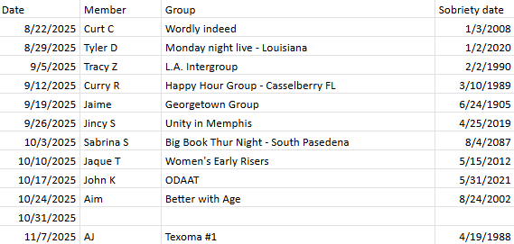

Questions/Discussion?
- No discussion

New Business
- Discuss eliminating IGR (Intergroup representative) service position to better fulfill our other group service needs. Can always be revisited in the future.
  - Motion: Temporarily eliminate the position and review in 1 year. Passed
- Motion by Donna M. Change the meeting formats section where we celebrate lengths of continuous sobriety
from: “30 days, 60 days, 90 days” to: “1 month, 2 months, 3 months”
  - Passed
- Montion by Donna M. Change the meeting formats section regarding chip requests from “Please visit our website and click on chip request if you are celebrating." To "Please visit our website and click on chip request when you have achieved any of these milestones."
  - Passed
Old Business – open service position – speaker seeker:
- Motion by Donna M. to elect Kelli T as speaker seeker.
  - Approved

- Add to next meeting’s old business: Donna noted a possible discrepancy in chip count. Take off-line and report on next meeting.

Monthly: Chairs and Cohosts:

August

Meeting | Chair | Cohost
Monday 7PM Discussion (1st Mon Tradition topic) | Kelly M | Kelley C
Wednesday 7PM Discussion | Katie S | Diane D (needs 8/27 covered)
Friday 7PM Speaker Meeting | Donna M | Sara S
Sunday 10AM Spiritual Meeting | Nona C | Craig H

September
Meeting | Chair | Cohost
Monday 7PM Discussion (1st Mon Tradition topic) | Stephanie G | Kelly M (Stephanie 9/1)
Wednesday 7PM Discussion | Shelby M | Diane P
Friday 7PM Speaker Meeting | Sara S | Stephanie G
Sunday 10AM Spiritual Meeting | Craig H | Karen H
October
Monday 7PM Discussion (1st Mon Tradition topic) | Kelley C | Shelby M
Wednesday 7PM Discussion
Friday 7PM Speaker Meeting | Donna M
Sunday 10AM Spiritual Meeting |  | Craig H

