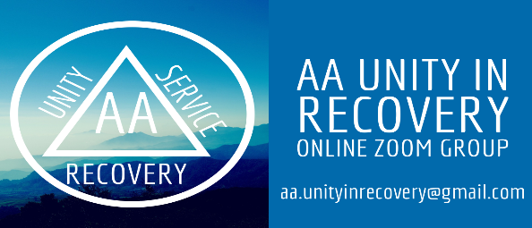
Meeting Chair (Host), and Admin (Co-host) Responsibilities
Role: Meeting Chair
This role will do the following:
- Log into Zoom as a participant on their computer at least 15 minutes prior to the start of the meeting. If you are chairing the Sunday Spiritual meeting, log on 15 minutes prior to the meeting. When chairing your first meeting, log on a bit sooner to familiarize yourself with setting up the meeting.
  - Open the Participants Box and click on the 3 dots, click on Claim Host, enter the Host Key, and click Claim Host again. Host key will be provided during initial training.
  - Open the Security Box. Ensure the only checked functions are Enable Waiting Room and Allow Participants to Chat.
    - Ensure options are removed for participants to unmute themselves.
    - Ensure options are removed for participants to rename themselves (If necessary, the Host and Co-Host can rename any participants).
    - Ensure opinions are removed for Collaboration Apps (new Dec 2022)
  - Open the Participants Box again, select the 3 dots, and ensure Mute Participants Upon Entry is checked.
  - Open the Chat Box and ensure Chat Only with the Host is selected.
  - You will leave your participants box and chat box open throughout the meeting.
- When the scheduled Admin logs in, assign them Co-Host access.
  - Respond to any chats sent to you as host or co-host from the participants.
- Chair the meeting by following the meeting format specific to your meeting.
  - Unmute and greet the participant and mute them after the welcome is complete. Suggested greetings are “Where are you logging in from”, “Glad you joined us”,
    - Do not use open ended questions
    - Once the meeting starts the co-host will let participants in from the waiting room.
  - The chair will unmute participants as they are selected to share and then mute them again after they share.
    - When a participant raises their hand, ask them to unmute after you have lowered their hand.
      - Be mindful of people who immediately enter and raise their hand. It is best if the cohost lowers their hand and asks if they need assistance in the chat.
  - Select participants with their video enabled first before moving on to participants who do not have video enabled. Use the chat to ask those without video if they would turn on their video to share. If they are unable to - use your discretion.

- End the Meeting for All.

Role: Meeting Administrator (Co-Host function in Zoom)
The Co-Host will sign into the meeting as a normal participant and will be assigned the Co-Host role by the Host. Use your computer to log on.
This role will do the following:
- Log into the Zoom as a participant.
- The host will assign you the co-host role.
- You will leave your participants box and chat box open throughout the meeting.
- Admit participants from the Waiting Room once the meeting starts. Select the name and Click “Admit”.
  - Only admit participants with “appropriate” names or Phone ID.
  - Watch the participants upon entry and throughout the meeting.
  - When possible, Chat with participants in the Waiting Room if you have concerns. Your chat will reach “everyone ” in the waiting room so admit those you are comfortable with first (if appropriate)
- Monitor for Zoom bombers and remove them from the meeting. Once a zoom bomber is removed - they cannot re-enter the meeting.
- Co-host can also change participant names, and should do so especially when a last name is present. Do this by clicking on the dots located on their video.
- Respond to any chats from the participants.
- When the proof of attendance, 7th tradition, post the link to the website: aaunityinrecovery.org
Musts for Host and Co-host
Chairs/Co-hosts must have a Desktop or LapTop. Touch screens also cause a distraction.
Leave your camera on at all times during the meeting
If help is needed during the meeting, send a chat to a member of the Steering Committee for additional support. Steering Committee Members are currently, Nona C., Kelly M, Sky E, and Jonathan P.

