Group Conscience Minutes 2.15.26
Secretary Report: Sara S
- Approval of 11/16/25 Group Conscience Minutes posted on Website (Under More/Group Conscience) after last meeting.
- Password Requests & Meeting Confirmations

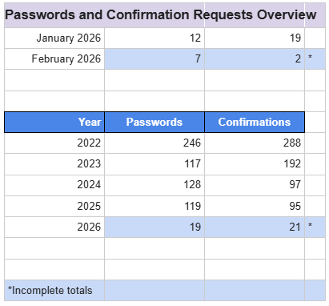

- Questions/Discussion: None

Web servant Report – Nona C
Created 1/16/26 (updated 2/11/26)
Analytics – Number of E-mail communications through our Website including password requests, meeting confirmations, chip requests and/or general questions.
- November 2025 – 27 emails
- December 2025 – 29 emails
- January (as of 1/16/26) – 14 emails
- 152 website visits from February 10th – February 17th
Chairs and Cohosts were posted for February 2026
March isn’t posted due to current Host and Cohost gaps for specified dates
Posted Speakers
Meeting Date | Name | Group | Sobriety Date
02/06/2026 | Jackie K. | Atlantic IA Group - Atlantic IA | 10/06/2008
02/13/2026 | Stephanie | AA Unity | 05/07/2022
02/20/2026 | Ryan | PPG Webster in Rochester, NY | 11/13/06
02/27/2026
03/06/2026 | Michelle Z | From Alaska | 03/02
03/13/2026 | Beth | Vero 12&12 in Vero Beach FL | 10/13/2006
03/20/2026 | Evarleigh | FOTS

Monday Meeting format:
- Verbiage for the traditions meeting was changed to mirror the language in our literature: “The 12 Traditions of AA are guidelines for navigating relationships between members, AA groups, the global fellowship, and the community as a whole.
- The format now also reads – “if you wish to share raise your hand in the reaction box”.
  - Questions/Discussion:
    - Tony C: enquired about Speaker Seeker position - Would like to stand for the position. To be voted on.

Treasurer Report – Kelley C
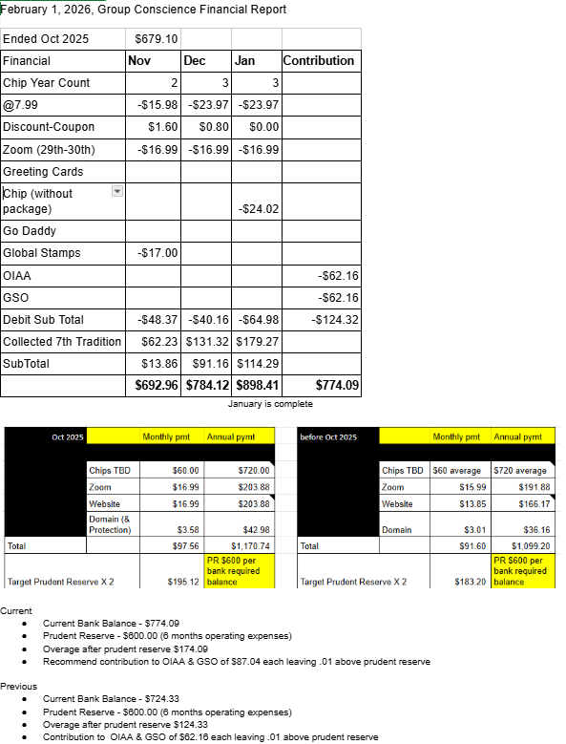
- Questions/Discussion/Approval:
  - Recommended contributions approved

Donna M. Member Services Report - February 2026
- During November, December and January we sent 4 Desire Chips, 11 Monthly Chips, and 8 Annual Chips:
  - 1yr-Liz H and Wallace D, 2yr-Nicolette B, 3yr-Pryor M, 4yr-Tara C, 26yr-Kelly M, 28yr-Diane P, 35yr-Nona C

- Purchased 10 global stamps for $17.00 and 30 monthly chips for $24.02.
- End of January inventory: 144 stamps, 7 global stamps, 13 cards, and 56 chips on hand.
- No training was done this quarter but I am available if anyone is interested in training or a refresher. So grateful for the opportunity to be of service!
- Questions/Discussion/Approval:
  - Approved

Chair Report: Kelly M
February 2026 Chair Report
Created 2/7/26
- We are staying sober, learning and growing, and being of service.
  - Craig H, who passed away in December, got sober in our group and we believe his almost 6 years of sobriety (2/28/2020) were the happiest of his life.
  - I recently realized that I do not need to worry about managing sponsorship opportunities, yes, I need to make myself available either online or at brick-and-mortar meetings. I recently began sponsoring new group members, thanks to our group and the atmosphere of recovery, unity, and welcome.
- AAWS Self Support monthly communication from Scott H., Chair of the General Service Board: Time and Money Scott H. English Letter - AAWS Recommendation
- General Service Office Quarterly Report F-14 Quarterly Report 2025 Fourth Quarter
  - Questions/Discussion: None

New Business:
- Speaker Seeker Kelli T. 6-month service commitment ends this month. Shelby M. is willing to stand.
  - Thank you Kelli & Shelby! Tony C is also willing.
    - Tony C has agreed to be Speaker Seeker
    - Shelby M will be Secretary starting in September in August
  - 6-month commitment includes scheduling speakers with at least 1 year of sobriety and a clear message (and has not spoken at our meeting for at least 1 year), and explaining the format to them, with each month’s speakers due on the drive spreadsheet by the 1st of each month.
  - We have 6 years of previous speakers contact info as a reference

Monthly: Chairs and Cohosts:

February
Meeting | Chair | Cohost
Monday 7PM Discussion (1st Mon Tradition topic) | Shelby M | Stephanie G
Wednesday 7PM Discussion | Sara S | Diane P
Friday 7PM Speaker Meeting | Donna M | Kelly M
Sunday 10AM Spiritual Meeting | Nona C | Kelley C

March: Discuss self-support through service
Meeting | Chair | Cohost
Monday 7PM Discussion (1st Mon Tradition topic) | Kelly M | Shelby M (Karen H 3/2)
Wednesday 7PM Discussion | McCaleb B | Sky
Friday 7PM Speaker Meeting | Sara S | Karen H (needs 3/27 covered)
Sunday 10AM Spiritual Meeting | Kelley C | KELLY M March 1st, 8th, 29th  (Shelby 15th & 22nd)  (Donna 27th)

Open Discussion:
Nona: Other positions in need of filling at end of July: Chair & Treasurer for 3 year terms. Board to decide in Mid March.
Donna is willing to Chair.

Close at 12:50 PM with Serenity Prayer.

