Group Conscience Minutes 5.18.25

Secretary Report: Approval of Minutes posted on Website (Under More/Group Conscience) after last meeting.
  - Questions/Discussion/Approval: Approved. After motion made, seconded & minutes approved, a question regarding which motions were approved under New Business. The review reflects the minutes that were not clear, and the chair will review future minutes after they are posted for clarity – the unclear motions were:
    - Motion made by Nona to reschedule group conscience from the last Sunday of each month to the 3rd Sunday to avoid holiday conflicts and make participation easier – passed.
    - Motion made by Sky to revise announcements from Chairpersons and cohosts are scheduled in advance to ensure our meetings will be held. A monthly commitment is each Monday, Wednesday, Friday, or Sunday in a month, and training is provided. Please visit our website and fill out the Be of Service form, to AA Unity in Recovery needs 3 service positions filled, web servant, member services, and AIGR the end April, and speaker seeker by June. Please fill out the “be of service form” on our website or contact our chair at aa.unityinrecovery@gmail.com if you are willing and able to serve – passed.

Password Requests & Meeting Confirmations – Sara S
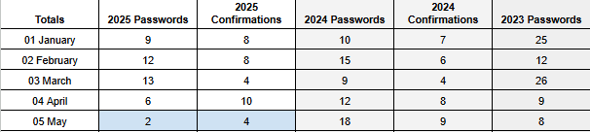
- Questions/Discussion:

Treasurer Report: Kelley C (display report via drive)
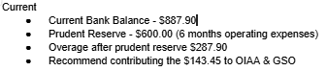

Questions/Discussion/Approval: Question regarding individual contributions process – q question was asked about individual contributions which are not listed. The process is that the treasurer transfers contributions in batches. Report and OIAA/GSO contributions pproved.

IGR/Report: Craig H: Attended the OIAA forum for which the primary discussion pertained to Zoom best practices and host tools. Many groups leave chat open
- Questions/Discussion:

Web Servant Report: Margie R
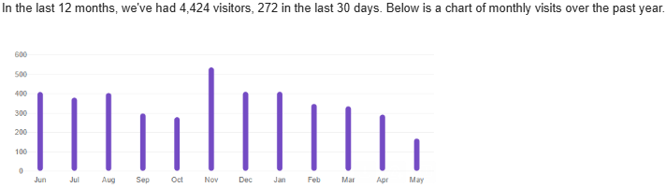
- Questions/Discussion: Great chart!

Chair Report: Kelly M
- I remain grateful for the opportunity to be of service, understanding that this helps me stay sober and sane. Thank you!

Member Services Report: Donna
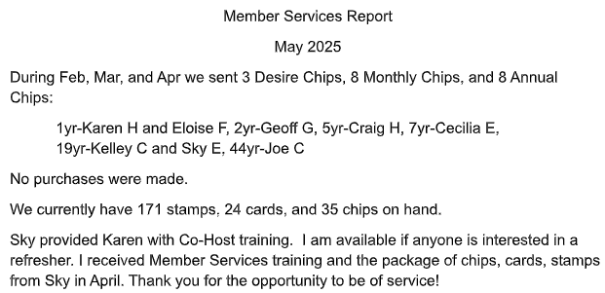

Questions/Discussion/Approval: Discussed line-by-line names for anniversary packages can be removed from treasurer report since they are on the member services report. Approved

Speaker Seeker Report: Stephanie G. (monthly speakers also now listed on our website). Speakers are scheduled through August and the 2nd Friday in September – thanks Stephanie!
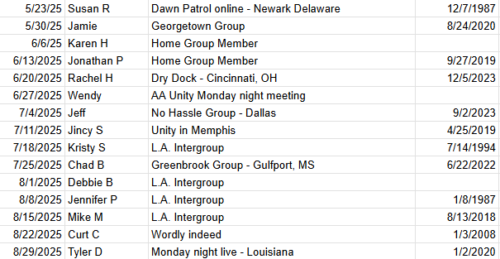

Questions/Discussion?

New Business – AIGR service position is open - requirements. Attend quarterly Online Intergroup of Alcoholics Anonymous (OIAA) forums and bring information to the group and share information with the group about Alcoholics Anonymous General Service Office. Commitment 1 year includes quarterly steering committee, quarterly group conscience meetings attendance, and chairing and cohosting recovery meetings.
Motion Kelley C: remove from the meeting agenda “On Group Conscience Meeting days, we will open fellowship for 5 minutes until the start of the Group Conscience Meeting - approved.
Also discussed adding AIGR to announcements or adding to Be of Service section of website – tabled
Old Business – Speaker Seeker needed with current trusted servant rotating out end of June. The steering committee voted to ask for volunteers monthly at the same time we ask for chairs and cohosts. Stephanie is willing to be continue – voted for her continuation.
- Chairs and Cohosts:

May

Meeting | Chair | Cohost
Monday 7PM Discussion (1st Mon Tradition topic) | Kelly M | Margie R
Wednesday 7PM Discussion | Shelby M | Karen H
Friday 7PM Speaker Meeting | Stephanie G | Donna M
Sunday 10AM Spiritual Meeting | Sara S | McCaleb B

June
Meeting | Chair | Cohost
Monday 7PM Discussion (1st Mon Tradition topic) | Kelley C (Kelly M 6/16) | Margie R
Wednesday 7PM Discussion | Katie S | Sara S (may need 6/4 coverage)
Friday 7PM Speaker Meeting | Kelly M | Donna M
Sunday 10AM Spiritual Meeting | Craig H | Kelly M

