AA Unity in Recovery Group Conscience Minutes 8/16/2026

Attendance: Tony C, Sara S, Karen H, Kelly M, Kelley C, Donna M, Nona C, Mary Ann W, Amanda R, Don ?
Secretary Report – Sara S

- Approval of 5/17/2026 Group Conscience Minutes posted on Website (Under More/Group Conscience) after last meeting.*Approved.
- Password Requests & Meeting Confirmations

Month | Password Req | Conf Req
Jan | 12 | 19
Feb | 18 | 16
Mar | 9 | 14
Apr | 10 | 6
May | 10 | 6
Jun | 11 | 7
Jul to date | 9 | 4
Total | 79 | 72
Year | Passwords | Confirmations
2022 | 246 | 288
2023 | 117 | 192
2024 | 128 | 97
2025 | 119 | 95
2026 to date | 79 | 72

- Questions/Discussion: *No Discussion

Technology Report – Nona C.

- Webpage has been updated to reflect Chairs and Co-Chairs through September*
- Speakers are published through August 21
- 109 Visitors to our site in the last 7 days (as of 8/2). Site visitors place us in the top 20% for non-profits in the last 5 years according to GoDaddy.
- Group conscience minutes were posted on the website for 5/17/26.

- Questions/Discussion: *No Discussion

Speaker Schedule

08/07/2026 Allison Ely Monday Noon Meeting 2/11/22
08/14/2026 Dave Lake Veronique 3/4/2008
08/21/2026 Amanda RU Willing 6/3/24
8/28/2026 Derik W Basic Text 5/25/23

- Questions/Discussion:
  - Looking for female speakers to represent
  - Tony agreed to act as speaker seeker for another 6 months

Treasurer Report – Kelley C

Financial | April | May | June | July
Chip Year Count | 0 | 3 | 2 | 1
@7.99 | $0.00 | -$23.97 | -$15.98 | -$7.99
Discount-Coupon |  | $0.00 |  | $0.80
Zoom (29th-30th) | -$16.99 | -$16.99 | -$16.99 | -$16.99
Greeting Cards |  | -$58.24
Chip (without package)
Go Daddy
Global Stamps
OIAA |  | $0.00 | $0.00
GSO |  | $0.00 | $0.00
Debit Sub Total | -$16.99 | -$99.20 | -$32.97 | -$24.18
Collected 7th Tradition | $57.82 | $80.85 | $90.16 | $107.80
SubTotal | $40.83 | -$18.35 | $57.19 | $83.62
 | $723.09 | $704.74 | $761.93 | $845.55

April was the last full month from the last report ending at 723.09

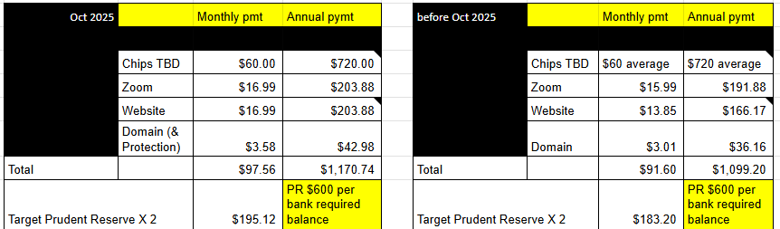

Current
- Current Bank Balance - $845.55
- Prudent Reserve - $600.00 (6 months operating expenses)
- Overage after prudent reserve $245.55
- Contribution to OIAA & GSO to be made after October Go Daddy payment

Previous ( April 2026)
- Bank Balance - $723.09
- Prudent Reserve - $600.00 (6 months operating expenses)
- Overage after prudent reserve $174.09
- Recommend contribution to OIAA & GSO only be made once a year after October Go Daddy, as this is a large (Est - $250) once a year payment.

- Questions/Discussion/Approval: *Approved

Member Services Report – Donna M

- During May, June and July we sent 4 Desire Chips, 14 Monthly Chips, and 6 Annual Chips:
  - 1yr-Natalie S and Mariela R, 2yr-Louise W, 4yr-Stepahnie G, 8yr-Stepahnie R and Cody B
- Purchased 24 greeting cards for $58.24.
- End of July inventory: 128 stamps, 6 global stamps, 20 cards, and 30 chips on hand.
- Kelly M trained Mary Ann to co-host.
- I truly enjoyed the Member Services service work and am always grateful for any opportunity to be of service. I am looking forward to serving our group in my new service position. Thank you for allowing me to be a trusted servant!

- Questions/Discussion/Approval:*Approved

Chair Report: Kelly M

As I rotate out of the group chair trusted servant position and into the member services trusted servant
position, I am filled with gratitude for the gift of sobriety and the opportunity to be of service and give back
what has been so freely given to me. Donna and I have been and will remain in communication as she rotates into the chair position. As the chair, Donna cannot hold more than one service position; as she has been our member services chair – I am grateful for the opportunity to fill that position so that I can still be of service to the group.
Thank you for my recovery, Kelly M.

- Questions/Discussion:*No discussion

Old Business:

New Business:

- Kelly M - Motion to change the requirement for the Sunday chair and cohost to log in 15 minutes early like we do for weeknight meetings instead of 30 minutes early. The Sunday meeting used to be larger so we were logging in 30 minutes early. Since it’s not as large, 15 minutes should be fine.*Approved
- Member Services will now answer password requests and confirmation emails. Changed in bylaws by Board of Directors. No approval needed.
Monthly: Chairs and Cohosts:

August Meeting | Chair | Cohost
Monday 7PM Discussion (1st Mon Tradition topic) | Kelly M | Sara S
Wednesday 7PM Discussion | Nona C | Jonathan P
Friday 7PM Speaker Meeting | Sky E | Stephanie G
Sunday 10AM Spiritual Meeting | Kelley C | Kelly M

September Meeting | Chair | Cohost
Monday 7PM Discussion (1st Mon Tradition topic) | Shelby | Diane
Wednesday 7PM Discussion | Sky | Sara S
Friday 7PM Speaker Meeting | Donna | Karen
Sunday 10AM Spiritual Meeting | Kelly M | Mary Ann W &  Stephanie G

*Motion to change format to allow speaker seeker to greet and introduce the speaker if speaker seeker is in attendance. Changed by secretary who then sends to tech servant. PASSED.

CLOSED AT 12:30 PM with the serenity prayer.

*Changes to Agenda/Minutes in Purple

