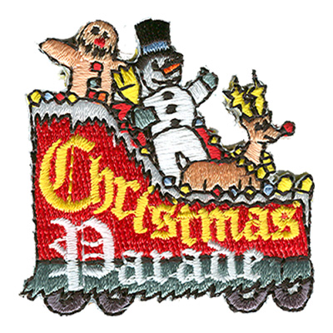
The parade with a purpose “ we feed the hungry”.
61 st Annual Lions Club Christmas Parade
Saturday December 4, 2021 10:00 AM …
Parade Chairman: Terry J. Askins P O Box 131 Mt Dora, FL 32757 352-551-0133 L/M - 352-449-8443
Sponsored by: MOUNT DORA LIONS CLUB
Starts at 11Th and Donnelly Street ENDS Gilbert Park
ENTRY FEE $25.00 OR A COLLECTION OF CAN GOODS. ( CHECKS PAYABLE TO LAKE CARES )
HAVE A FOOD DRIVE AND BRING THE CAN GOODS TO OUR SITE ON DAY OF THE PARADE. (ALL FOOD WILL STAY IN LAKE COUNTY.)
Return this form by 11/25/21 mountdoralionsclub@gmail.com (email all applications and questions)
--------------------------------------------------------------------------------------------------------------------------------------------------------------------------------------------------------
ENTRY INFORMATION & CHECKLIST CHECK________ (OR) FOOD DRIVE_______ LINE UP # __________
_______________Marching / Foot Unit, Number of People_________
_______________ Cars, _______________Band, Number of Members __________
_______________Truck ___under 25 feet___under 35 feet______or specify_______
Name of Group/Business____________________________________ All Semi’s will be at rear of parade.
Contact_____________________Phone____________Email____________@_______
****ALL ENTRIES MUST GO TO THE END AT GILBERT PARK NO BREAKING OFF *****
You will be notified of your line-up & staging area between the Nov 27 – 29, 2021 Line up 9:00 AM Step-off 10 AM SHARP
Disclaimer: Entrant hereby discharges & releases Parade Organizers from an responsibility or personal Liability due to injury, loss, or damage to property during their participation in the event, regardless of how caused. MT DORA LIONS CLUB HAS FINAL SAY ON WHO WILL PARTICIPLE IN THE PARADE. NO POLICITCAL AFFILIATED GROUPS WILL BE ALLOWED.
NO SANTAS IN ANY DISPLAYS. SANTA WILL BE AT THE END OF THE PARADE PROVIDED BY THE MT DORA LIONS CLUB .

