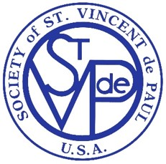
Society of St Vincent de Paul
4491 Springfield Rd
Glen Allen, Virginia 23060
info@svdp-rva.org

To: Recipient of St. Vincent de Paul (SVDP) rent payments

The St. Michael’s St. Vincent de Paul Organization is providing this letter to inform you that IRS requires we report any amount of $600 or more provided for rent to private individuals. In order to do that, we will need you to provide a completed and signed IRS Form W-9 which is attached.

At your convenience, please complete the form and return it to the address above, marked ”Attention SVDP Treasurer”, no later than 15 December 2022. We will keep the W-9 information confidential and only use it to prepare a Form 1099-Misc. We will mail the 1099-Misc to you by January 31st 2023, in accordance with the current IRS schedule.

Thank you for your cooperation with SVDP and your support for those in need. Please call the number below if you have any questions or email us at info@svdp-rva.org and note in the subject line ”Attention SVDP Treasurer”. You may leave a message and we’ll return your call as soon as possible.

St. Michael’s SVDP
804-372-3460

Attachment: IRS Form W-9

