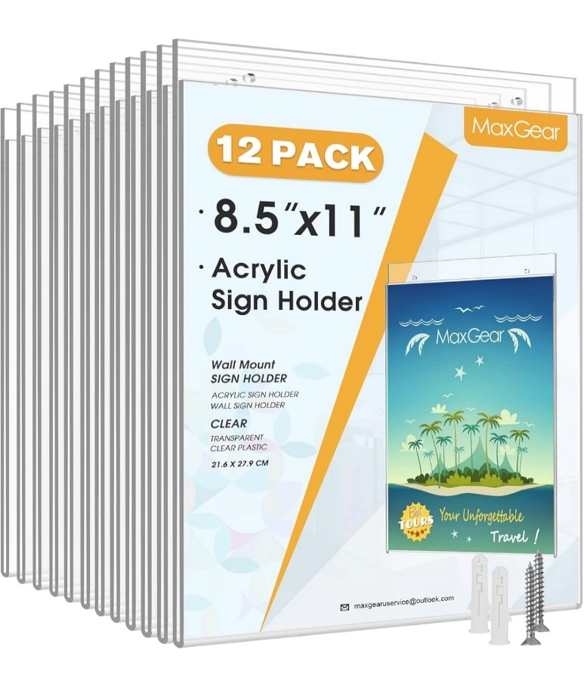
We order document holders from Amazon.

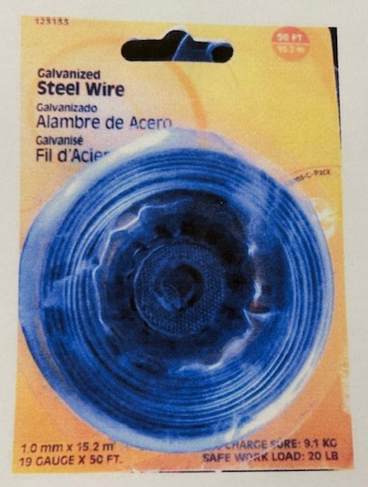
Wire we use to hang from dropped ceilings.

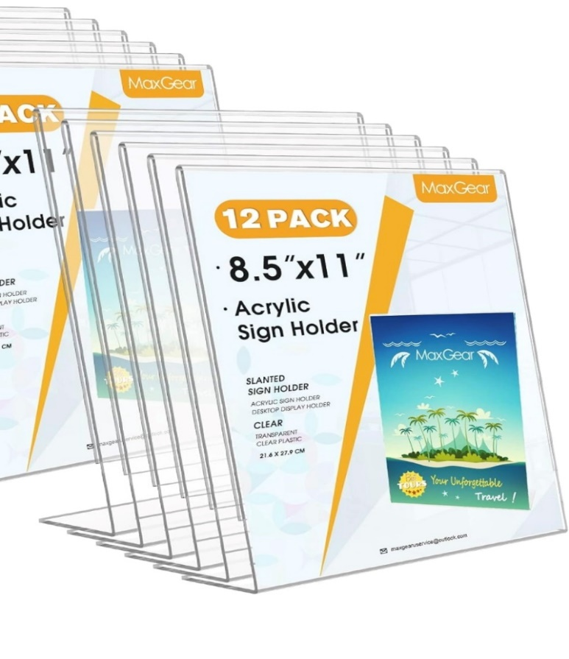

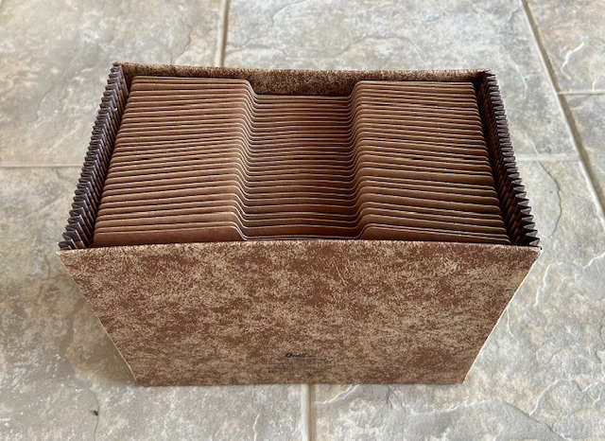
Expandable folders with Proverbs available to congregation. We keep in Fellowship Building.

