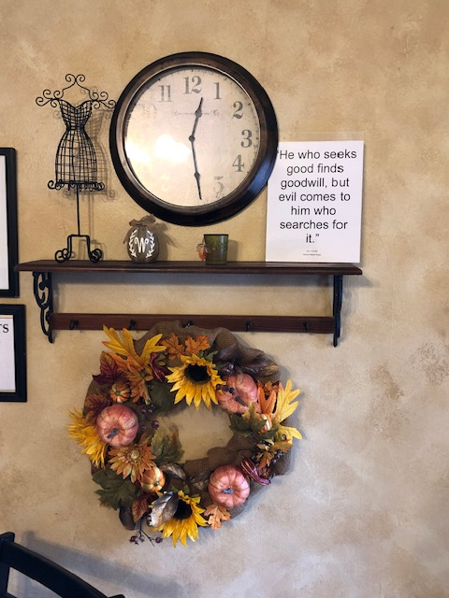
Donna’s Beauty Shop
Paint Rock, TX

