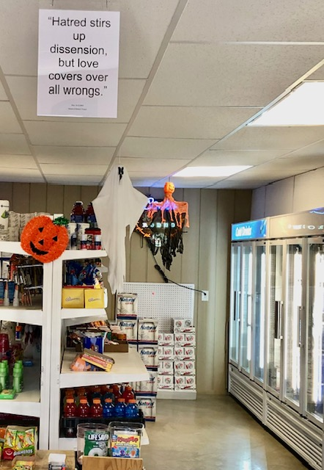

Willie’s Beer, Wine & R.V. Campground

Voss, TX